CUDA BITES
October 28, 2025
“Dream Big, AIM Higher”


INFORMATION:
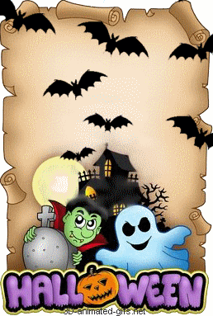

Good morning Cudas, Today is October 28, 2025

Consistent attendance builds the foundation for a bright future for all CUDAS

Wanting a little bit of a scare? SGA is hosting Haunted Highschool on Saturday, November 1st, from 7-9pm. There will be haunted hallways, food, a kid zone, and a movie for all to enjoy. Tickets are bought at the door for $5 (Cash Only), and kids under 5 get in for free. We hope to see you there.

"International club has a meeting on Wednesday, during lunchtime, in Rm 5-205. Please, plan to attend the club is open to everyone who is interested in joining. Thank you".

Senior Results for class song, flower, and motto
Song: “Landslide" by: Fleetwood Mac
Flower: Tiger Lily
Motto: "Sometimes you will never know the value of a moment until it becomes a memory." - Dr. Suess

Seniors: Make sure to pay your senior dues, Class officers will be passing out Senior T-shirts in front of activities on Thursday and Friday. You can make payment in cash, check or card. You must pay your senior dues to get your shirt.

Students interested in taking the ASVAB can sign up in school counseling now. The ASVAB will be held on November 6 at 8:30am

Flu Shot Vaccines on campus will be on November 7th. Students will receive a Flu Shot Vaccine Consent Form for parents to complete, sign, and return prior to that date. See your first period teacher for a form.

DUAL ENROLLED STUDENTS…

If you want to take classes at Daytona State College next semester, in January, start planning now.

The course search and Spring Dual Enrollment Form are now open.

Registration begins October 30^{th,} and the deadline is December 5th.

Please go see your School Counselor before school or at lunch if you have questions!

Seniors’ important scholarship opportunities:
Scholarships available worth up to $30,000 for the most valuable student. Applications due November 12, 2025
Up to $40,000 available for the Legacy Awards Deadline February 2, 2026
Elks National Foundation awards ($1,000-$7,500) per year.

Thank you and have a great week!


