CUDA BITES
October 23, 2025
“Dream Big, AIM Higher”


INFORMATION:
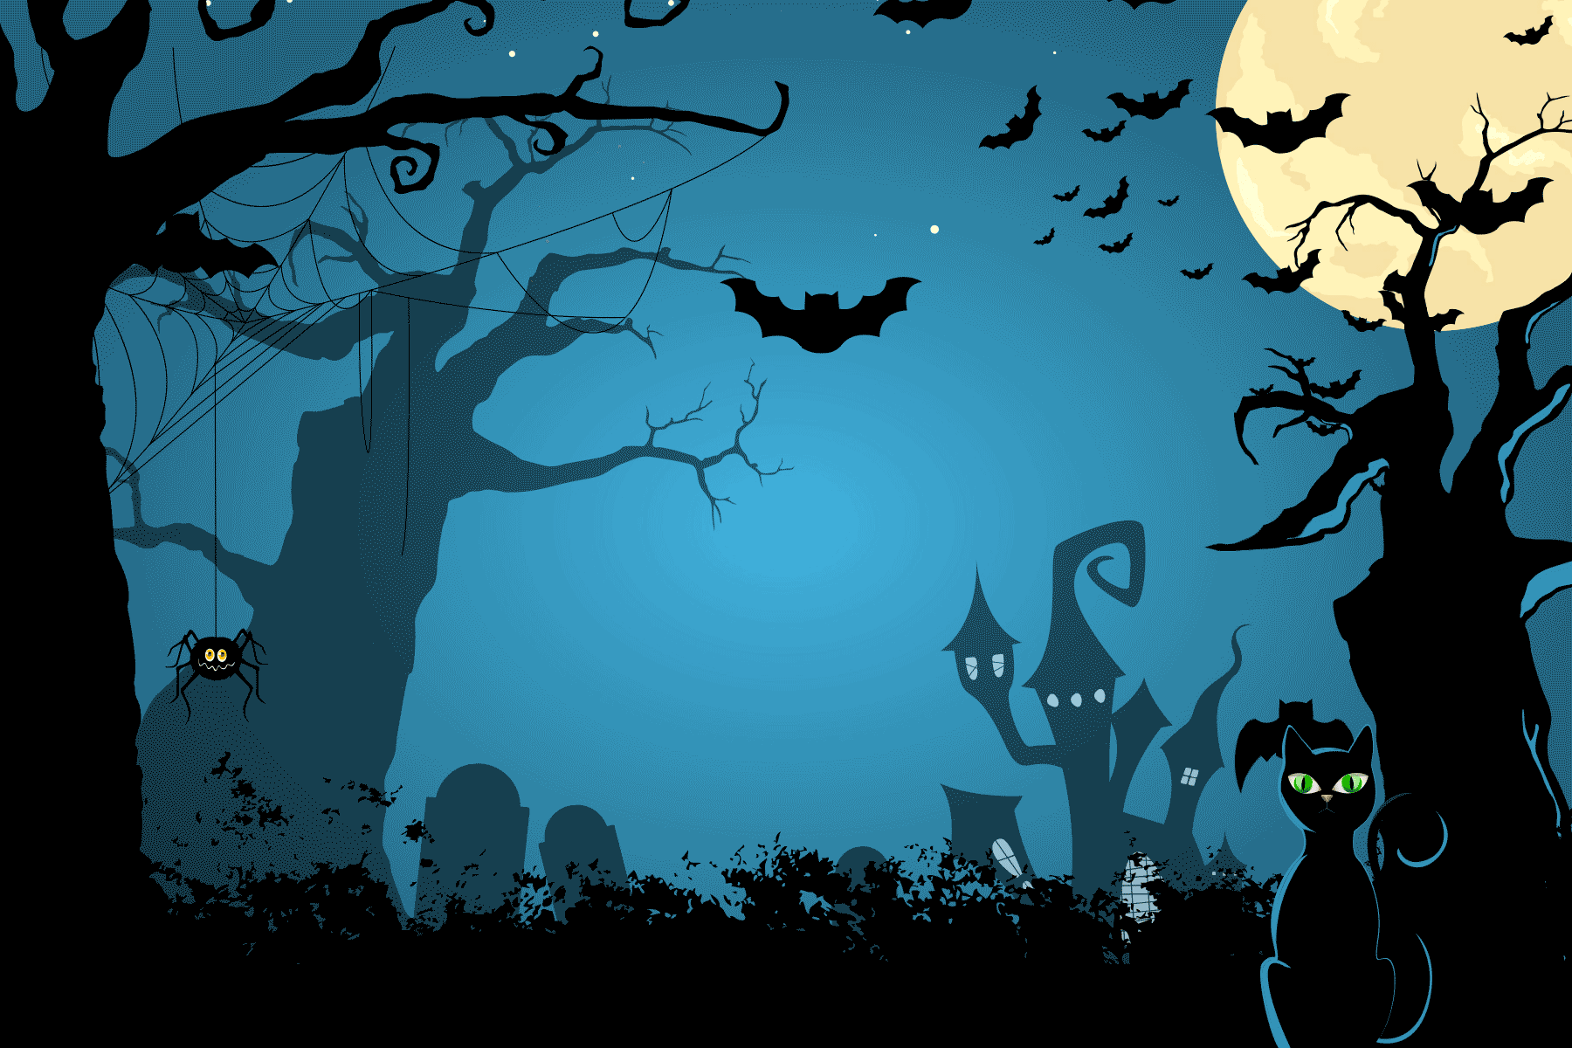

Good morning Cudas, Today is October 23, 2025

Success begins when CUDAS show up ready to learn!

Wanting a little bit of a scare? SGA is hosting Haunted Highschool on Saturday, November 1st, from 7-9pm. There will be haunted hallways, food, a kid zone, and a movie for all to enjoy. Tickets are bought at the door for $5 (Cash Only), and kids under 5 get in for free. We hope to see you there.

Students interested in taking the ASVAB can sign up in school counseling now. The ASVAB will be held on November 6 at 8:30am

Hey Cudas, HOSA wants your blood!!! On Friday, October 24th HOSA is hosting a blood drive from 9:00 am to 3:00 pm. All donors will receive food, a T-shirt, and a wellness checkup. Go see Mrs. Markland to sign up in room 6-103 or find any HOSA board members!

Flu Shot Vaccines on campus will be on November 7th. Students will receive a Flu Shot Vaccine Consent Form for parents to complete, sign, and return prior to that date. See your first period teacher for a form.

Attention Seniors: Please check your VCS email to vote on the class of 2026's class song, flower, and motto. Voting will end on Friday.

Seniors’ important scholarship opportunities:
Scholarships available worth up to $30,000 for the most valuable student. Applications due November 12, 2025
Up to $40,000 available for the Legacy Awards Deadline February 2, 2026
Elks National Foundation awards ($1,000-$7,500) per year.

Thank you and have a great week!


