Barbara Bush Primary School
Comprehensive School Counseling Program Framework
Program Curriculum Sequence

Implementation Master Plan

Resources Needed | Timeline | Owner of Work
Human Resources:  Counselor |  | Counselor
Financial Resources:  Counseling Program Budget |  | Principal
Leadership Resources:  - Campus Advisory Council Meetings  - Updated Policies and Procedures  - Updated Program Foundation  - Updated Curriculum Sequence |  | Counselors, parents, campus admin, campus staff, community members
Other Resource Needs Allocations:

Implementation Activity #1  ( complete & publish framework with administrator approval) | June
Implementation Activity #2  (teacher training) | Early August: Back to school staff days
Implementation Activity #3  (rollout) | Late August
Implementation Activity #4  (MOY evaluation of program) | January
Implementation Activity #4  (EOY evaluation of program) | May/June

Program Foundation
Statutory & Regulatory Requirements Related to School Counseling
The importance of the school counseling profession is evident through the statutory and regulatory requirements that govern school counselors’ work.
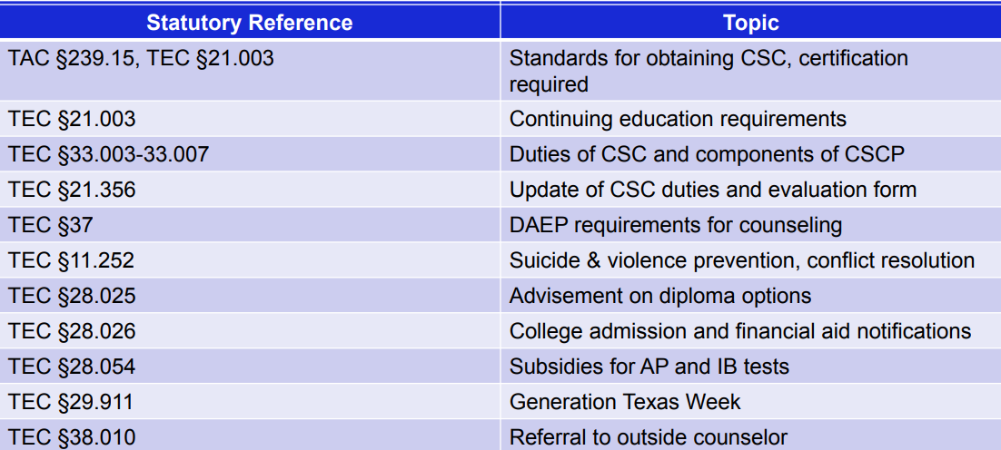
Program Mission Statement
Defining the intent and direction of the program
The mission of Sulphur Springs ISD School Counseling Program is to provide a proactive, comprehensive, and developmentally appropriate program that addresses students’ academic and career goals in addition to supporting their personal and social needs. This is accomplished through a partnership with parents, staff, and community members to enable all students to become productive citizens and lifelong learners in a diverse and changing world.

Program Definitions
Defining program parameters
The school counselor’s primary focus is facilitating instruction by removing impediments to student learning.
A comprehensive school counseling program is developmental and systemic, sequential, clearly defined, and accountable. Certified school counselors with the support of teachers, administrators, students, and parents implement it. The identified needs of all students in PK-12 provide the basis for the developmental counseling program.
As Texas Education Code §33.005 requires, the counseling program is presented through four delivery components.
Guidance Curriculum:
- Helps students develop their full potential including the student’s interests and career objectives
Individual Planning System:
- Guides a student as the student plans, monitors, and manages the student’s own educational, career, personal, and social development
Responsive Services:
- Intervenes on behalf of any student whose immediate personal concerns or problems put the student’s continued educational, career, personal, or social development at risk
System Support:
- Supports the efforts of teachers, staff, parents, and other members of the community in promoting the educational, career, personal, and social development of students

As described in The Texas Model for Comprehensive School Counseling Programs, 5th ed. (2018), the counseling program curriculum is designed to help students acquire age-appropriate competencies with the scope of four content areas, The student competencies addressed under each of the four content areas are listed below.

Content Area: Intrapersonal Effectiveness:
Student Competencies:
- Positive student self-concept
- Effective executive functioning skills
- Appropriate behavior to the situation and environment
Content Area: Interpersonal Effectiveness:
Student Competencies:
- Effective interactions with diverse populations
- Effective and appropriate communication skills
- Recognition of personal boundaries, individual rights and privacy needs of others
- Effective conflict resolution skills
- Development of healthy relationships
Content Ara: Post-secondary Planning & Career Readiness:
Student Competencies:
- Motivation to succeed in personal endeavors
- Demonstration of career exploration skills
- Possession of the knowledge and skills to gather information for the purpose of postsecondary education and career planning
- Demonstration of awareness of the importance of postsecondary education
- Understanding of the relationship of academics to the world of work and to life at home and in the community

Content Area: Personal Health & Safety:
Student Competencies:
- Incorporation of wellness practices into daily living
- Demonstration of resiliency and positive coping skills
- Possession of assertiveness skills necessary for personal protection

The school counseling pyramid for comprehensive and direct services is driven by school improvement and depicts methods and approaches to delivering direct services for 100% of the students. The school counseling pyramid is designed to provide equity and access for all students.

Tier 1: Guidance Curriculum where all students receive access to information and learn skills at their developmental levels to address each of the four content areas above.

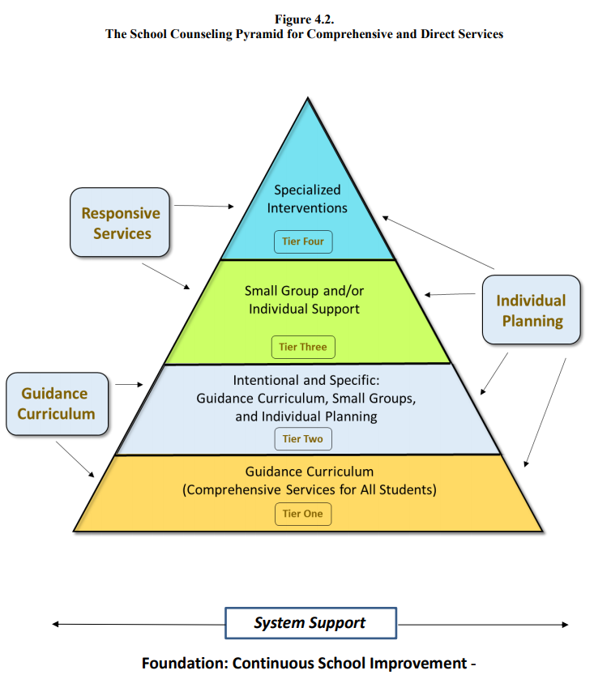
Tier 2: Increased direct, specific, and intentional services provided through guidance curriculum, various-sized groups, and individual planning. Students receive services via intentional guidance activities that are developed to assist them to reach the same level of performance in the student competencies listed above as the majority of students.

Tier 3: Direct services delivered through small group and/or individual level to identified students who require specialized school counseling interventions. Services are response (preventative, remedial, crisis) and are not necessarily pertinent to the entire student population.

Tier 4: Individual counseling interventions to a specific student. School counselor services in this tier are provided until the student’s needs exceed the duties or competencies of the school counselor. At this point, school counselors use referral to other district or community services to address the student’s needs.

Program Rationale
Defining why the program is needed
Compelling empirical evidence demonstrates the positive impact a comprehensive school counseling program has on the overall academic achievement of students, their attendance, and behavior as well as the overall school climate (The Texas Model for Comprehensive School Counseling Programs, pg. 11).

Program Assumptions for Conditions & Resources
Defining the basic conditions and resources needed for the program
To effectively implement the comprehensive school counseling program, certain programmatic conditions must exist, and resources must be allocated.

Conditions:
- The minimum level school counseling program provides for each of the four delivery system components and employs.
- The school counseling program employees a professionally certified school counselor(s).
- All students, parents, teachers, and other recipients of the school counseling program have equal access to the program regardless of gender, gender identity, sexual orientation, race, ethnicity, cultural background, religious or spiritual preference, disability, socioeconomic status, learning ability level, or native language.
- Parents will be full partners with educators in the education of their children (TEC Chapter 26).
- The conditions required for effective school counseling program implementation include a positive work environment; administrative commitment to the support of the school counseling program; and an adequate budget and school counseling materials.
- School administrators understand and support the school counseling program’s priorities and its demands. Administrators make decisions and establish policies and procedures considering this understanding.

Resources:
- Staff: Sufficient attention is given to staff in order to best support the appropriate implementation of the program.
- Program & Staff Development: Time and opportunity are provided for designing and evaluating the program; relevant training is available.
- Budget: An adequate budget is established to support program needs and goals.
- Materials, Supplies, and Equipment: The School counselor has the items necessary to support the development and implementation of the program.
- Facilities: The facilities accessible to the school counselor are sufficient and appropriate.

Program Needs
Determining student needs
Based upon staff needs assessments, our three greatest areas of need are in emotional regulation recognition/skills in students, developing social and character skills within students, and supporting student academic achievement.
Program Goals
Assigning intention, meaning and, and direction to program activities
- By the end of the 2023 school year, the reported incidences (thru office/counselor referrals) of students experiencing dysregulation (to the point where they must leave the classroom for disciplinary purposes or cool down with counselor) would decrease by 25%.
- By the end of the 2023 school year, teacher reported classroom behavior management issues related to conflict resolution or ineffective communication skills will decrease by 25%.
- By the end of the 2023 school year, students with a positive mindset about their classwork and academic abilities will increase by 25% as indicated by a change from the beginning of the year student perceptions survey to the end of the year student perceptions survey.
- By the end of the 2023 school year, students will demonstrate an intrinsic motivation to achieve self-set goals and higher expectations by tracking their own success and receiving fewer extrinsic motivators.

Program Evaluation
Evaluating program outcomes and staff
Counselor Job Description

Primary Purpose:
Work with school faculty and staff, students, parents, and community to plan, implement, and evaluate a comprehensive developmental guidance and counseling program at school assigned. Counsel students to fully develop each student’s academic, career, personal, and social abilities and address the needs of special populations students.

Qualifications:
Education/Certification:
Master’s degree in guidance counseling
Valid Texas counseling certificate
Special Knowledge/Skills:
Knowledge of counseling procedures, student appraisal, and career development
Excellent organizational, communication, and interpersonal skills
Ability to instruct students and manage their behavior
Experience:
Two years teaching experience

Major Responsibilities and Duties:

Guidance
- Teach campus developmental guidance curriculum consistent with district’s guidance program plan and tailored to campus needs.
- Assist teachers in the teaching of guidance-related curriculum.
- Guide individuals and groups of students to develop education plans and career awareness.

Counseling
- Counsel individual students and small groups with presenting needs and concerns.

Consultation
- Consult parents, teachers, administrators, and other relevant people to enhance their work with students.
- Work with school and community personnel to bring together resources for students.
- Maintain a communication system that effectively collects and disseminates information to other professionals as appropriate.
- Develop and maintain positive working relationships with other school professionals and representatives of community resources.
- Use an effective referral process to assist students and others to use special programs and services.

Assessment
- Participate in planning and evaluation of campus standardized testing program.
- Interpret tests and other appraisal results appropriately and communicate to school personnel, students, and their parents.
- Maintain the confidentiality of student assessment.

Program Management
- Plan school guidance and counseling programs to ensure that they meet identified needs, priorities, and program objectives.
- Implement a comprehensive and balanced program.
- Develop and coordinate a continuing evaluation of the guidance program and individual activities and make changes based on findings.
- Educate the school staff, parents, and community about the guidance program through a public information program.
- Compile, maintain, and file all required physical and computerized reports, records, and other documents.

Administration
- Comply with policies established by federal and state law, State Board of Education rule, and board policy in guidance and counseling area.
- Comply with all district and campus routines and regulations.
- Maintain a positive and effective relationship with supervisors.
- Communicate effectively with colleagues, students, and parents.

Professional
- Adhere to ethical and legal standards and model behavior that is professional, and responsible.
- Participate in professional development to improve skills related to job assignment.

Supervisory Responsibilities:
Supervise assigned counseling aide(s) and clerical employee(s).

Working Conditions:
Mental Demands/Physical Demands/Environmental Factors:
Maintain emotional control under stress.

*Includes information from the Professional School Counselor Performance Evaluation Form and Job Description distributed by the Texas Education Agency.

Counselor Evaluation

Campus principals use a non-TTess performance evaluator through STRIVE

Counseling Program Evaluation

Program will be evaluated based upon completion of goals set each year.

PROGRAM CURRICULUM SEQUENCE for SSISD ELEMENTARY CAMPUSES
CONTENT AREA: INTRAPERSONAL EFFECTIVENSS
Student Competency | Goal | Age-Appropriate Competency Indicators | Activities
Students have a positive self-concept | Students will have accurate self-concepts | Become aware of the importance of liking themselves  Becoming aware of their personal traits and characteristics that contribute to the uniqueness of each individual  Identify their beliefs about themselves
   | Delivery/ Activity/Population Served | Person Responsible | Timeline
  Tier 1 | Growth mindset guidance lessons | Counselor | January
  Tier 2 | Small groups/individual support | Counselor | September & on
  Tier 3 | Targeted small groups | Counselor | ongoing
  Tier 4 | Targeted individual support | Counselor or outside referral | ongoing
   | Delivery/ Activity/Population Served | Person Responsible | Timeline
  Tier 1 | Emotional regulation guidance lessons | Counselor | December
  Tier 2 | Small groups/individual support | Counselor | September & on
  Tier 3 | Targeted small groups | Counselor | ongoing
  Tier 4 | Targeted individual support | Counselor or outside referral | ongoing
Students have a positive self-concept | Students will appreciate their uniqueness | Describe what makes them feel good about themselves  Discuss individual rights and privileges
Students have a positive self-concept | Students will develop self-regulation skills | Identify their feelings  Recognize their feelings while they experience them  Become aware of how they manage their feelings  Develop skills for managing feelings

Student Competency | Goal | Age-Appropriate Competency Indicators | Activities
Students utilize executive functioning skills | Students will develop effective decision-making skills | Become aware of choices they make  Describe the steps in the decision-making process  Become aware that some choices are made for them and some they make for themselves
   | Delivery/ Activity/Population Served | Person Responsible | Timeline
  Tier 1 | Guidance lessons for Goal Setting/Problem Solving | Counselor | January & February
  Tier 2 | Small groups/individual Support | Counselor | ongoing
  Tier 3 | Targeted individual support | Counselor | ongoing
  Tier 4 | Targeted individual support | Outside referral | ongoing
Students utilize executive functioning skills | Students will be able to develop a plan of action | Become aware of the need to use time effectively  Explain achieving goals requires planning
Students utilize executive functioning skills | Students will be able to engage in goal setting | Define what a goal is  State personal goals
Students utilize executive functioning skills | Students will be able to engage in effective problem solving | Identify problems  Become aware to solve problems effectively a systematic process is used/can be used

Student Competency | Goal | Age-Appropriate Competency Indicators | Activities
Students behave appropriately to the situation and environment | Students will behave in a responsible manner | Behave appropriately in various school settings  Know school/classroom rules and expectations  Be able to follow rules and directions and complete tasks  Describe areas in school in which they are self-sufficient and which they are not  Understand that school rules are to provide order to enhance the learning environment for everyone  Become aware of the differences between acceptable/unacceptable social behaviors in various school settings  Become aware of responsibilities at school  Become aware of feelings concerning school rules  Use knowledge of school rules and expectations when faced with choices that could interfere with learning
   | Delivery/ Activity/Population Served | Person Responsible | Timeline
  Tier 1 | Listening/Rule following guidance lesson K&1st | Counselors | August/ September
  Tier 2 | Small group/individual lessons | Counselor
  Tier 3 | Targeted small group/individual
  Tier 4 | Individual support | Refer out
   | Delivery/ Activity/Population Served | Person Responsible | Timeline
  Tier 1 | Responsibility guidance lesson  2nd & 3rd | Counselors | August/ September
  Tier 2 | Small group/individual lessons | Counselor
  Tier 3 | Targeted small group/individual
  Tier 4 | Individual support | Refer out
 | Students will take responsibility for their own behaviors | Identify their own behaviors  Accept rewards and consequences for behavior  Explain the relationship between rules of conduct and their responsibilities to selves and others  Use behaviors that demonstrate respect for feelings, property, and interests of others  Describe the relationship between behavior and consequences
 | Students will develop self-management skills | Know and follow rules  Describe situations where they have no control, some control, or almost total control over selves

CONTENT AREA: INTERPERSONAL EFFECTIVENSS
Student Competency | Goal | Age-Appropriate Competency Indicators | Activities
Students interact effectively with a diverse population | Students will appreciate their own culture | Express pride in their families  Recognize the traditions/beliefs of their culture
   | Delivery/ Activity/Population Served | Person Responsible | Timeline
  Tier 1 | Celebrating our differences guidance lesson | Counselors | October
  Tier 2 | Small group/individual lessons | Counselor
  Tier 3 | Targeted small group/individual
  Tier 4 | Individual support | Refer out
Students interact effectively with a diverse population | Students will respect others as individuals and accept them for the cultural membership | Respect others as unique individuals  Demonstrate awareness of others’ cultural membership
Students interact effectively with a diverse population | Students will effectively relate with others based on appreciation for differences/similaties | Become aware that friends may have different/similar families, beliefs, rules, and traditions  Demonstrate appreciation for differences in others
 |  | Students will evaluate how stereotyping affects them and their relationships with others |  |  | Understand the meaning of the term “stereotyping”
Students utilize effective and appropriate communication skills |  | Students know that communication involves speaking, listening, and nonverbal behavior |  |  | Describe listening and speaking skills that allow them to understand others and others to understand them  Become aware that good communication skills help people work well together
   | Delivery/ Activity/Population Served | Person Responsible | Timeline
  Tier 1 | Effective Communicators guidance lesson | Counselors | April
  Tier 2 | Small group/individual lessons | Counselor
  Tier 3 | Targeted small group/individual
  Tier 4 | Individual support | Refer out
 |  | Students will effectively express themselves |  |  | Express their feelings appropriately  Identify ways individuals express feelings  Describe ways to express need for help
 |  | Students will use communication skills to know when and how to ask for help |  |  | Become aware of the need to be a good listener  Listen to others and repeat their ideas  Become aware of and accept/tolerate opinions of others in group discussions
Student Competency |  | Goal |  | Age-Appropriate Competency Indicators |  | Activities
Students will recognize personal boundaries, individual rights and privacy needs of others |  | Students will understand the need for personal boundaries |  | Understand personal boundaries
   | Delivery/ Activity/Population Served | Person Responsible | Timeline
  Tier 1 | Play it Safe guidance | Counselor and outside agent | January or March
  Tier 2 | Small groups/individual support | Counselor
  Tier 3 | Individual support | Counselor
  Tier 4 | Targeted individual support | Outside referral
 |  | Students will understand individual rights and privacy needs of others |  | Recognize rights and privacy needs of self and others
Student Competency | Goal |  | Age-Appropriate Competency Indicators |  |  | Activities
Students will utilize effective conflict resolution skills | Students will develop and use conflict resolution skills |  | Respect alternative points of view  Learn to speak directly to each other  Recognize when a cooling off period is needed
   | Delivery/ Activity/Population Served | Person Responsible | Timeline
  Tier 1 | Conflict resolution guidance  I-messages, Talk It Out | Counselor | September
  Tier 2 | Small groups/individual support | Counselor
  Tier 3 | Individual support/Targeted small groups | Counselor
  Tier 4 | Targeted individual support | Outside referral

Student Competency | Goal | Age-Appropriate Competency Indicators | Activities
Students develop healthy relationships | Students will define healthy and unhealthy relationships | Describe characteristics in themselves that enable them to be a good friend  Describe the processes involved in making and keeping friends
   | Delivery/ Activity/Population Served | Person Responsible | Timeline
  Tier 1 | Be a friend/Make a friend guidance | Counselor | February
  Tier 2 | Small groups/Individual support | Counselor
  Tier 3 | Targeted small group/individual | Counselor
  Tier 4 | Individual support | Refer out
Students develop healthy relationships | Students will identify characteristics of healthy & unhealthy relationships | Describe the role of trust and ways to establish trust in a relationship  Identify who to trust when they feel unsafe

CONTENT AREA: POST-SECONDARY PLANNING & CAREER READINESS
Student Competency | Goal | Age-Appropriate Competency Indicators | Activities
Students are motivated to succeed in personal endeavors | Students will develop their own academic potential | Become aware of what learning is and that they are learners  Become aware of the benefits derived from learning  Become aware of learning interests; describe learning they most enjoy  Participate in the school setting in a positive, active way  Explain the benefits they derive from learning  Become aware of the relationship between learning and effort  Become aware of how interests and beliefs help motivate them in school  Become aware that success and disappointment are a normal part of life and learning, and that they can learn from their mistakes
   | Delivery/ Activity /Population Served | Person Responsible | Timeline
  Tier 1 | Success Makers-Leaders in Life Guidance Lessons (Incorporate the WILDCAT way) | Counselor | March
  Tier 2 | Small groups/Individual support | Counselor
  Tier 3 | Targeted small groups/individual | Counselor
  Tier 4 | Individual support | Refer out
Students are motivated to succeed in personal endeavors | Students will will take advantage of their educational opportunities | Become aware of the skills and attitudes needed to achieve in school  Participate in school activities  Become aware of the school as both a work setting and a place of academic learning, and of the relationships between education and work
Students are motivated to succeed in personal endeavors | Students will identify attitudes and behaviors that lead to successful learning | Become aware of their learning interests, describe learning that they enjoy most
Students are motivated to succeed in personal endeavors | Students will develop leadership skills | Take turns as class leaders  Describe the responsibilities of identified school/community leaders

Student Competency | Goal | Age-Appropriate Competency Indicators | Activities
Students demonstrate career exploration skills | Students will identify career opportunities that allow them to fulfill their potential | Recognize a variety of jobs that people do in school/community  Describe responsibilities at home and tasks preferred
   | Delivery/ Activity/Population Served | Person Responsible | Timeline
  Tier 1 | Careers On Wheels  Career Day  Career Exploration Lessons | Counselors | November  May
  Tier 2 | Small group/individual lessons | Counselor
  Tier 3 | Targeted small group/individual
  Tier 4 | Individual support | Refer out
Students demonstrate career exploration skills | Students will make connections between personal skills, interests and abilities, and career choices | Identify personal skills, interests, and abilities that may affect career choice
Students demonstrate career exploration skills | Students will understand and explore their expanding world views | Explore world views

Student Competency | Goal | Age-Appropriate Competency Indicators | Activities
Students possess the knowledge and skills to gather information for the purpose of postsecondary education and career planning | Students will develop skills to locate, evaluate, and interpret career information | Become aware of different types of jobs
   | Delivery/ Activity/Population Served | Person Responsible | Timeline
  Tier 1 | Careers On Wheels  Career Day  Career Exploration Lessons | Counselors | November  May
  Tier 2 | Small group/individual lessons | Counselor
  Tier 3 | Targeted small group/individual
  Tier 4 | Individual support | Refer out
 | Students will learn how to apply goal-setting skills in career | Describe steps in Goal setting process for career
 | Students will apply decision-making skills to career planning and career transition | Become aware of the choices they make in careers  Describe ways they make decisions towards career choices
 | Students will demonstrate knowledge of the career-planning process | Participate in career planning

Student Competency | Goal | Age-Appropriate Competency Indicators | Activities
Students will demonstrate awareness of the importance of postsecondary education | Students will demonstrate awareness that education and training is needed to achieve career goals | Understand the relationship between classroom performance and success in career goals
   | Delivery/ Activity/Population Served | Person Responsible | Timeline
  Tier 1 | Careers On Wheels  Career Day  Career Exploration Lessons | Counselors | November  May
  Tier 2 | Small group/individual lessons | Counselor
  Tier 3 | Targeted small group/individual
  Tier 4 | Individual support | Refer out

Student Competency | Goal | Age-Appropriate Competency Indicators | Activities
Students understand the relationship of academics to the world of work and to life at home in the community | Students will develop a positive attitude toward work and learning | Understand the difference between learning and work  Develop a positive attitude toward work and learning
   | Delivery/ Activity/Population Served | Person Responsible | Timeline
  Tier 1 | Careers On Wheels  Career Day  Career Exploration Lessons | Counselors | November  May
  Tier 2 | Small group/individual lessons | Counselor
  Tier 3 | Targeted small group/individual
  Tier 4 | Individual support | Refer out
 | Students will understand the relationship between educational achievement and career success | Identify personal preferences and interests influencing career choice and success

CONTENT AREA: PERSONAL HEALTH AND SAFETY
Student Competency | Goal | Age-Appropriate Competency Indicators | Activities
Students incorporate wellness practices into daily living | Students will understand wellness as an element of healthy functioning | Identify healthy activities to do when alone  Identify healthy/unhealthy things
   | Delivery/ Activity/Population Served | Person Responsible | Timeline
  Tier 1 | Mindfulness/Coping guidance lesson | Counselors | March
  Tier 2 | Small group/individual lessons | Counselor
  Tier 3 | Targeted small group/individual
  Tier 4 | Individual support | Refer out
Students incorporate wellness practices into daily living | Students will learn techniques for managing stress | Describe feelings related to stress  Demonstrate understanding stress and conflict and ways of managing

Student Competency | Goal | Age-Appropriate Competency Indicators | Activities
Students demonstrate resiliency and positive coping skills | Students will effectively manage change | Describe how they are different this year vs. previous year  Summarize what can/cannot be controlled  Identify changes
   | Delivery/ Activity/Population Served | Person Responsible | Timeline
  Tier 1 | Mindfulness/Coping guidance lesson | Counselors | March
  Tier 2 | Small group/individual lessons | Counselor
  Tier 3 | Targeted small group/individual
  Tier 4 | Individual support | Refer out
Students demonstrate resiliency and positive coping skills | Students will effectively manage transitions | Describe how the people available can help them when needed  Find strategies for feeling secure in change  Become aware of other changes that will occur as they continue in school

Student Competency | Goal | Age-Appropriate Competency Indicators | Activities
Students possess assertiveness skills necessary for personal protection | Students will demonstrate the ability to set boundaries for physical, social, and emotional protection | Understand safe/unsafe touch  Difference between good secrets and bad secrets  Identify adults available to help
   | Delivery/ Activity/Population Served | Person Responsible | Timeline
  Tier 1 | Play it Safe lesson  Kindness Week | Counselors plus outside agent | January
  Tier 2 | Small group/individual lessons | Counselor
  Tier 3 | Targeted small group/individual
  Tier 4 | Individual support | Refer out
 | Students will demonstrate an appreciation for the rights of others to have a physically, emotionally, and socially safe environment | Understand respect  Understand kind/Unkind  Identify feelings associated with being excluded

PROGRAM MONTH-BY-MONTH IMPLEMENTATION PLAN
Month | Tiered Services  Guidance & Individual Planning | System Support Activities | Non-Counseling  Duties
ONGOING |  | Facebook updates, CogAT preparation, Crisis Management, Backpack Buddies, Morning Car Duty, Staff Care Activities, Twitter Updates
July |  | Finalization/Approval of Implementation plan
August | Minute Meetings to Introduce myself & my role  Listening/Rule Following/Problem Solving | Teacher Training of implementation plan
September | Kindness/I Messages | Literacy Night  Hispanic Heritage
October | Celebrating Diversity  Conflict Resolution Skills/Bullying | Red Ribbon Week  Carnival  CogAT NTD testing
November | Thankfulness/Gratitude  Careers on Wheels | CogAT Testing
December | Success Makers-Leadership in Life  Managing Emotions | Christmas families
January | Goal Setting/Growth Mindset | MOY Needs Assessments
February | Be a Friend & Make a Friend | Math Night  Kindness Week  GT Nominations
March | Play It Safe  Kindness Week | Open House, TELPAS  GT Testing | TELPAS Verifier
April | Celebrate Differences
May | Career Exploration/Career Day | EOY Data Assessment, STAAR
June

