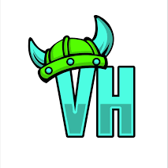
Dear Parent or Guardian:

Villa Heights Elementary School has been authorized by the North Carolina Department of Instruction and Charlotte-Mecklenburg Schools to operate a Title I Schoolwide Program. As a result, schools receive resources from the state and federal governments that enable us to upgrade the entire educational program in order to help all students meet state standards. A comprehensive needs assessment and an analysis of the student achievement data were conducted to develop a School Improvement Plan. This was completed through the collaborative efforts of staff and parents. The schoolwide program includes strategies to raise the academic achievement of all students.

The following services are available from the school’s Title I site-based resources to assist your child:
● paraprofessionals
● teacher professional development
● additional support staff
● computers
● parental involvement activities

Please attend the Annual Title I Meeting to be held with Curriculum Night on 9/18/25 to learn more about the school’s programs:

Location: Villa Heights Elementary School
Time: 5:00-5:30 PM

If you are unable to attend the Annual Title I meeting or if there are questions or concerns regarding our school’s academic program please contact the school office at 980-343-3666. Slides and resources will be provided through Parent Square and our school’s website.

