Sellwood Weekly News
1-27-2016

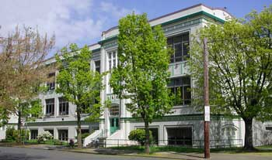

SCHOOL NEWS PTA FOUNDATION PEAK PIL ATHLETICS

COMMUNITY_NEWS

  Mark Your Calendar
  This Week
  1/27 - New Parent Info Mtg., 7 - 8:30 pm
  Next Week
  Plan Ahead
  2/8 - Foundation
  Fundraiser at McMenamins Barley Mill, 5pm-12am
  2/15 - No School
  2/16 - Foundation Mtg., 6 pm
  PTA Mtg, 7 pm
  2/17 - Late Opening, 11:05 am
  2/27 - Sellwood Bridge Dedication Celebration
  3/1 - Pizzicato Fundraiser
  3/15 - Foundation Mtg., 6 pm
  PTA Mtg., 7 pm
  3/16 - Late Opening, 11:05 am
  3/18 - All School Celebration, 2:45 pm
  3/21 - 3/25 - No School
  Sellwood Calendar
  PPS Calendar (pick language)
  SCHOOL NEWS
  From Your Administration
  Greetings Sellwood Families,
  We are officially in the second semester of the school year and as usual, the fun begins. Tonight (Wednesday) is our Parent Information Night at Sellwood, from 7-8:30 PM. This is primarily for incoming 6th grade families, joining us for the 2016-17 school year. Our 6th grade staff and some elective teachers will be present to meet and great, our Jazz band will perform. Our Peer Helpers and Student Council will give guided tours of our school. This will be our only tour since we have no openings, and as written before, are expecting to exceed 600 students next year. Remember, if you are one of the families living outside the Sellwood catchment area, chances are likely you will be returning to your neighborhood middle or K-8 school for 6th grade; this also goes for high school. If you are on transfer to Sellwood, and have an 8th grade student, they most likely will not go to Cleveland unless you apply through the lottery. We will address this at the Information Night, but you can also go to the Enrollment and Transfer website at http://www.pps.k12.or.us/departments/enrollment-transfer/10546.htm. By the way, the lottery dates for high school run from 2/3 through 2/17, and elementary and middle from 2/8 to 3/9. This next quarter will be a very busy time, especially for our 8th grade students. We have been working with them as you know, to prepare them for the high school transition. Make sure you are trying to get out to the open houses and fulfilling any requirements they may have for acceptance. Again, most of that information is on the above website.
  Monday was teacher planning day, and staff worked on this quarter's report cards. Classified staff attended professional development at Kellogg Middle. At the last minute, our Marimba students were asked to perform, and they did a wonderful job. Thank you to Mr. Beck, students, and parents for helping get us there very early in the morning. Our band did an amazing job, and helped to set the tone for the day. Thanks to everyone who helped pull this off with little notice.
  Our Sellwood Peak Dance Team took first place this past weekend at Milwaukie High School, at the "Dancesation" competition. Congrats to our dance team, coaches, and volunteers! Thank you Rose Mary Price for your tireless efforts with our wonderful PEAK program at Sellwood.
  Have a great week and thank you for all you do for your students and our school.
  Brian and Marylyn
  Please Remember
  When you are dropping students off at school, please do not do this while stopped at the stop sign. This presents a dangerous situation to our kids when cars go around a stopped car while students are crossing in the crosswalk. Thanks for your help on this.
  From the School Nurse
  New laws regarding immunizations and exemption laws went into effect on March 1, 2014. Letters have been sent to families, but if parents have marked a religious exemption in the past, that will no longer be sufficient. In order to claim a nonmedical exemption, a parent must either complete the required education from a health care practitioner or complete an online vaccine module and return it to the school nurse along with the completed Certificate of Immunization status form.the module can be found at www.healthoregon.org/vaccineexemption.
  For parents who don't have a regular pediatrician for their child, they can call the school based clinics listed below for an appointment.
  Lane Middle school clinic-503-988-5640, Harrison Park- 503-988-4577, or Cleveland High School -503-988-3350, George Middle School-503-988-3829.
  If you have any questions, contact the school Nurse, Bev O'Brien bobrien@mesd.k12.or.us
  EDUCATE & ENGAGE 2016:
  THE PARENT-TEACHER CONFERENCE
  Saturday, March 12, 2016, 9am-noon
  Lewis Elementary School / 4401 SE Evergreen
  Sponsors: PPS & Concordia University
  Audience: Parents
  Technology is changing how today's students learn. The creativity and innovation of teachers is advancing educational opportunities - allowing students to connect with and learn from teachers, the world and each other more than ever before. On Saturday, March 12, 2016, local school districts are partnering to host Educate & Engage 2016: The Parent-Teacher Conference, offering parents an opportunity to hear from teachers about the roles and implications of technology both in and out of today's modern classroom. A device is not necessary, but you can bring your own (laptop, tablet, smartphone) if you want. Limited childcare available.
  Sessions Include:
  · Social Media in Education
  · Google Apps for Education (also in Spanish)
  · Coding and Computer Science
  · Parenting in the 21st Century (also in Spanish)
  · How Technology is Changing Teaching and Learning
  · What is STEM/STEAM?
  · Cyberbullying
  Registration is open Feb. 1-29. For more information and to register, visit http://bit.ly/educateengage2016.
  Melissa Lim, Instructional Technology
  x63030 mlim@pps.net
  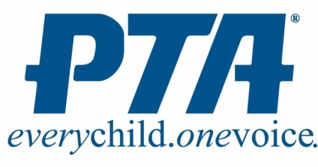
  JOIN US FOR OUR NEXT PTA MEETING
  ON FEBRUARY 16TH 2016 AT 7 PM!
  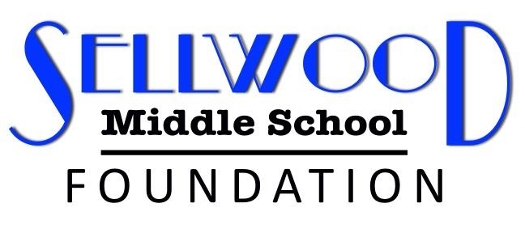
  Mark Your Calendars...
  What: Dine Out for The Foundation
  Where: McMenamins Barley Mill Pub (SE Hawthorne)
  When: Monday, February 8th *All Day*
  PEAK
  The PEAK Winter Session is over the week of 2/26/2016, and the Spring PEAK Session will begin the week of 2/28/2016 and run until the week of 5/27/2016.
  BoyStrength Class - 2/29/2016-4/25/2016-
  forms on the PEAK Office Door. No Charge for the Class but you need to fill out a PEAK form to be in the Class-Mondays in the Small Gym
  There are openings in: PEAK Chess, PEAK Homework Club, PEAK Computer Class and try outs for the Spring PEAK Play will be on February 11, 2016. The blue Spring PEAK Booklets are in the office and on the PEAK Door-Room 214. You can also download the PEAK Registration Form at the Sellwood School Site with the link to PEAK.
  The PEAK Spring Computer Class will be on Tuesdays, 3:45pm-5:15pm, in the Mac Lab-cost $20.00.The Class is for Girls only. Moms are also invited. The Class will introduce a variety of computer programs and it should be a great experience for the girls at Sellwood. Howard Abrams the Computer Instructor is very happy to offer this Spring Computer Class to Girls only.
  There may be a Craft Sewing Class in the Winter Session that would have a limited number of Classes. Still working on the time and day.
  If you have any comments or questions contact Rose Mary Price, Sellwood PEAK Coordinator.rprice@pps.net.
  PIL Athletics
  Registration for track will begin in February. We're still ironing out details for next season. We will have to cap registration, so be sure you're ready to turn forms and fees in by the deadline! The search for coaches has already begun, however! Email Jessica at jrussell@pps.net if you're interested in being a track coach (paid or unpaid). Please visit our website for more information on any of our sports.
  www.ClevelandClusterAthletics.weebly.com
  COMMUNITY NEWS
  
  
  Play Ball!
  Registration remains OPEN for the 2016 season of Sellwood/Cleveland Junior Baseball & Softball for Kindergarten through Eighth Grade! At any grade, players of all skill levels are welcome. We encourage early registration but registration will remain open through February 1, 2016 for 3rd through 8th graders and up and February 29, 2016 for younger players. The season will begin around spring break. You may register player online at www.sellwoodbaseball.com. You may get answers to any questions by emailing prez@sellwoodbaseball.com.
ENews copy must be submitted to Catherine Cleveland by email at: crcleveland@pobox.com ENews goes out on Wednesday. Items must be submitted by the prior Monday at 5 pm to be included.

"Portland Public Schools is an equal opportunity employer and recognizes the diversity and worth of all individuals and groups and their roles in society. It is the policy of the Portland Public Schools Board of Education that there will be no discrimination or harassment of individuals or groups on the grounds of age, color, creed, disability, marital status, national origin, race, religion, sex or sexual orientation in any educational programs, activities or employment. "

