Sellwood Principal’s Newsletter – February 21, 2020
Greetings Sellwood Community,
I apologize for the late newsletter; it was a very busy Friday.
A shout out to the Math Club; they did very well at their regional MathCounts competition this weekend.
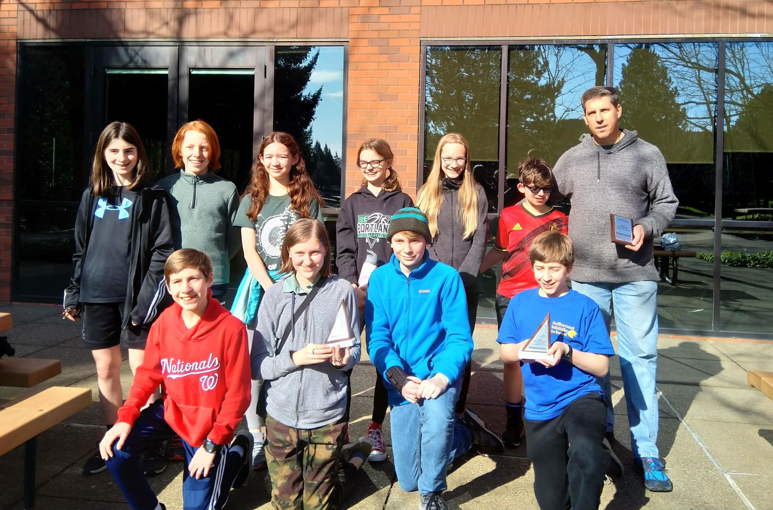
Congrats to Alex, Alida, Ben, Celia, Eli, Elli, Evan, Thor, India, Quinn for placing 2nd at MathCounts regional. Good luck to Alex, Celia, Eli, and Thor as they move on to the next round on March 7th! I would also like to express my gratitude to math coach Patrick Vennebush for all of his hard work and dedication to the Sellwood Math Club! Thank you, Patrick!
Enjoy the spring weather this weekend ☺
Jeandré Carbone
Sellwood MS Principal

Important Dates to Remember
March 12: Sellwood Math Carnival, 5:00-8:00 PM
March 13: Coffee with the Principal, 9:15 AM
March 18: Site Council, 4:00-5:00 PM
March 18: Foundation Meeting, 6:30 PM
March 18: PTA Meeting, 7:00 PM
March 23 to March 27: Spring Break
April 3: End of Quarter 3
April 6: No School for Students
April 15: Site Council, 4:00-5:00 PM
April 15: Foundation Meeting, 6:30 PM
April 15: PTA Meeting, 7:00 PM
April 17: Coffee with the Principal, 9:15 AM
May 3: Sellwood 5K
May 6: Spring Band Concert, 7:00 PM
May 13: Spring Marimba Concert, 7:00 PM
May 17-22: Outdoor School for 6th-graders
May 20: Site Council, 4:00-5:00 PM
May 20: Foundation Meeting, 6:30 PM
May 20: PTA Meeting, 7:00 PM
May 25: No School, Memorial Day
May 26: Ambassador Awards, 6:00 PM
June 2: Student Showcase, 5:00 PM
June 4: 8th-grade Field Trip to Bullwinkles
June 5: Last Day of School – Half Day
June 5: 6th & 7th-grade Walking Field Trip to Oaks Park
June 5: 8th-grade Promotion Ceremony, 10:30 AM

PTA NEWS:
Next meeting Wednesday, March 18, 7pm in the library.
Red Cross Babysitting Certification-SPRING SESSION- APRIL 6th 2020.
Registration opens: Friday, February 21,2020! Please note that other PEAK classes will have a later registration date. Thank you.
“The American Red Cross is the nation’s leader in babysitting classes and child care training and will prepare you to be the best sitter in your neighborhood. In fact, 8 in 10 surveyed parents said they would pay more for a trained babysitter who holds Red Cross babysitter certifications. Start your babysitting business on the right foot and learn how to be a safe, professional, and reliable sitter.”
Limit 20 participants per class, $120
Register at https://sites.google.com/view/sellwoodpta and then go directly to SchoolPay ( https://www.schoolpay.com/login ) to make payment. Your child's registration will not be confirmed until payment is made.)

Successful Schools Survey
Shape the future of your student's education!
What is the first thing that comes to your mind when you hear the phrase “successful schools?” We believe that successful schools are safe, healthy and welcoming learning spaces that are inclusive for all students, but we want to hear your thoughts.
In 2019-20, Portland Public Schools is again partnering with Panorama Education to gather information students and families that will help us improve student experiences across the district. We will survey students in grades 4, 5, 7-10 on their experiences in their classrooms and schools, and families about their perception of the school their child attends.
The survey covers topics on sense of belonging, school safety, school climate, barriers to family engagement, as well as how students are thinking and feeling about diversity, equity, and inclusion in school.
The survey launched on January 27th and the family survey window will be open until March 5th.
If you have not yet taken the survey, here is the link.
http://surveys.panoramaed.com/portlandor/ppsfamily
Please be honest and thoughtful, we value your feedback!
Yearbook News
Yearbook... You know you want one!
Ordering a yearbook has never been easier. Simply log in to SchoolPay and add a "2019-2020 Sellwood Yearbook" to your cart. They are $17 and will be distributed to students in June. Order before Spring Break to guarantee you'll get one. (If you can't access SchoolPay, please use the blue form that was given to students.)
Backpacks Needed
The counselors at Sellwood Middle School run a food backpack program and are partnered with several local community members to ensure all of our students have access to food over the weekends. We are looking for new or slightly used backpack and tote bags to help students transfer the food they receive on Friday afternoons home. If you have questions or would like to participate in the backpack program please email or call Katie Francis at kfrancis@pps.net or 503.916.5656 X70616.
You can drop donations off in the main office. We are also happy to take hygiene products and non-perishable food donations as well i.e.- shampoo, conditioner, body wash, deodorant, tooth brushes, tooth paste, cereal, granola bars, trail mix, juice boxes, fruit cups, etc.
Thank you for your support!

Volunteers during Lunch/Recess
Thank you to all of the parents that have been helping out with lunch and recess. We are so happy you are taking part in the fun, and we appreciate your presence so much!
We are always in need of additional parents to volunteer during lunch/recess, from 12:05 to 12:50 PM. Mondays and Fridays are particularly high needs. Come experience a slice of middle school and better understand your child’s life here at school!
Sign up for any dates you are available on our volunteer calendar: https://signup.com/go/RkzGZUt

