Waverly Yowell Elementary School
4th Grade Supply List
2025-2026

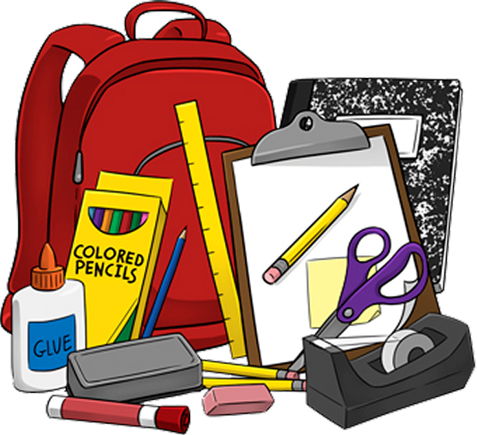

Supplies Needed:
- 4 wide ruled spiral notebooks
- 1 pencil box (NO lock boxes) or 1 pencil pouch
- 2-3 plastic folders- any colors
- 1 pair 5” scissors
- 1 box of crayons or colored pencils
- 60+ #2 pencils
- 2 yellow highlighters
- 2-4 black dry erase markers
- 6+ LARGE size glue sticks

Optional (Needed in our classroom but not required):
- Large boxes of tissues
- Ziploc gallon storage bags and/or sandwich bags
- Antibacterial hand sanitizer (pump bottle)
- Clorox/Disinfecting Wipes
- Paper Towels

