Kindergarten Supply List

1. Backpack
2. Change of clothes in a bag to be left in their cubby (just in case).
3. Water Bottle
4. Headphones (no ear buds or blue tooth please) (maybe even 2 headphones)
5. Glue sticks
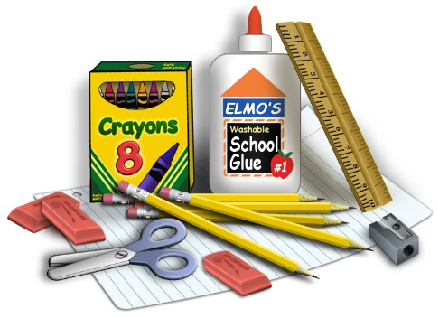
6. Crayons
7. Pencils
8. Pack of White Board Markers
9. Markers
10. Clorox Wipes
11. Kleenex
12. Ziploc Bags (gallon, sandwich, or quart)
13. Paper Towels
14. Snacks (pretzels, goldfish, crackers, fruit snacks, cereal bars, popcorn, rice krispy treats…)
15. Ream of white paper (500 count) (or more than 1 if on sale)

