5th Grade School Supply List
- 4 glue sticks
- 2 24-pack pencils
- Pencil box
- 3 packages of lined paper
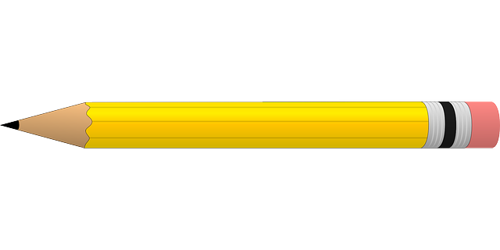
- 1 2-inch binder *with cover sleeve
- 3 composition notebooks
- 3 folders with prongs (1 blue, 1 green, 1 choice color)
- 2 Headphones or earbuds (must be wired or USB plug)
- Scissors
- 2+ Tissues
- Clorox Wipes
- Ream of White Paper (500 sheets)
- Colored pencils
- Girls: sandwich Ziploc bags & hand soap
- Boys: quart or gallon Ziploc bags & hand sanitizer
- Shareable HEALTHY snacks
(fruit snacks, crackers, goldfish, cereal, etc.)

*NO pencil sharpeners! Thank you.

