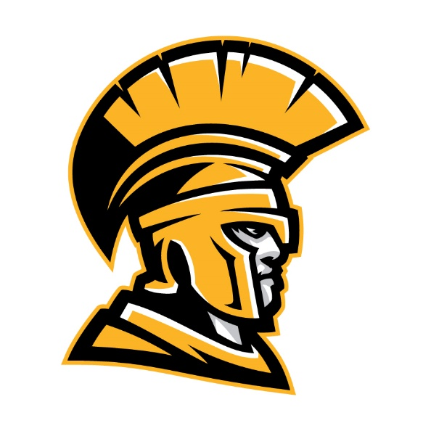
LAKEWOOD GIRL’S BASKETBALL 2024 MLK CLASSIC SCHEDULE
1400 54th Avenue South, St. Petersburg, Fl 33705
Friday, January 12, 2024
3:00pm Plant vs. Boca Ciega
4:30pm Flagler Palm Coast vs. Clearwater
6:00pm Lakewood vs. Miami Norland
7:30pm Keswick vs. Palmetto
9:00pm Cardinal Mooney vs. Calvary Christian Ormund
Saturday, January 13, 2024
11:00am Boca Ciega vs. Flagler Palm Coast
12:30pm Miami Norland vs. Clearwater
2:00pm Lakewood vs. Plant
3:30pm Sickles vs. Cardinal Mooney
5:00pm Calvary Christian Ormund vs. Keswick
***HOME TEAM IS LISTED FIRST AND WILL WEAR WHITE***

