ExCEL Merchandise Sale!
All proceeds support the ExCEL program, including a scholarship for a senior.

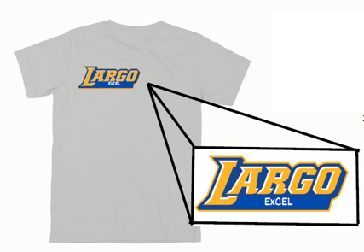
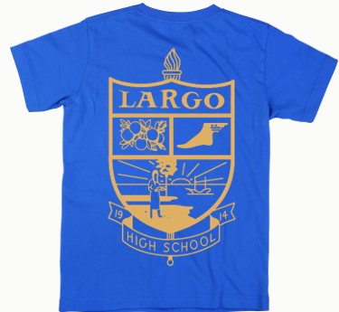
3 Designs to Choose From:
Grey ExCEL

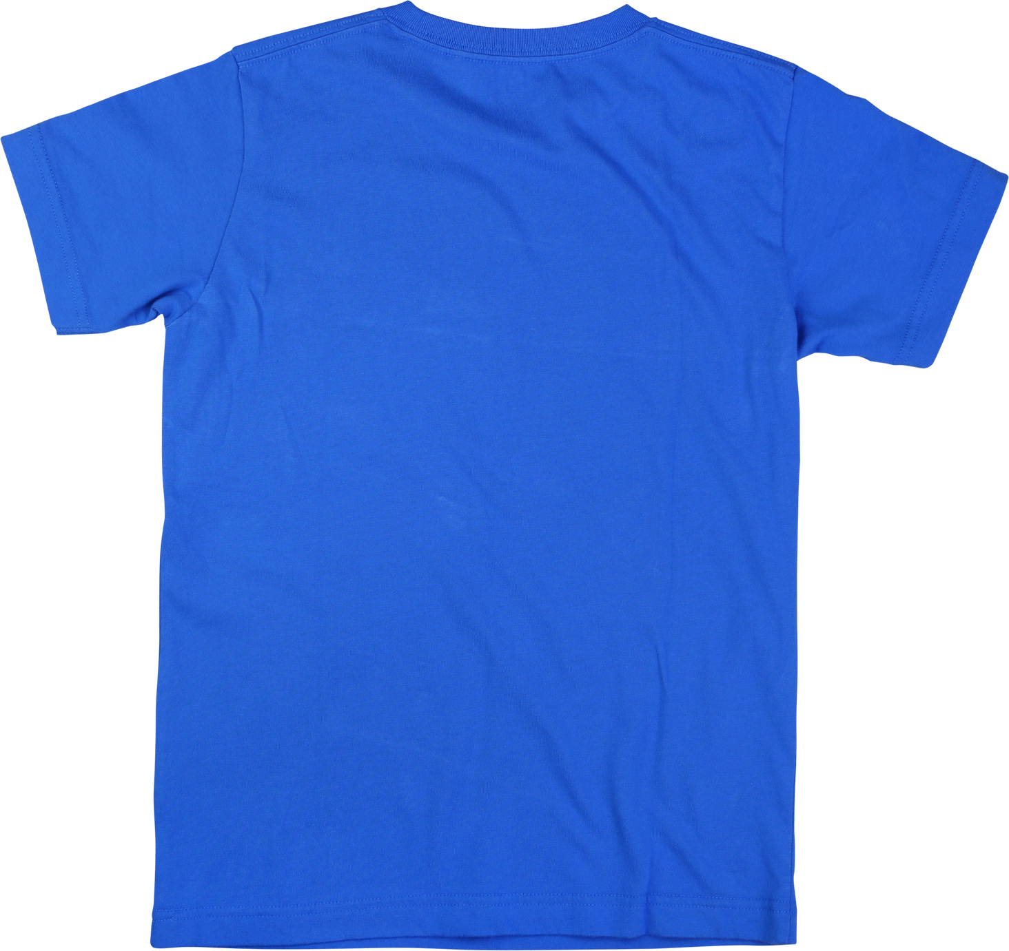

Largo Crest

ExCEL Logo

T-SHIRTS $20
HOODIES $ 40
Most Sizes In Stock!

Order in the ExCEL office or online, then stop by for pick up!
Click the link for either a shirt or hoodie for online payment.
Online payments charged non-refundable 3.25% processing fee

