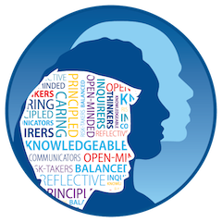 IB Learner Profile Monthly Leaders 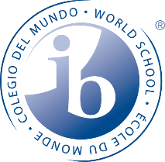
The aim of all IB programs is to develop internationally minded people who, recognizing their common humanity and shared guardianship of the planet, help to create a better and more peaceful world. Each month we will focus on one of the profiles to recognize student leaders and the faculty that inspire their leadership.
August  Caring | We show empathy, compassion and respect. We have a commitment to service, and we act to make a positive difference in the lives of others and in the world around us.
September Inquirers |  | We nurture our curiosity, developing skills for inquiry and research. We know how to learn independently and with others. We learn with enthusiasm and sustain our love of learning throughout life.
October Risk-takers |  |  | We approach uncertainty with forethought and determination; we work independently and cooperatively to explore new ideas and innovative strategies. We are resourceful and resilient in the face of challenges and change.
November Reflective |  |  | We thoughtfully consider the world and our own ideas and experience. We work to understand our strengths and weaknesses in order to support our learning and personal development.
December Balanced |  |  |  | We understand the importance of balancing different aspects of our lives—intellectual, physical, and emotional—to achieve well-being for ourselves and others. We recognize our interdependence with other people and with the world in which we live.
January Principled |  |  |  |  | We act with integrity and honesty, with a strong sense of fairness and justice, and with respect for the dignity and rights of people everywhere. We take responsibility for our actions and their consequences.
February Open-minded |  |  |  |  |  | We critically appreciate our own cultures and personal histories, as well as the values and traditions of others. We seek and evaluate a range of points of view, and we are willing to grow from the experience.
March Thinkers |  |  |  |  |  |  | We use critical and creative thinking skills to analyze and take responsible action on complex problems. We exercise initiative in making reasoned, ethical decisions.

April Communicators | We express ourselves confidently and creatively in more than one language and in many ways. We collaborate effectively, listening carefully to the perspectives of other individuals and groups.
May Knowledgeable | We develop and use conceptual understanding, exploring knowledge across a range of disciplines. We engage with issues and ideas that have local and global significance.

