YEARS 3 & 4 – PROGRAMMING & MULTI-USER SIMULATION:
Students will create digital portfolio & iSTEM Lab legacy projects, incorporate various program languages & utilize 2D or 3D game engines in their work & teach other peers. Next, they’ll explore the world of Virtual Reality with Oculus/Meta Quest equipment.
Students will build and test single and multiplayer games for various platforms and learn backend server technology integration. Unity Certifications include: Unity Artist, Programmer & VR. Students will compete & present at the PCS District Showcase, iSTEM Lab Advisory Board meetings & more!
Students also may learn ARRL Ham Radio Communication & Coding technician skills & pursue that FCC license later in class or as part of the Cougars Who Code & Girls Who Code Clubs.
YEAR 2 – GAME DESIGN: Get ready to advance in detailed knowledge of game design from the 2D process and be introduced to 3D art and animation tools. Students will learn Unity Essentials for game design and begin portfolio development & Unity certification prep. They will master C# and be introduced to Blender software & the Unity Asset Store. Students will work collaboratively on projects to showcase, share & compete.
YEAR 1 – FOUNDATIONS: Students gain a working knowledge of the game design process, vocational opportunities, 2D art and animation, and use 2D block-based game engines. Students collaborate in teams & work independently on projects. Semester 2 involves learning Python and creating games with Procedural Programming & obtaining the Info Technology Specialist (ITS) Python certification.
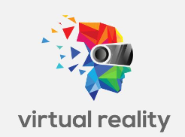

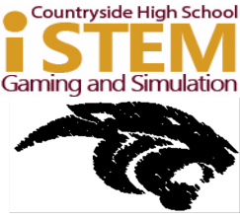
COURSE OVERVIEW
Step into a world of creativity and virtual reality as you learn how to program and make games & simulations of a professional nature. Use a variety of software & gaming environments with proficiency, enabling you to gain essential programming, design & debugging skills.
What are the benefits?
- You master your craft in game design as you develop a portfolio
- Make games with maximum design efficacy and user interface satisfaction by gamers
- Showcase your games to potential employers, investors, Boards & in Districtwide competitions
This program offers sequential courses of rigorous content aligned with challenging academic standards and relevant technical knowledge/skills needed to prepare students for IT careers such as: Game & Simulation Designer, Programmer, Software Developer, or other Information Technology careers. This sets you above the rest as you obtain ITS & Unity Artist, Programmer & Virtual Reality industry certifications.

GAME &
SIMULATION

