What Students Learn in this Program |  |  | Certifications
Prerequisite: DIT |  | Digital Info Tech | Word Press
Foundations of Programming | HTML/CSS & Intro to JavaScript | Coding basics, design thinking process, flowcharts; labs & Career-oriented focus | Info Technology Specialist- HTML/CSS
JavaScript Programming | JavaScript & Intro to Python | Block based coding, extensive programming in JavaScript; Portfolio & Ecommerce Site work | ITS - JavaScript
Procedural Programming | Python & Responsive Design | Interactive Coding & Navigation, Site Maps Responsive Design; Project & Portfolio work | ITS –Python
Object-Oriented Program Fundamentals | HTML/CSS  HTML5 | Script Programming in a Visual Studio Integrated Data Environment | ITS – JavaScript & Intro to HTML5 App Dev Fd
Web Programming | HTML & CSS | Web Labs, Storyboards, Launch/Maintain ISTEM Ecommerce website | ITS - HTML5 App Dev & Computational Thinking
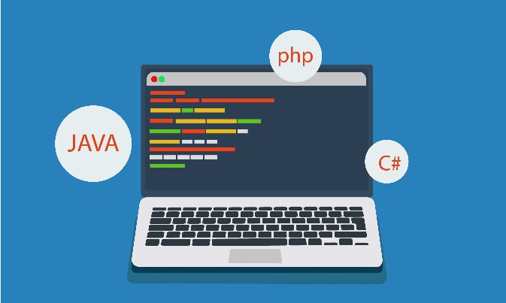
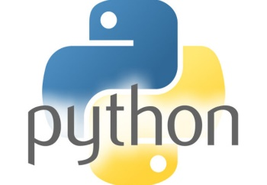
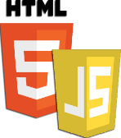
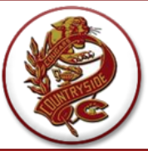
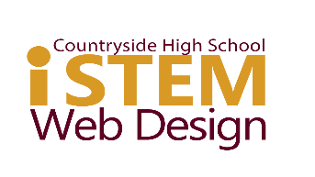
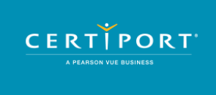

This Photo by Unknown Author is licensed under CC BY-SA-NC
In this CHS ISTEM Strand advance your programming skills and knowledge to prepare you for some of hottest in-demand career fields as you pass Industry Certifications & build a Digital Portfolio! Be ready to create websites & web apps like professionals do for Ecommerce, Retail & Wholesale industries & more.
WEB APPLICATION
DEVELOPMENT & PROGRAMMING
Julie Yaeger - yaegerj@pcsb.org

