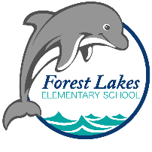2025-2026 VPK School Supplies
Student Supplies:
- 1 – 8ct glue sticks, purple
- 4 – 8ct packs Crayola Crayons
- 1 – 12ct pack Crayola Colored pencils
- 1 – 10ct pack Crayola Markers
- 4 – plastic folders with pockets and prongs
- 2 – spiral notebooks
- 1 – 4ct Expo dry erase markers, black
- 1 – 4ct Expo dry erase markers, colored
- Backpack your child can wear and fit their belongings in – no wheels
- Full change of clothes (top, bottom, undergarments and socks) in a Ziploc labeled with your child’s name
Optional, but appreciated:
- Colored construction paper
- Play-Doh
- Stickers
- Band-aids
- Ziploc bags – Gallon and/or snack
- Tissues
- Clorox wipes
- Hand soap
- Hand sanitizer
- Paper towels

