Step-by-step directions for finding & requesting a library book

“Follow the directions below to find a book in Destiny and then email me back the title so I can check it out to you and put it in the front office for you to pick up 😊”
----------------------------------------------------------------------------------------------------------------------------------------
1) Think of a subject that you are interested in (soccer, dance, dogs, gardening, sci fi, dystopia, mystery etc...)

2) Go to Clever & find Destiny
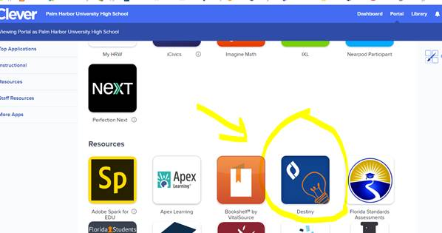

3) You may have to fill in this page if you haven’t used Destiny before
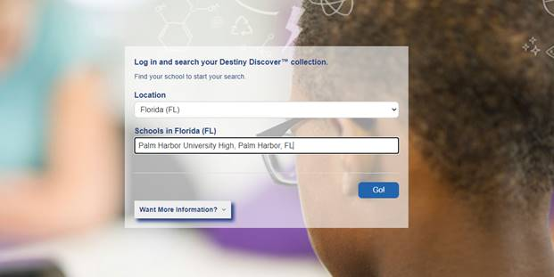

4) (optional) Set your parameters so that you are searching for Reading Counts books
1 - click “Search Options”
2 – Make you options MATCH mine in the pic (if your teacher specified a minimum number of
points)
3 – Click “Set Options”
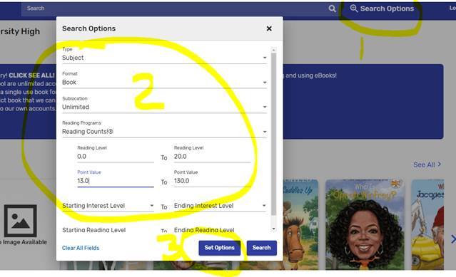

5) Now Search 😊
1 – pick a subject (I chose “DOGS”)
2 – Make sure you pick a book with a GREEN “IN” flag
3 – You can see the Reading counts points on the RIGHT
4- Click on the TITLE to read a synopsis of the book
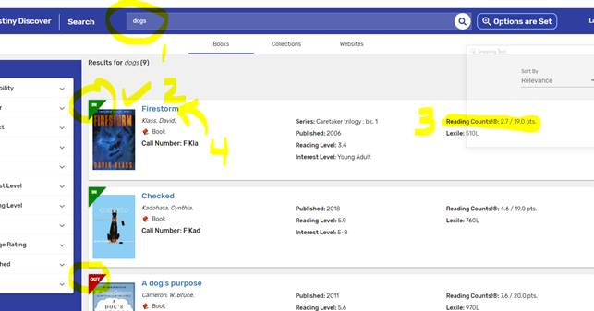

6) FINALLY, email me the title of the book that you want and I will check it out in your name and place it in the FRONT OFFICE for you or a parent/guardian to pick up😊

Crosleyj@pcsb.org

