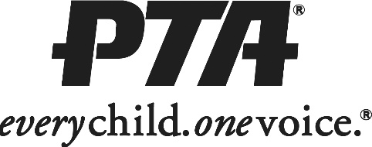

2018-2019 New Heights Elementary PTA

Membership Form
Name
Relationship to Student
Do you prefer to be contacted by:
E-mail
Home Phone
Cell Phone
Parent Grandparent
Teacher Staff
Other
(please check one)

Street Address
City, State, ZIP
E-mail Address
Home Phone Cell Phone
Student Name(s) Teacher Grade
Are you interested in participating as a:
Volunteer
Committee Member
Officer / Board Member

Membership is $5 per person. Checks payable to New Heights Elementary PTA.

