  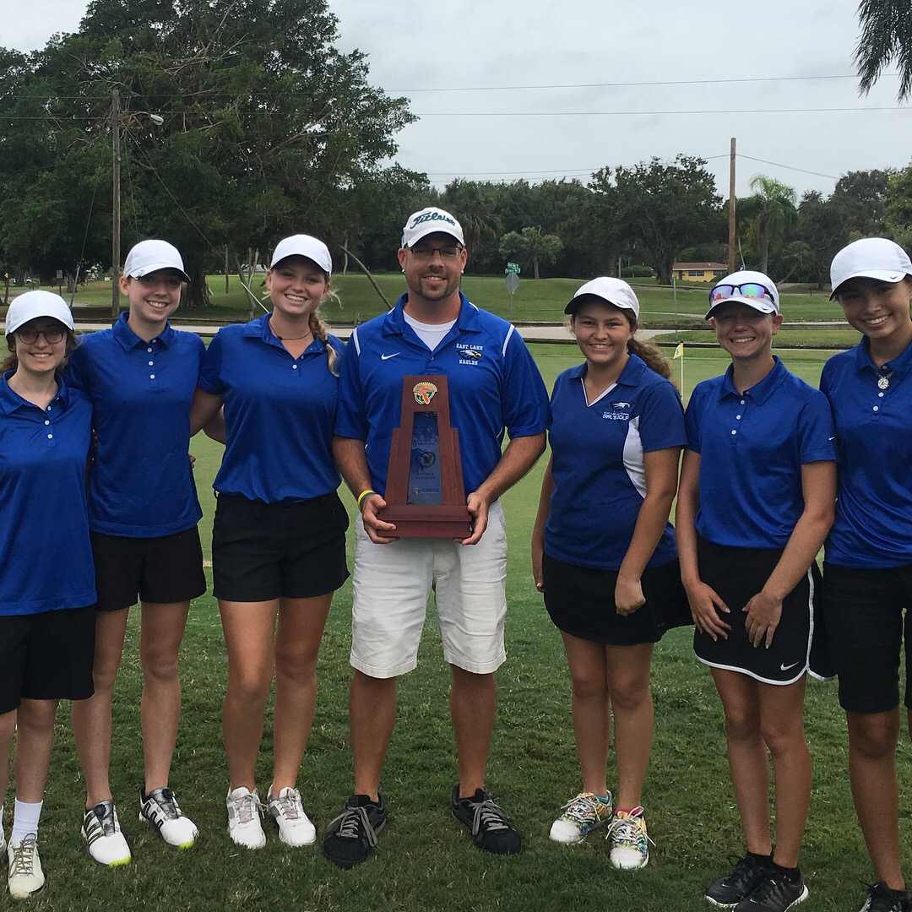
  Sponsors needed
  East Lake Eagles Athletic Hall of Fame
  The Hall of Fame Committee is seeking Title Sponsor(s) and sponsors to support our mission: To recognize outstanding athletic achievements by East Lake Eagles Student Athletes.
  Hall of Fame Park Coming Soon!
  Our goal is to design and build a designated area on campus to recognize the outstanding athletic and academic achievements of our student athletes. The area, to be known as the Eagles Hall of Fame Park, will be adjacent to the gymnasium and football stadium. Sponsors will receive timeless recognition prominently displayed on the monuments in addition to our eternal gratitutde!
  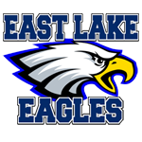
  East Lake Eagles
  Title Sponsors Needed
  Display
  Display your company name permanently in the Hall of Fame Park
  Restaurant Sponsor Needed to Host Annual Hall of Fame Induction Banquet
  Restaurant Needed to publicly display plaques
  A
  A
  East Lake Eagles
  1300 Silver Eagle Drive
  Tarpon Springs, Fl 34688
  https://www.pcsb.org/Page/213
  1st Class to Be Inducted in 2018

