K/1 ASD – Ms. South
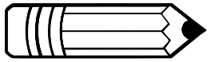
Classroom Supply/Wish List

Supply List:
- 1 inch binder (any color/pattern)
- Crayons
- Glue sticks
- Scissors
- Black skinny expo markers
- A change of clothes to keep in the classroom (including underwear and socks) – please label with your child’s name
- Pull ups and wipes (as needed)
- Snacks for your child during snack time
- Water bottle for your child to drink out of – please label with your child’s name

Wishlist:
- Tissues
- Hand sanitizer
- Disinfectant spray
- Disinfectant wipes
- Ziploc bags
- 1 package plain white copy paper
- Individually wrapped snacks for the class

