Kindergarten Supply List
To help us out throughout the year, it would be greatly appreciated if you would bring the following school supplies for your child to use in our classroom. They will be classroom supplies for our class. Please include your child’s name on the outside of the bag holding the supplies.
Please provide the following supplies:
- Backpack – large enough to fit a binder, no wheels please (to be emptied everyday)
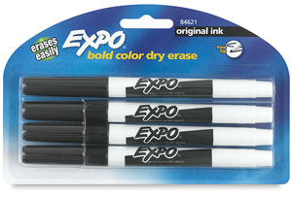
- Bag of extra uniform clothes, underwear, and socks label each piece of clothing with name
- Water bottle/thermos filled with water only, labeled with name
- 1 plastic pencil box (8 inches by 5 inches and at least 2 inches tall)
- 1 pack of 4 or more skinny fine tip Expo Dry Erase markers (BLACK ONLY PLEASE)
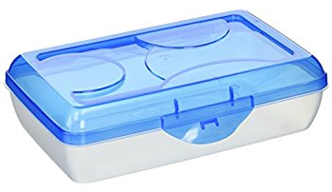
- 1 RED PLASTIC folder with 3 prongs and pockets

- 1 BLUE PLASTIC folder with 3 prongs and pockets

- 1 YELLOW PLASTIC folder with 3 prongs and pockets

- 1 black composition notebook with lines
- 1 pack of Ticonderoga Beginners Pencil (FAT Pencils)
- 1 WHITE plastic 3 ring binder with pockets inside and clear front cover (1 INCH ONLY)
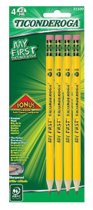
- 1 pair of headphones with microphone and traditional headphone jack
- 1 ream of white copy paper
- 1 large box of tissues for classroom use
- 1 bottle of hand sanitizer (unscented) 8 oz or larger for classroom use

