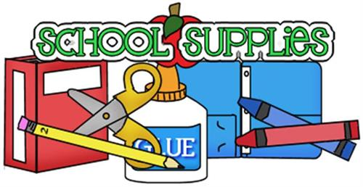

SAWGRASS LAKE ELEMENTARY
2nd GRADE

* 2 packs of plain yellow #2 pencils sharpened
* 1 box of 16 count crayons and colored pencils
* 6 glue sticks
* 2 bottle of hand sanitizer
*2 container of Lysol wipes and/or Lysol spray
* 2 boxes of Kleenex tissue
* 1 Pencil box
* 1 plain white 1½ inch 3 ring binder with a clear outer layer
* 2 black composition notebooks (Math)
* 2 green composition notebooks (Science Journal)
* 1 red 3-pronged folder with pockets (Writing)
* 1 orange plastic folder without prongs (Homework)
* 1 pencil pouch for binder
* 1 ream of computer paper
* 1 pack of lined notebook paper
* A pair of headphones with microphone
* A pack of dry erase markers

