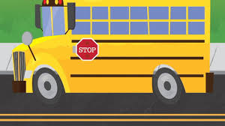
As we are prepare to leave one school year behind, here are some supply items that will help next year get off to a great start! Please remember that school supplies are optional, and all items necessary will be provided.
4th Grade Supply List (Optional)
- 2 packs of wide ruled paper
- Pencils, non- mechanical
- Ear buds/ headphones (Walmart, Dollar Tree)
- Dry Erase Markers

- Wish list: tissues, hand sanitizer, gallon (boys) and sandwich (girls) size zip-lock bags.
Thank you for partnering with us and having your child prepared for learning!

