1st Grade Supply List
These are the supplies your child will use in 1st grade! All supplies are optional. If you can provide them, we would appreciate it.

- 1 standard size plastic pencil box

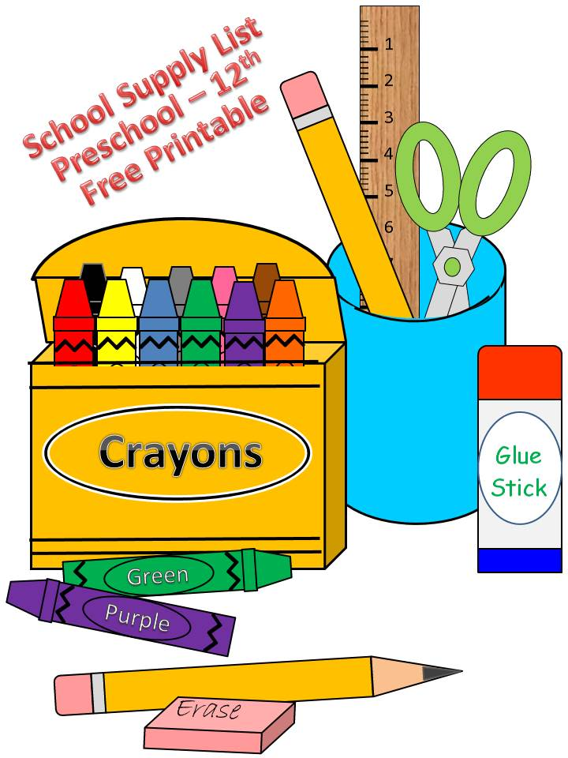
- 4 jumbo glue sticks
- 1 pack of #2 pencils (sharpened)
- 2 boxes of 24 count crayons
- Student/child scissors
- 1 box of black dry erase markers
- Clorox Wipes
- Zip –Lock Baggies
- Tissues
- 1 pack of lined 3 x 5 index cards
- Headphones (these will be for your child only)

Wish List

- Crayola twistable crayons
- Ziploc baggies (all sizes)
- Paper plates (all sizes)
- Colored Copy paper
- Markers
- Tissue paper
- White paper lunch bags
- Treasure box items
- Tubs of foam letters, numbers, shapes, etc.
- Playdough
- Stickers
- Plastic-ware (spoons, forks, knives)
- Post-It Notes
- Dry erase markers

*** Items on our wish list are things that we purchase or that we use on a regular basis. We may also request additional supplies at various times during the school year. Donations are always welcome and greatly appreciated! ***

