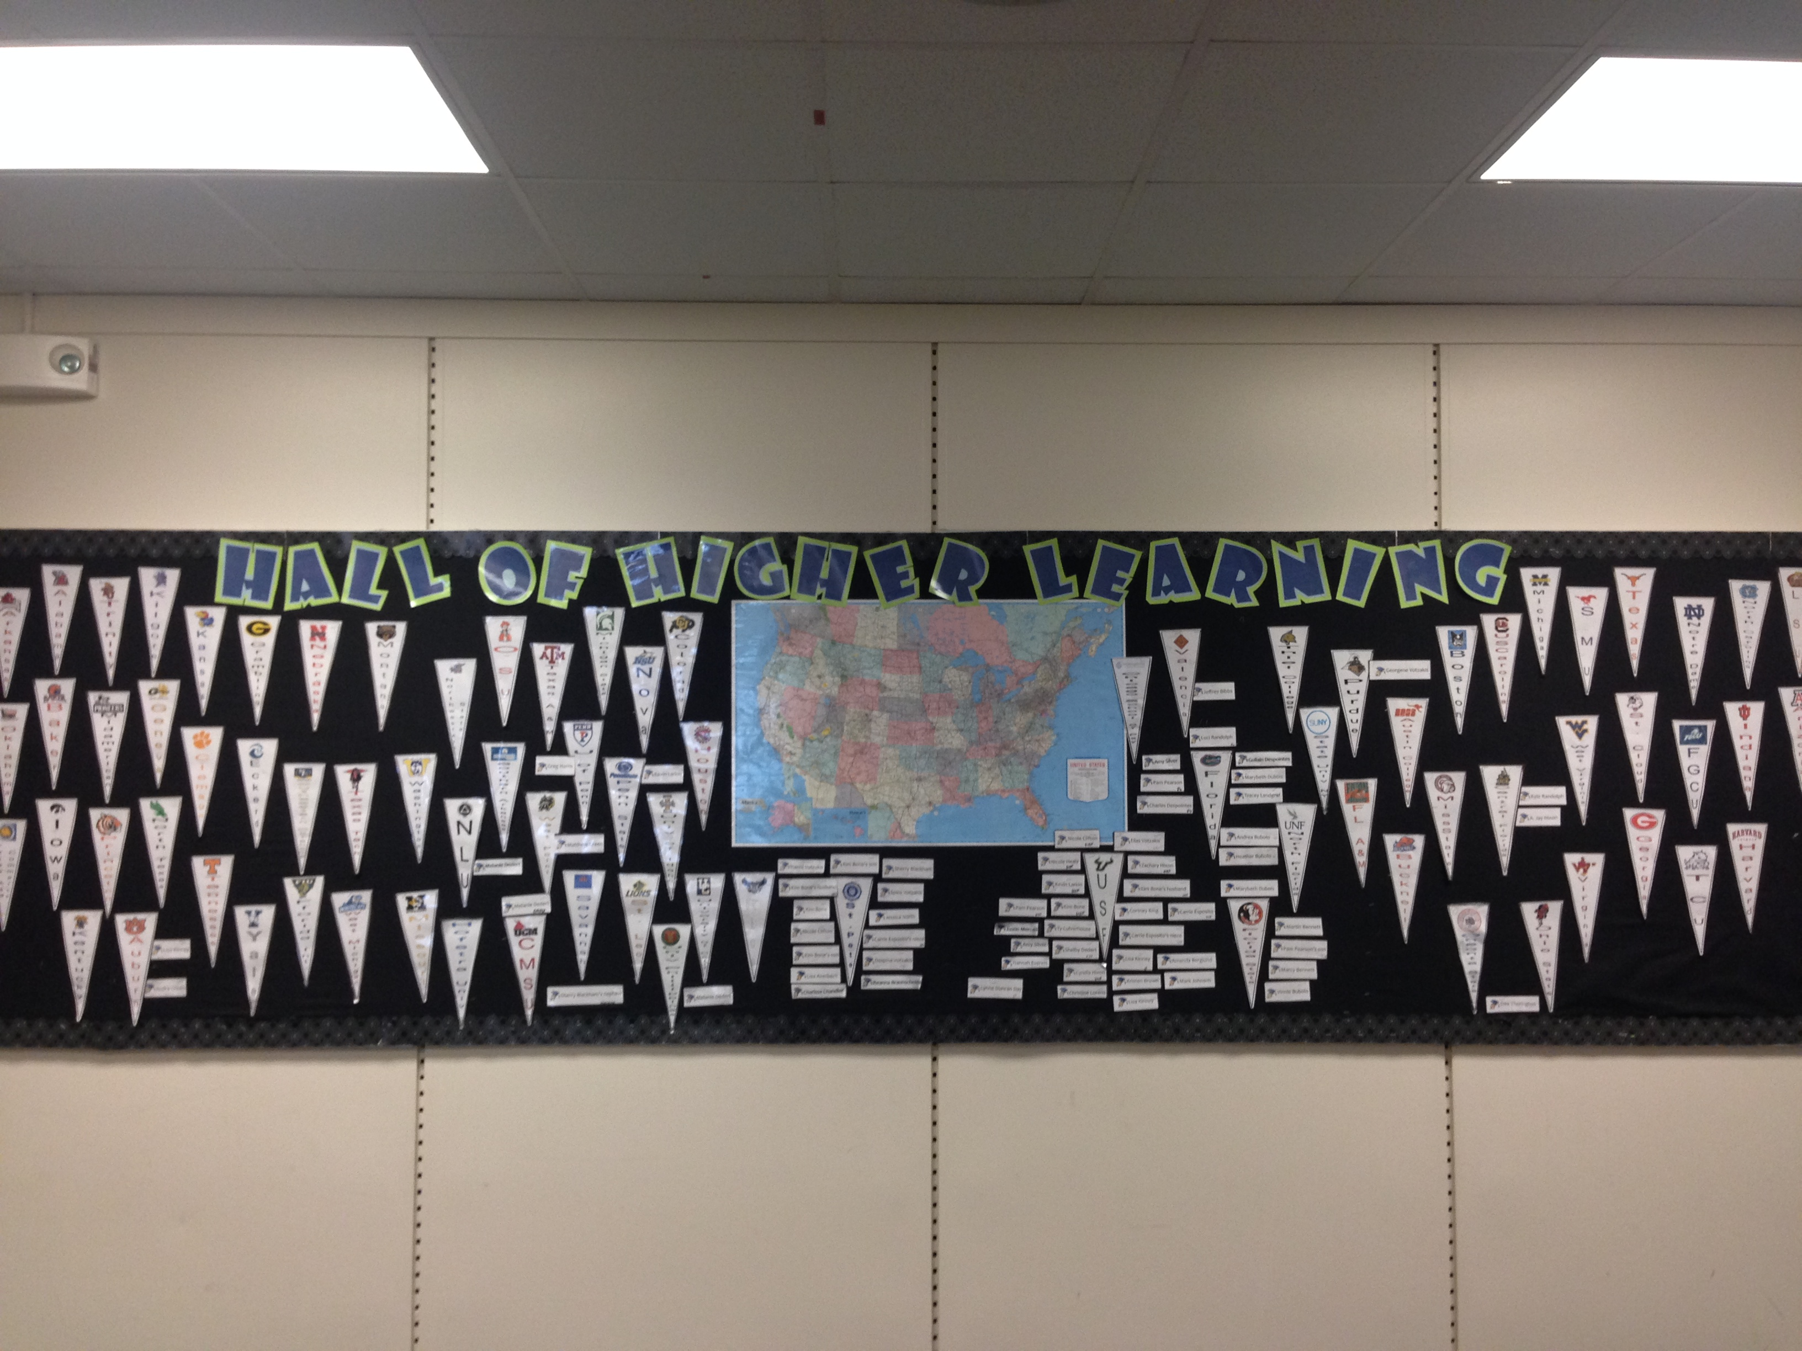
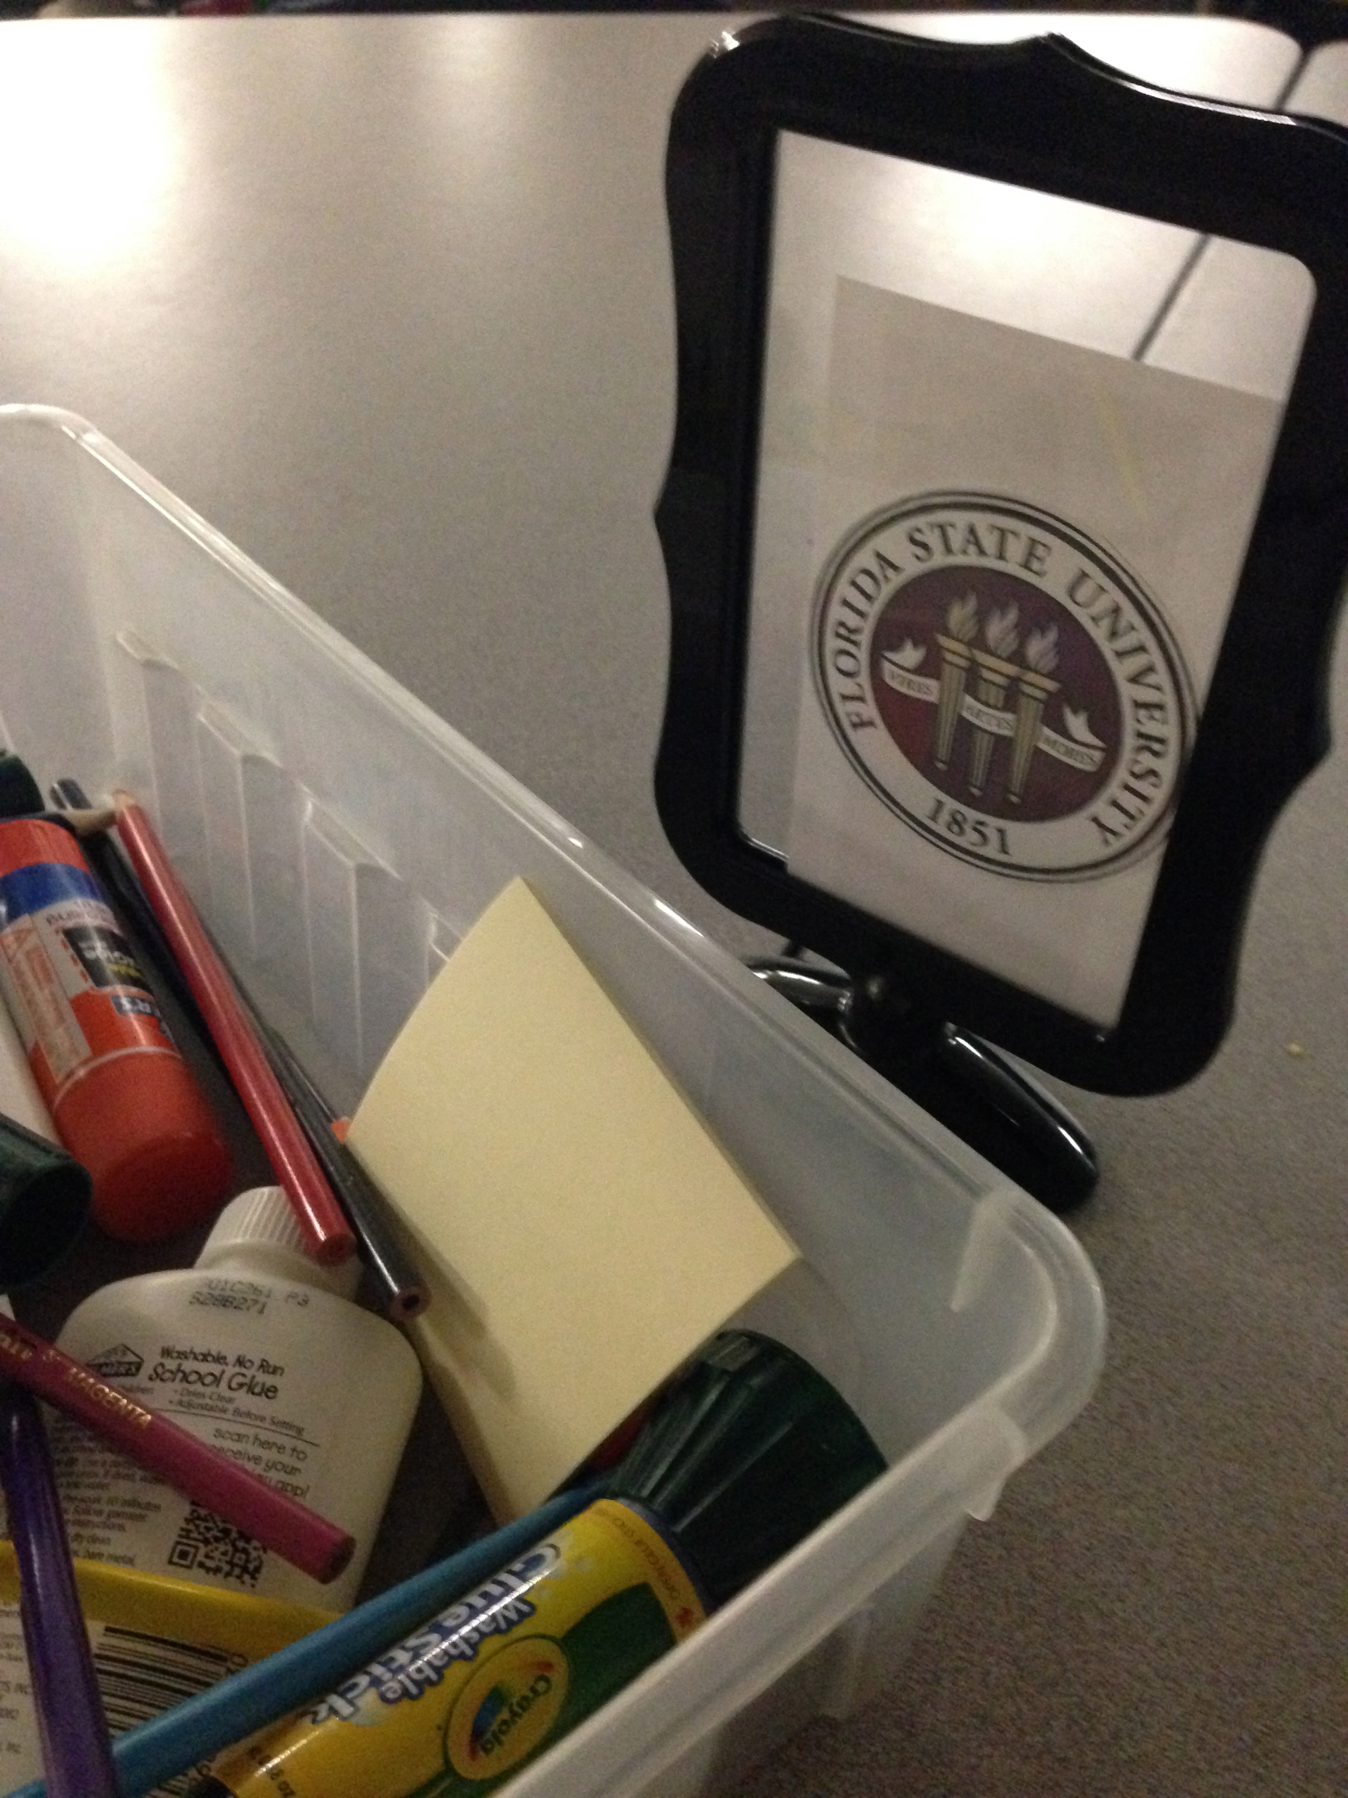
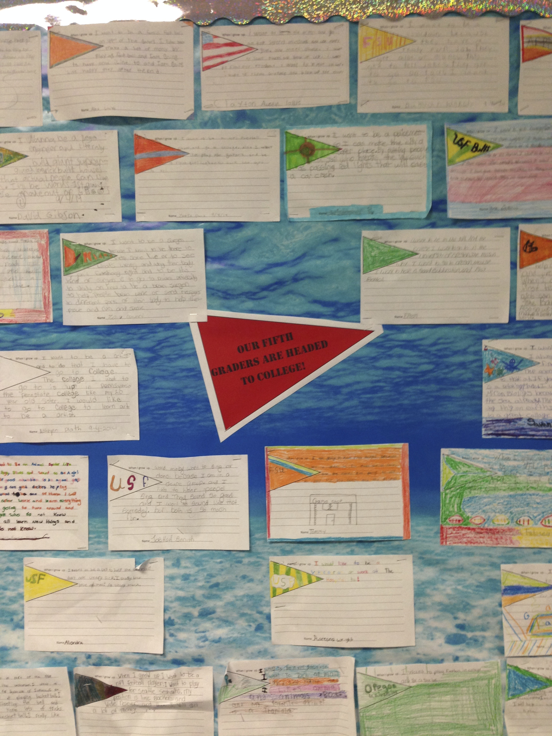
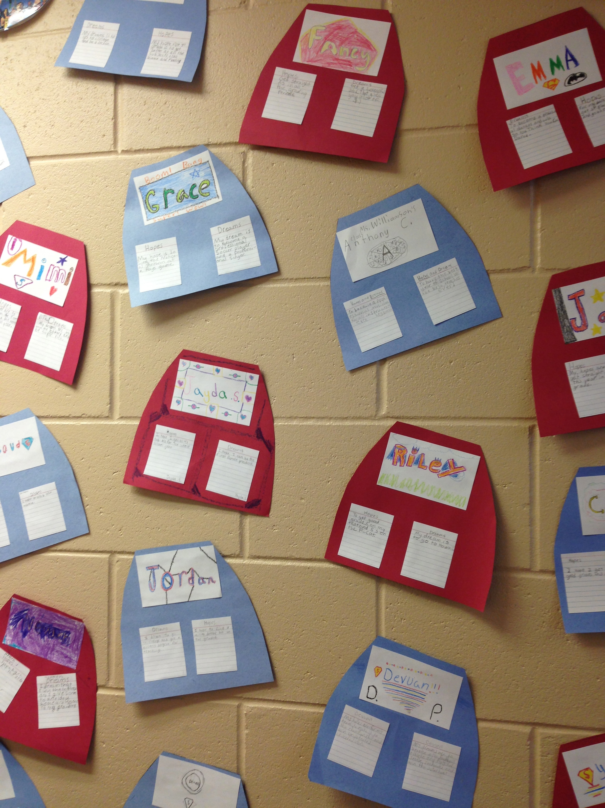
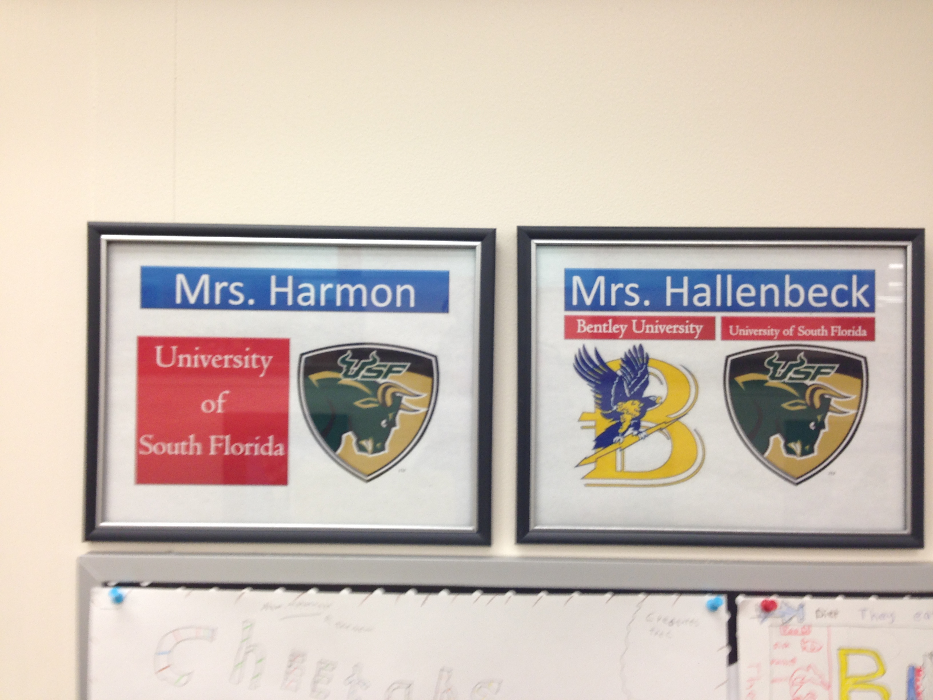
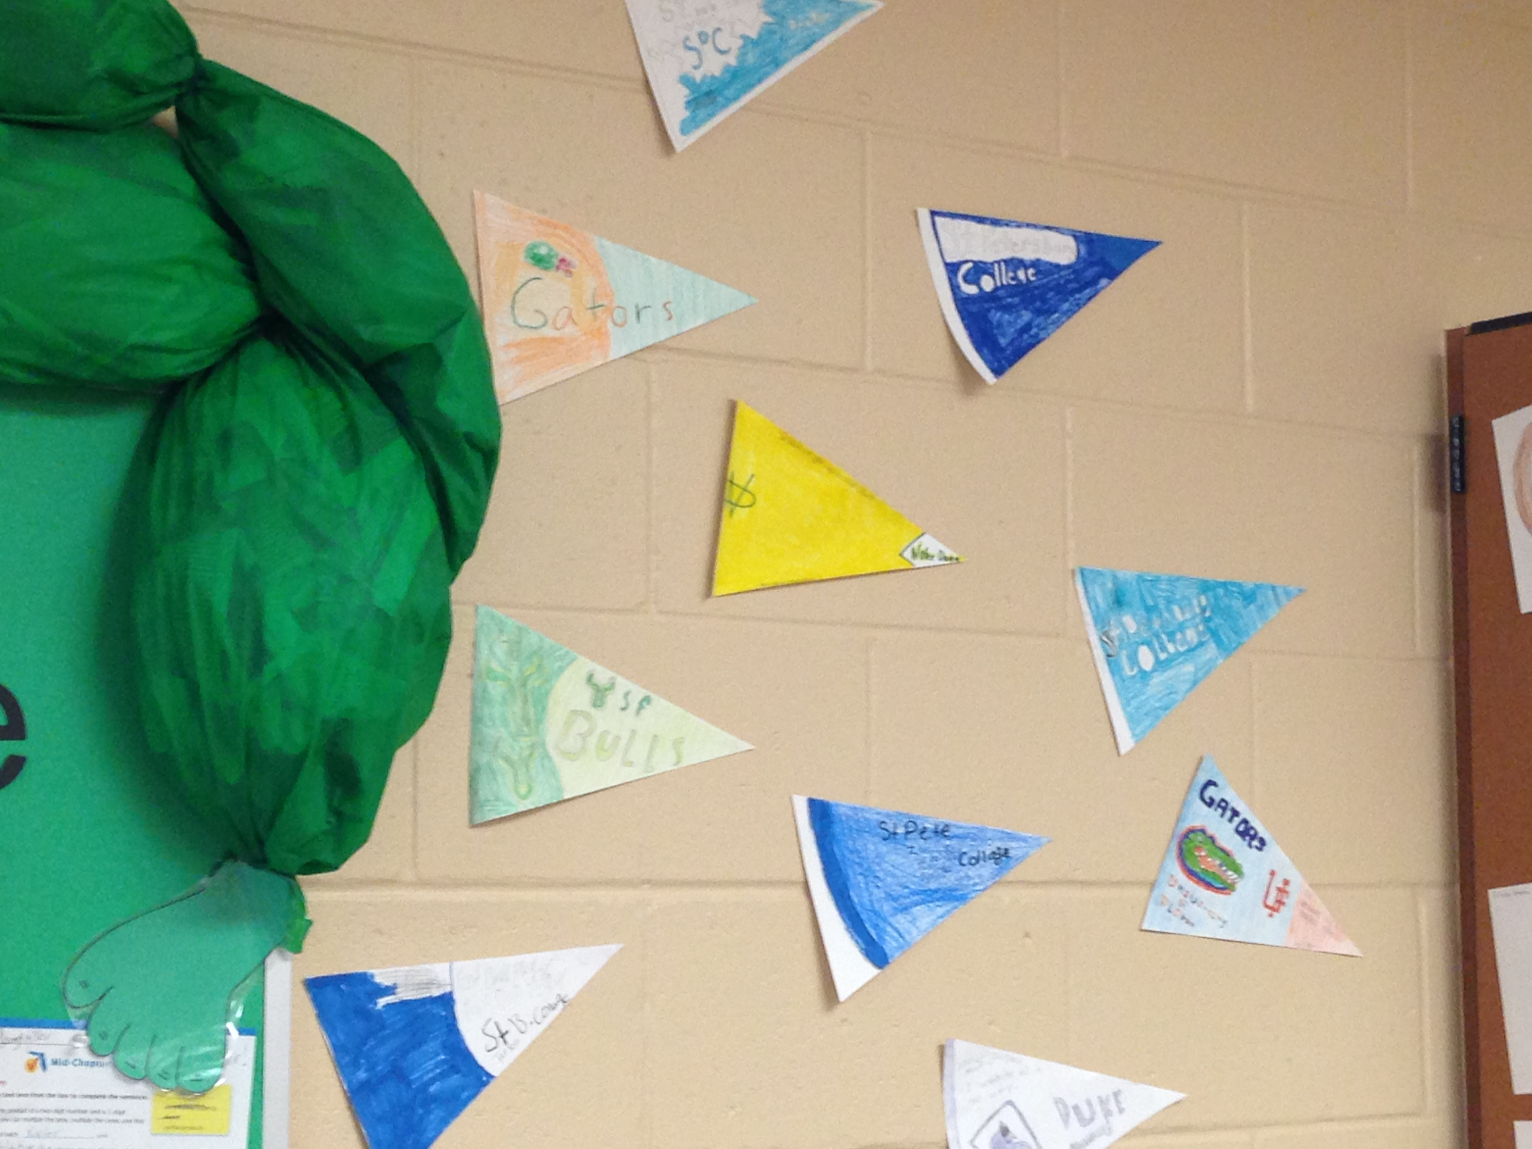
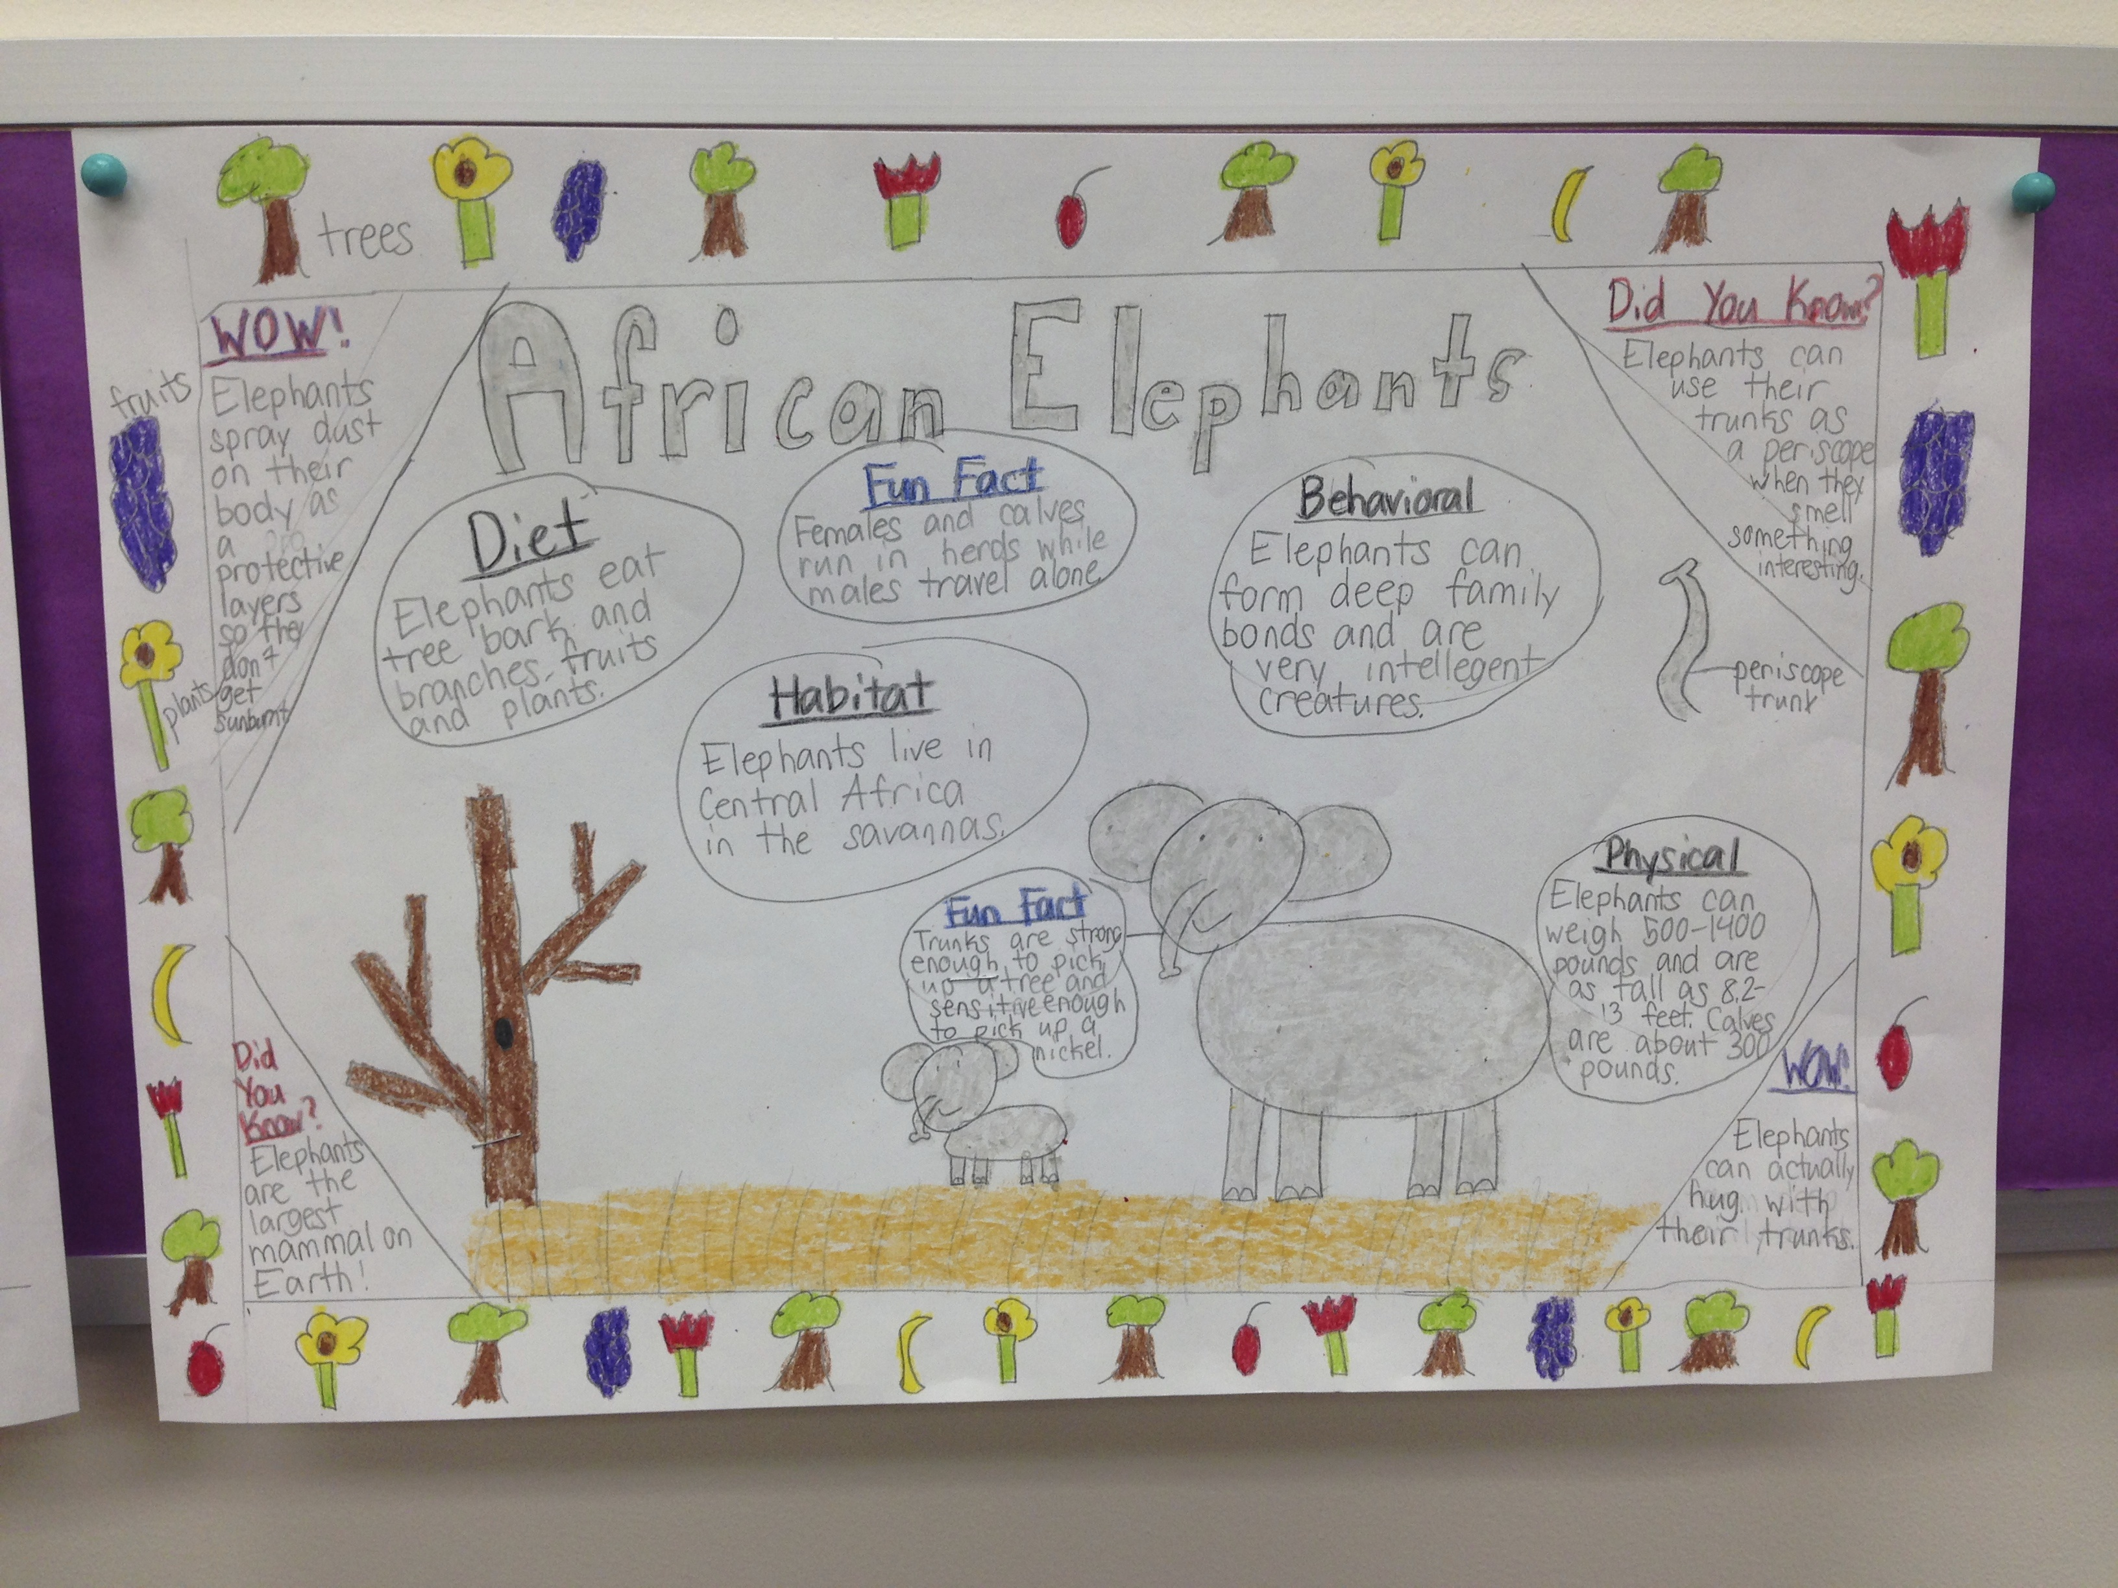
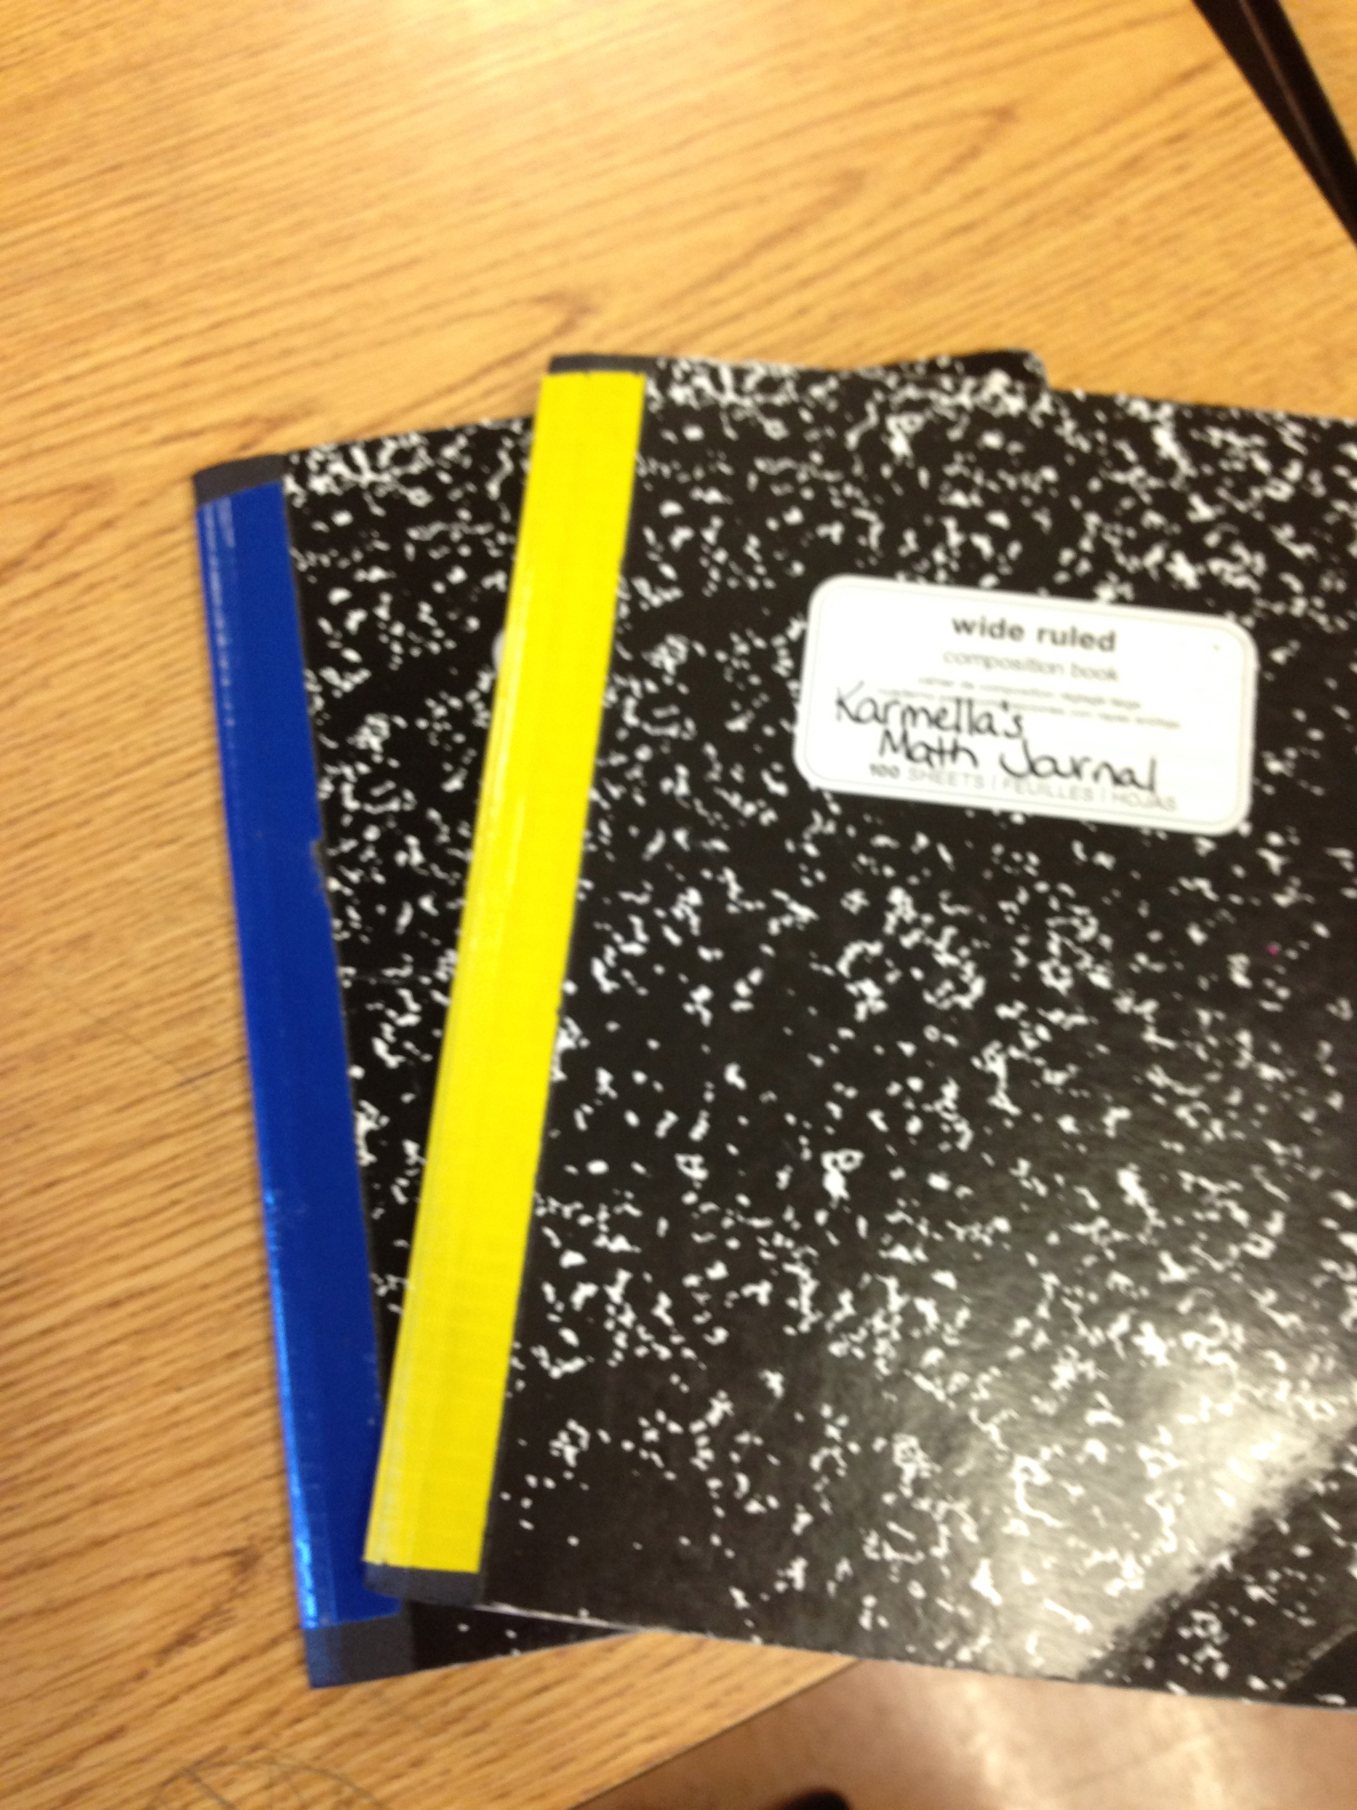
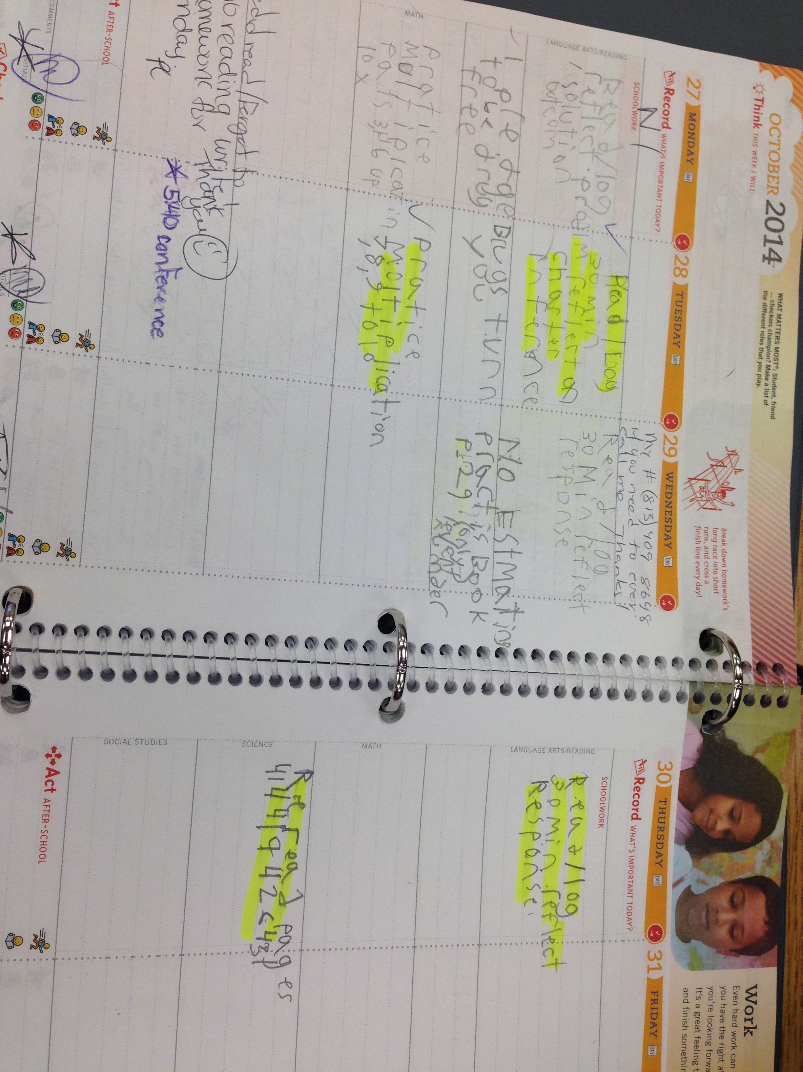
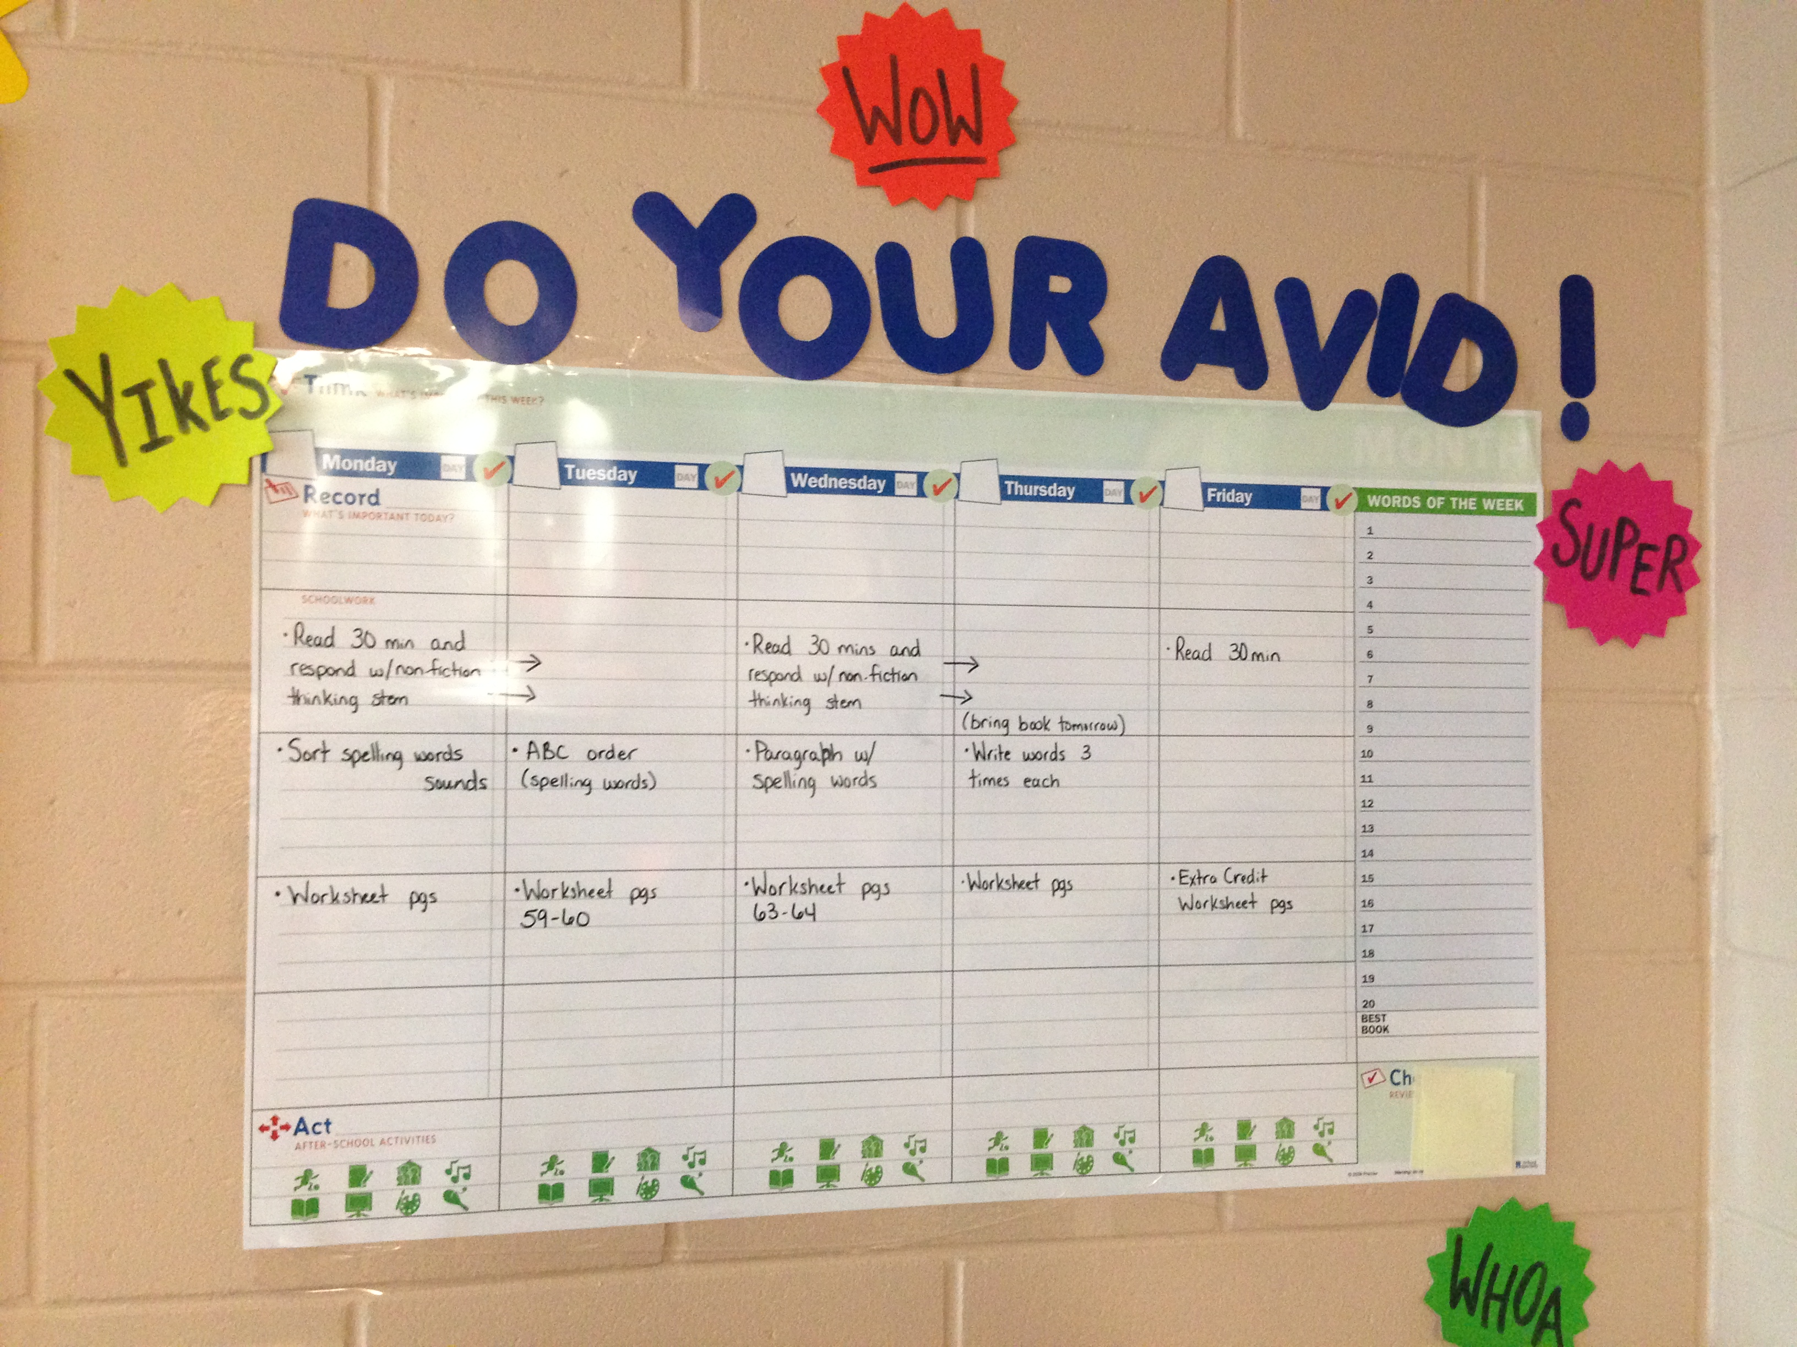
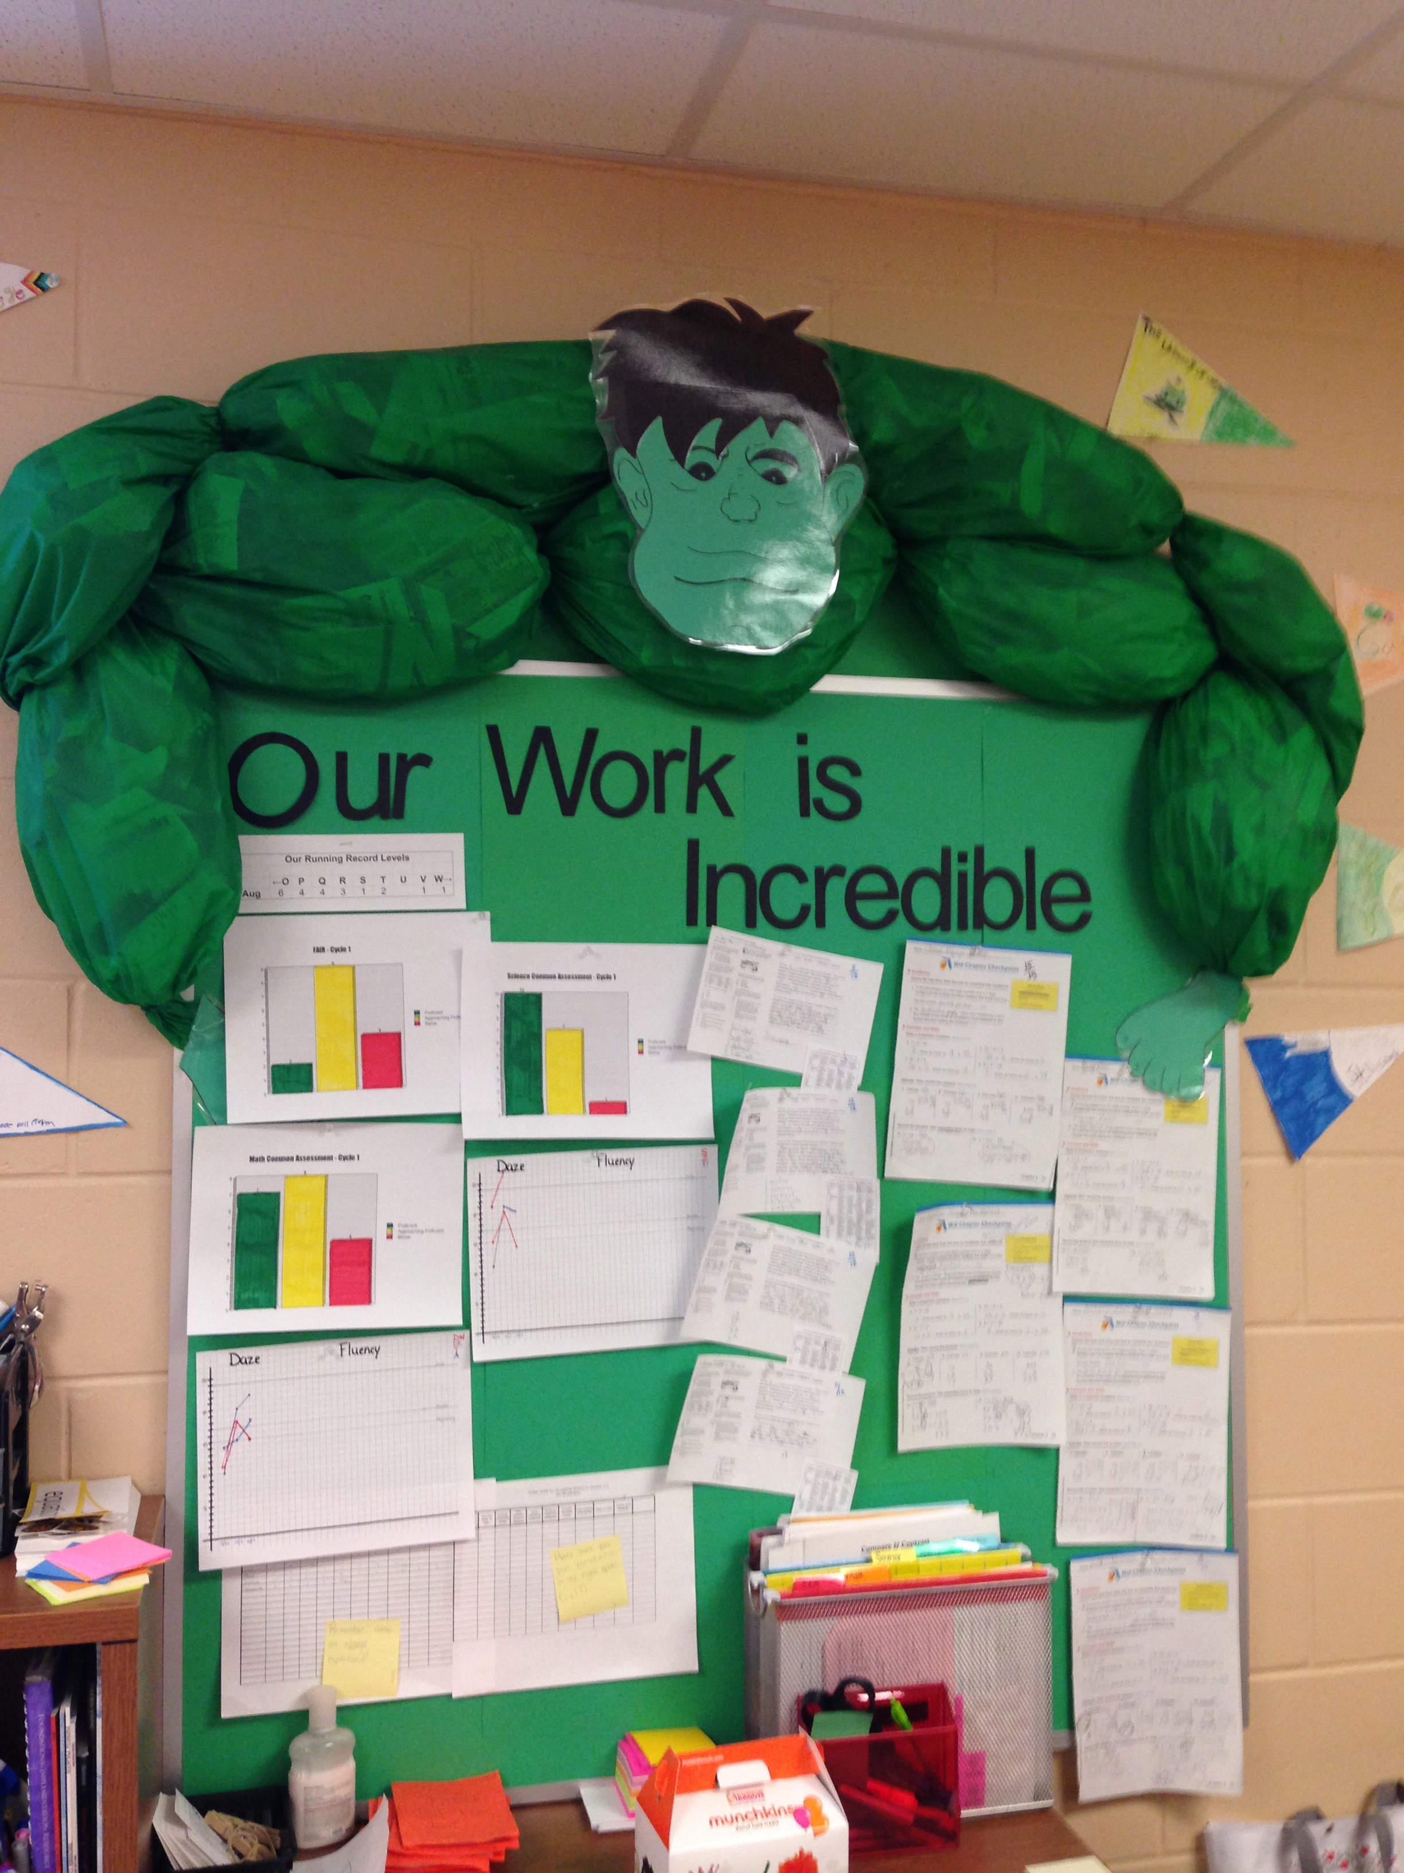
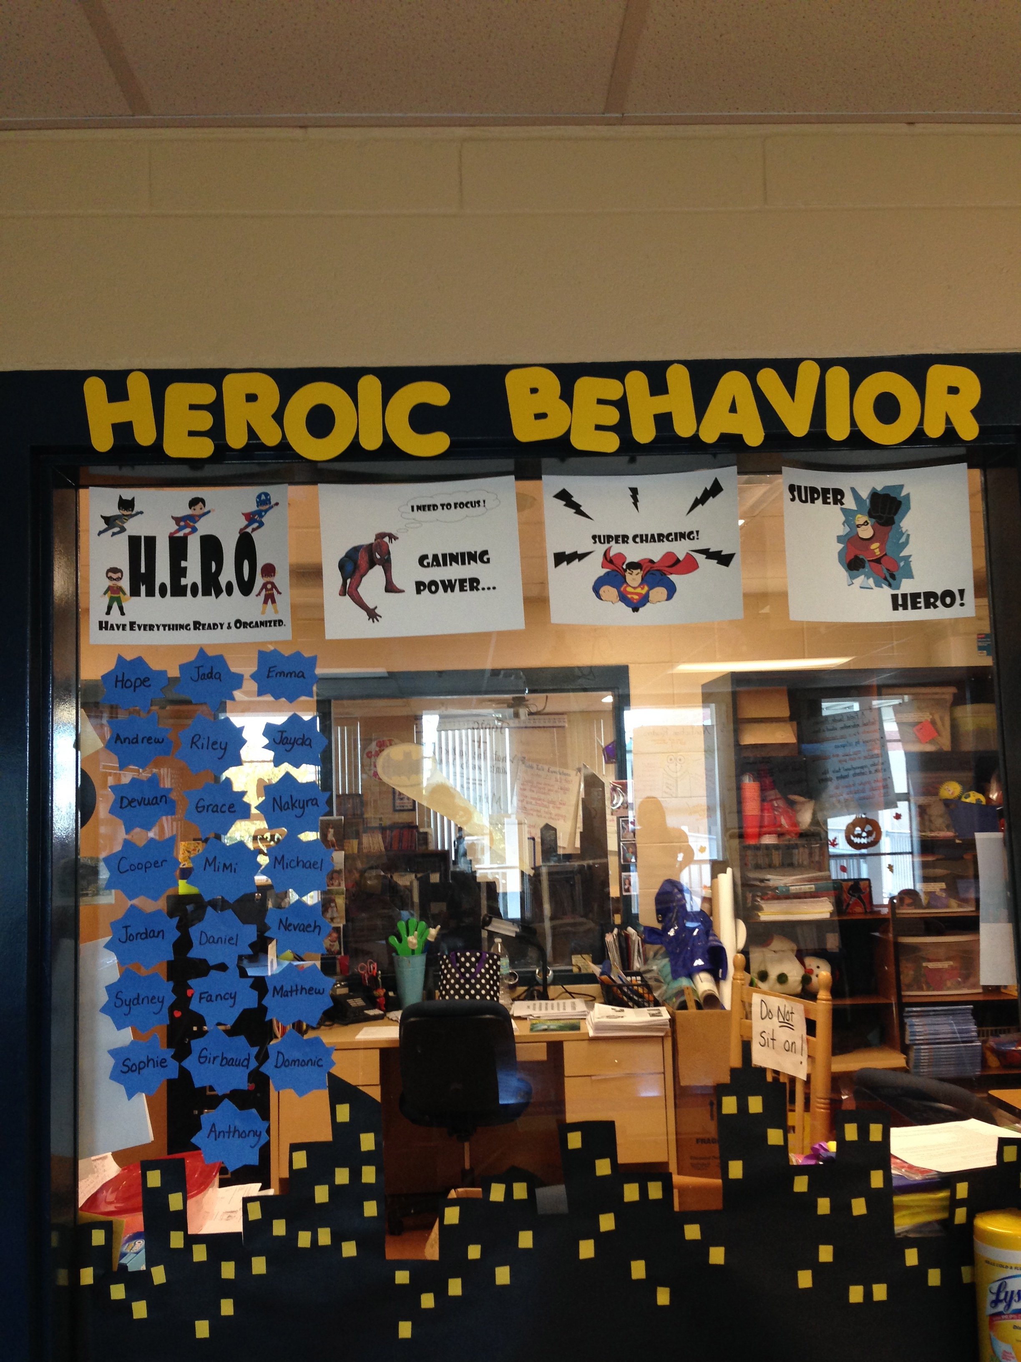
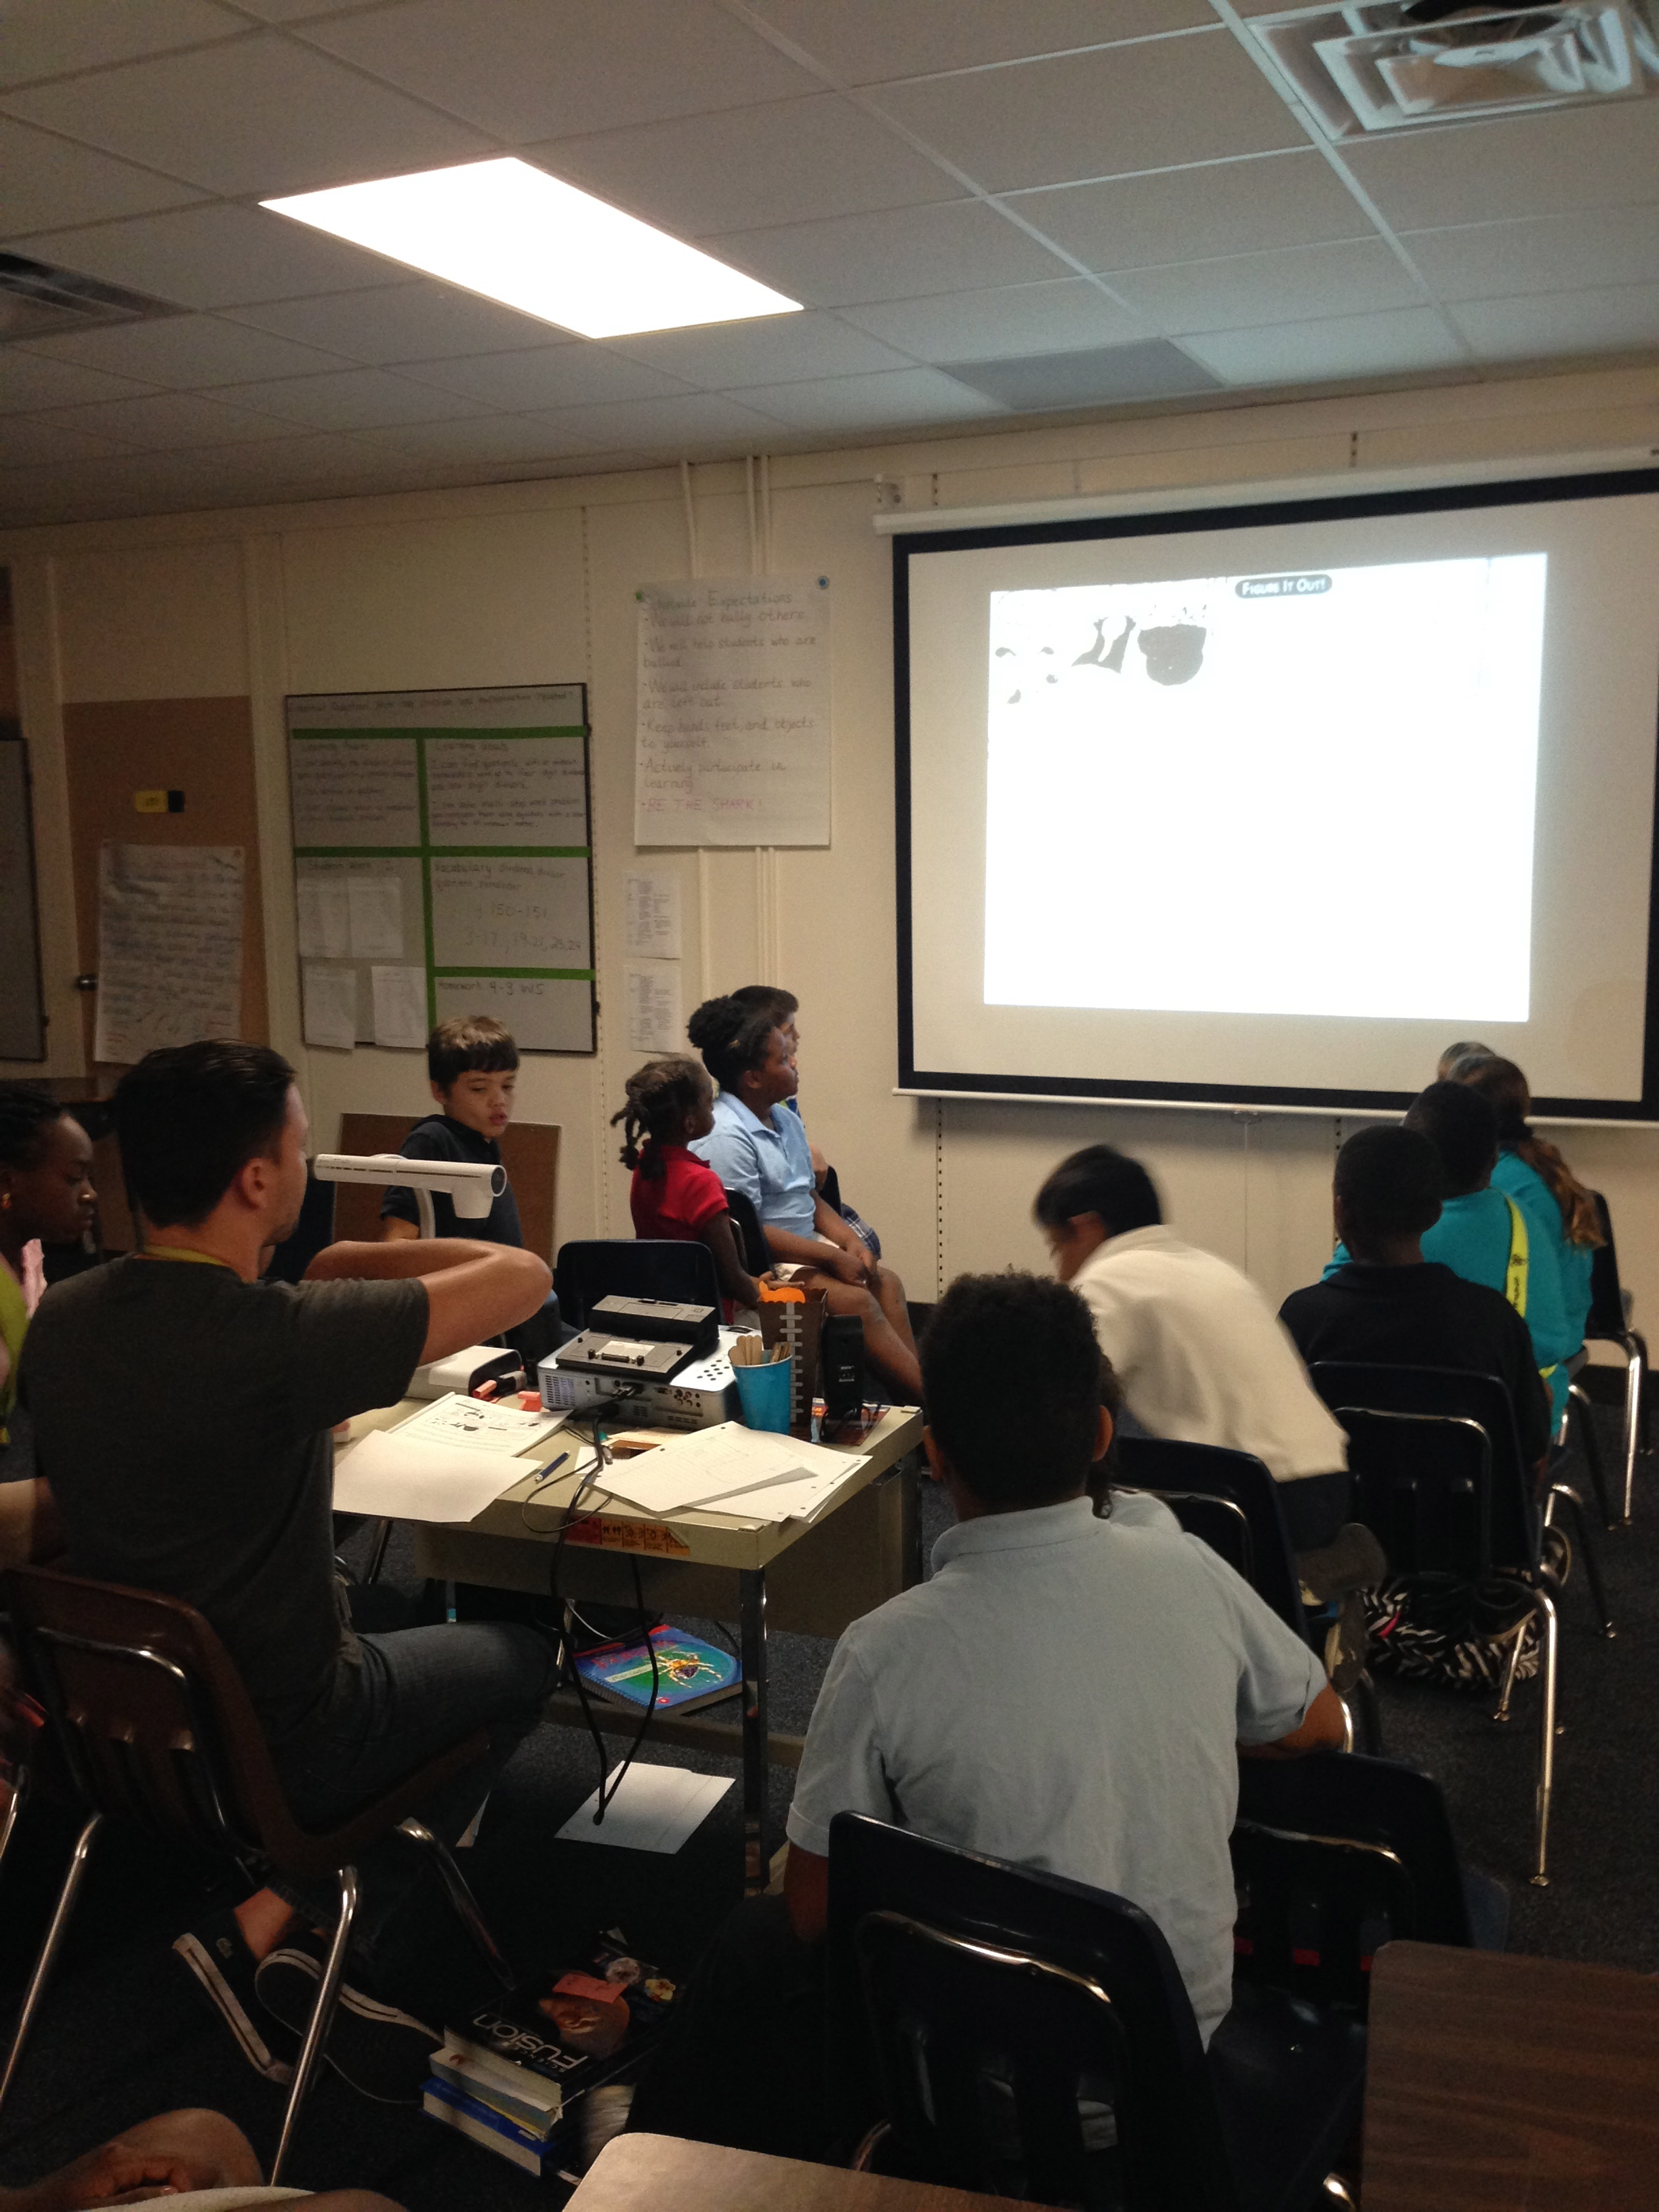
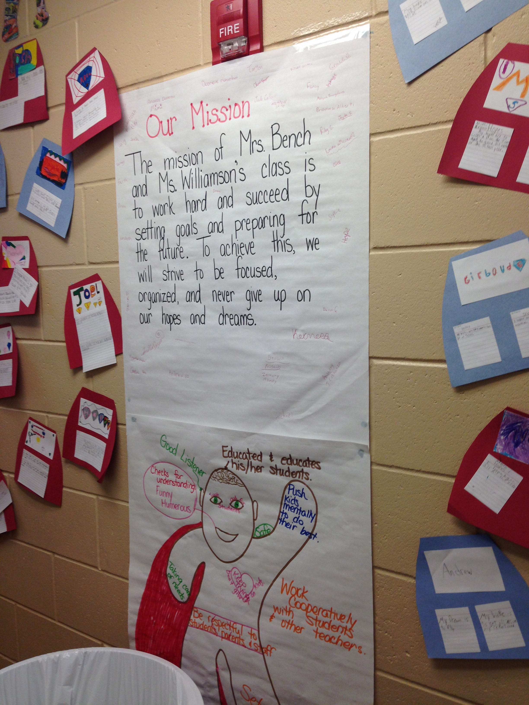
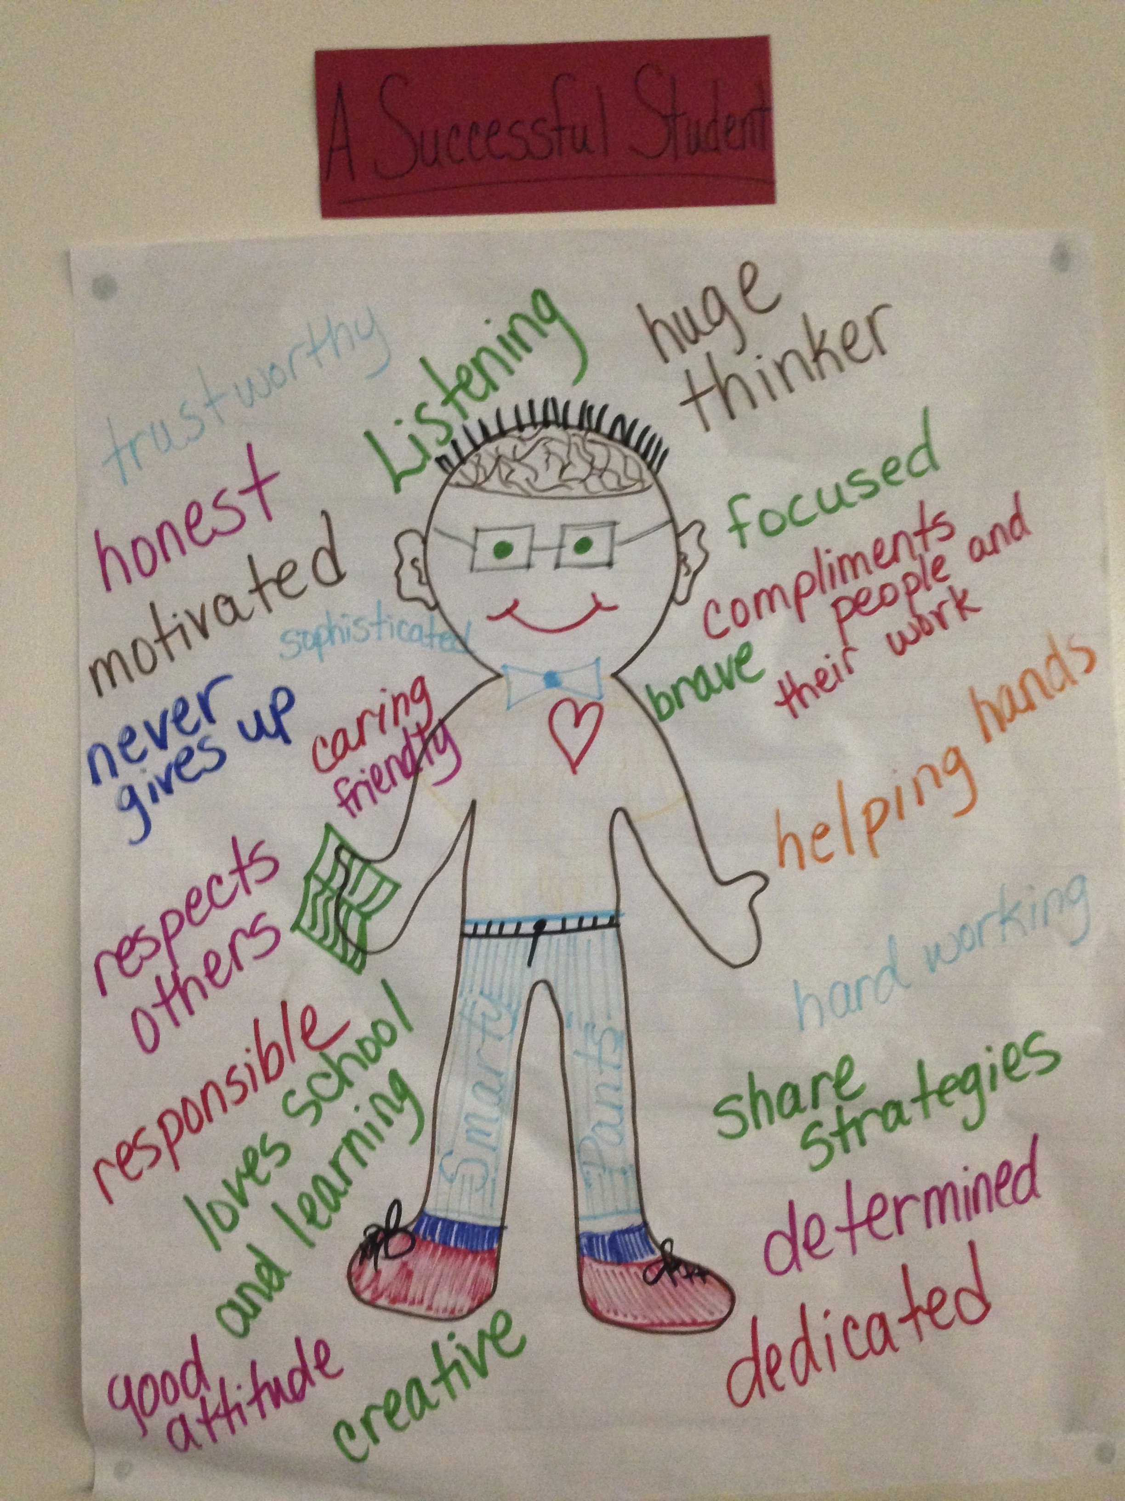
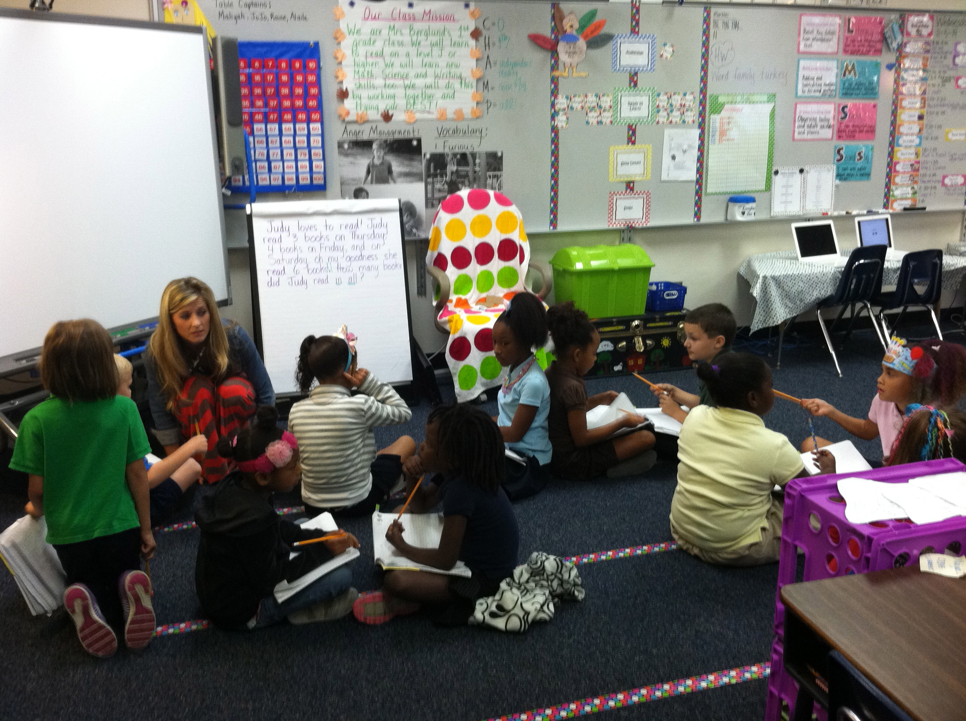
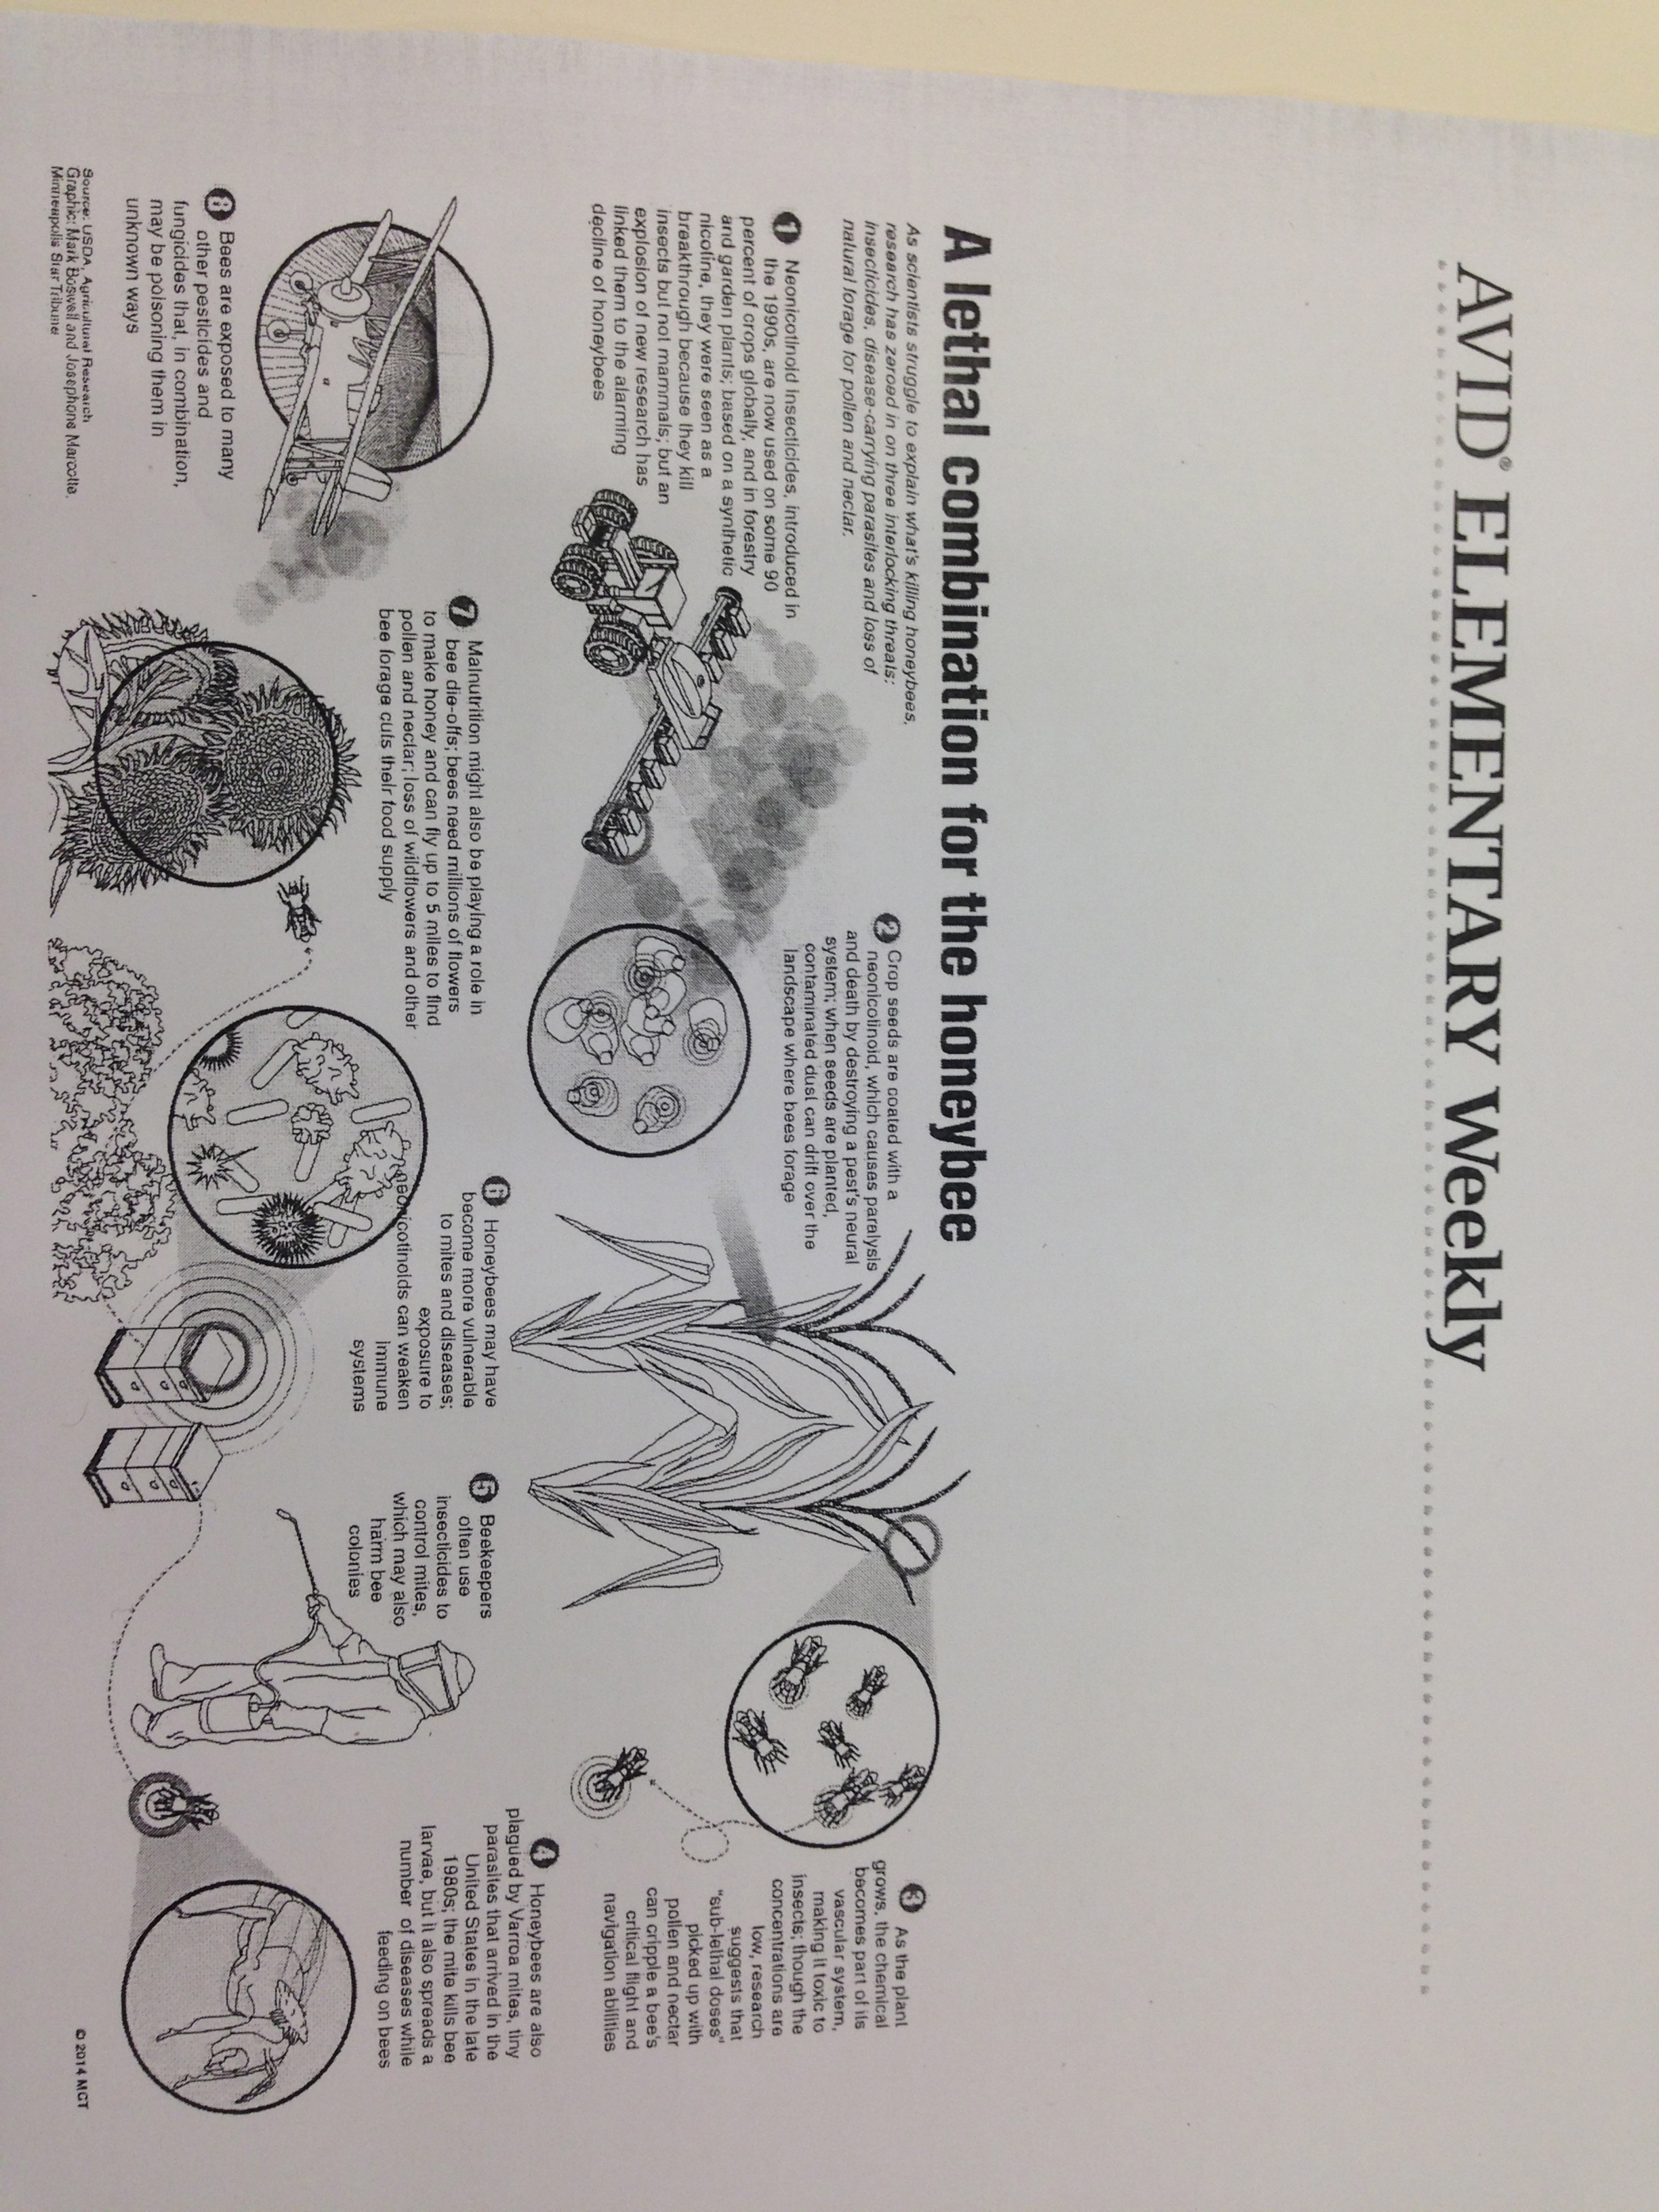
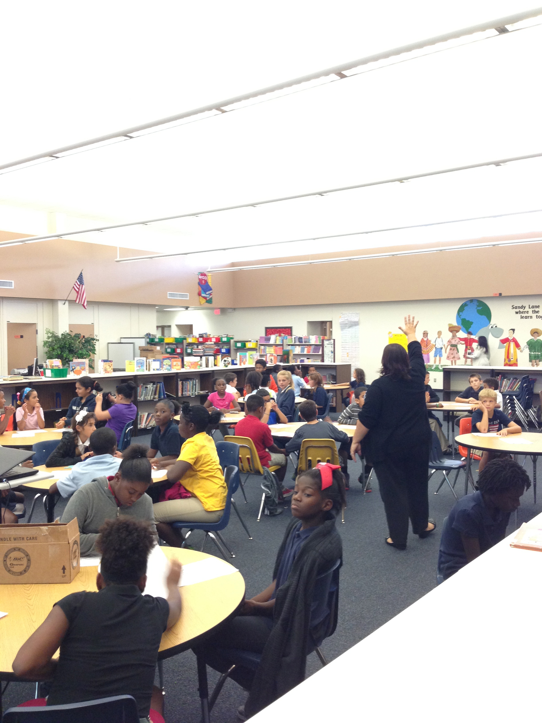
Creating a College Going Culture in Our Schools

Student’s Hopes and Dreams Brainstorms, Student Created College Pennants, College Labeled Table Groups, Teacher Name Signs With Colleges, Grade Level Career and College Goals with Pennants that read “Our ____ Graders are Going to College”, Bulletin Board of Staff Alma Maters. Thank-you to the teachers and administration at New Heights, Pinellas Central, and Sandy Lane for all the great pictures!
Organization is the Key!
Heroic Behavior: HERO – Have Everything Ready and Organized, Data Walls to promote students tracking their progress and self-monitoring, Subject specific color-coding for all class materials, Poster sized calendars to model planning, Planners with highlighting, One-Pagers to organize notes and thoughts into a product that can then be used to write about or present.
AVID Weekly Lesson with Principal Clifton at Sandy Lane and all 55 fifth graders!!
Purposeful turn and talk in a 1st Grade for math. Great use of inquiry and collaboration!!!
4th Graders using inquiry and collaboration to reinforce math facts!
Classroom Missions and “Successful Student” Anchor Charts! This is a great way to build purpose and community.

