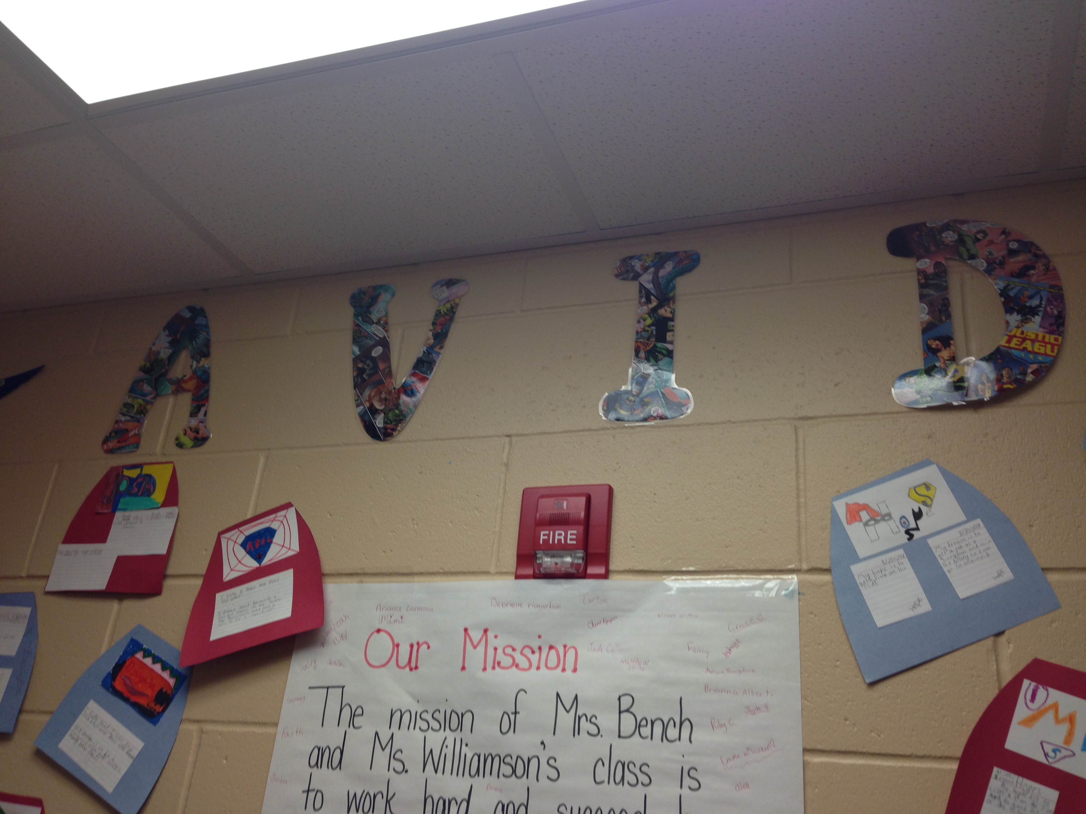
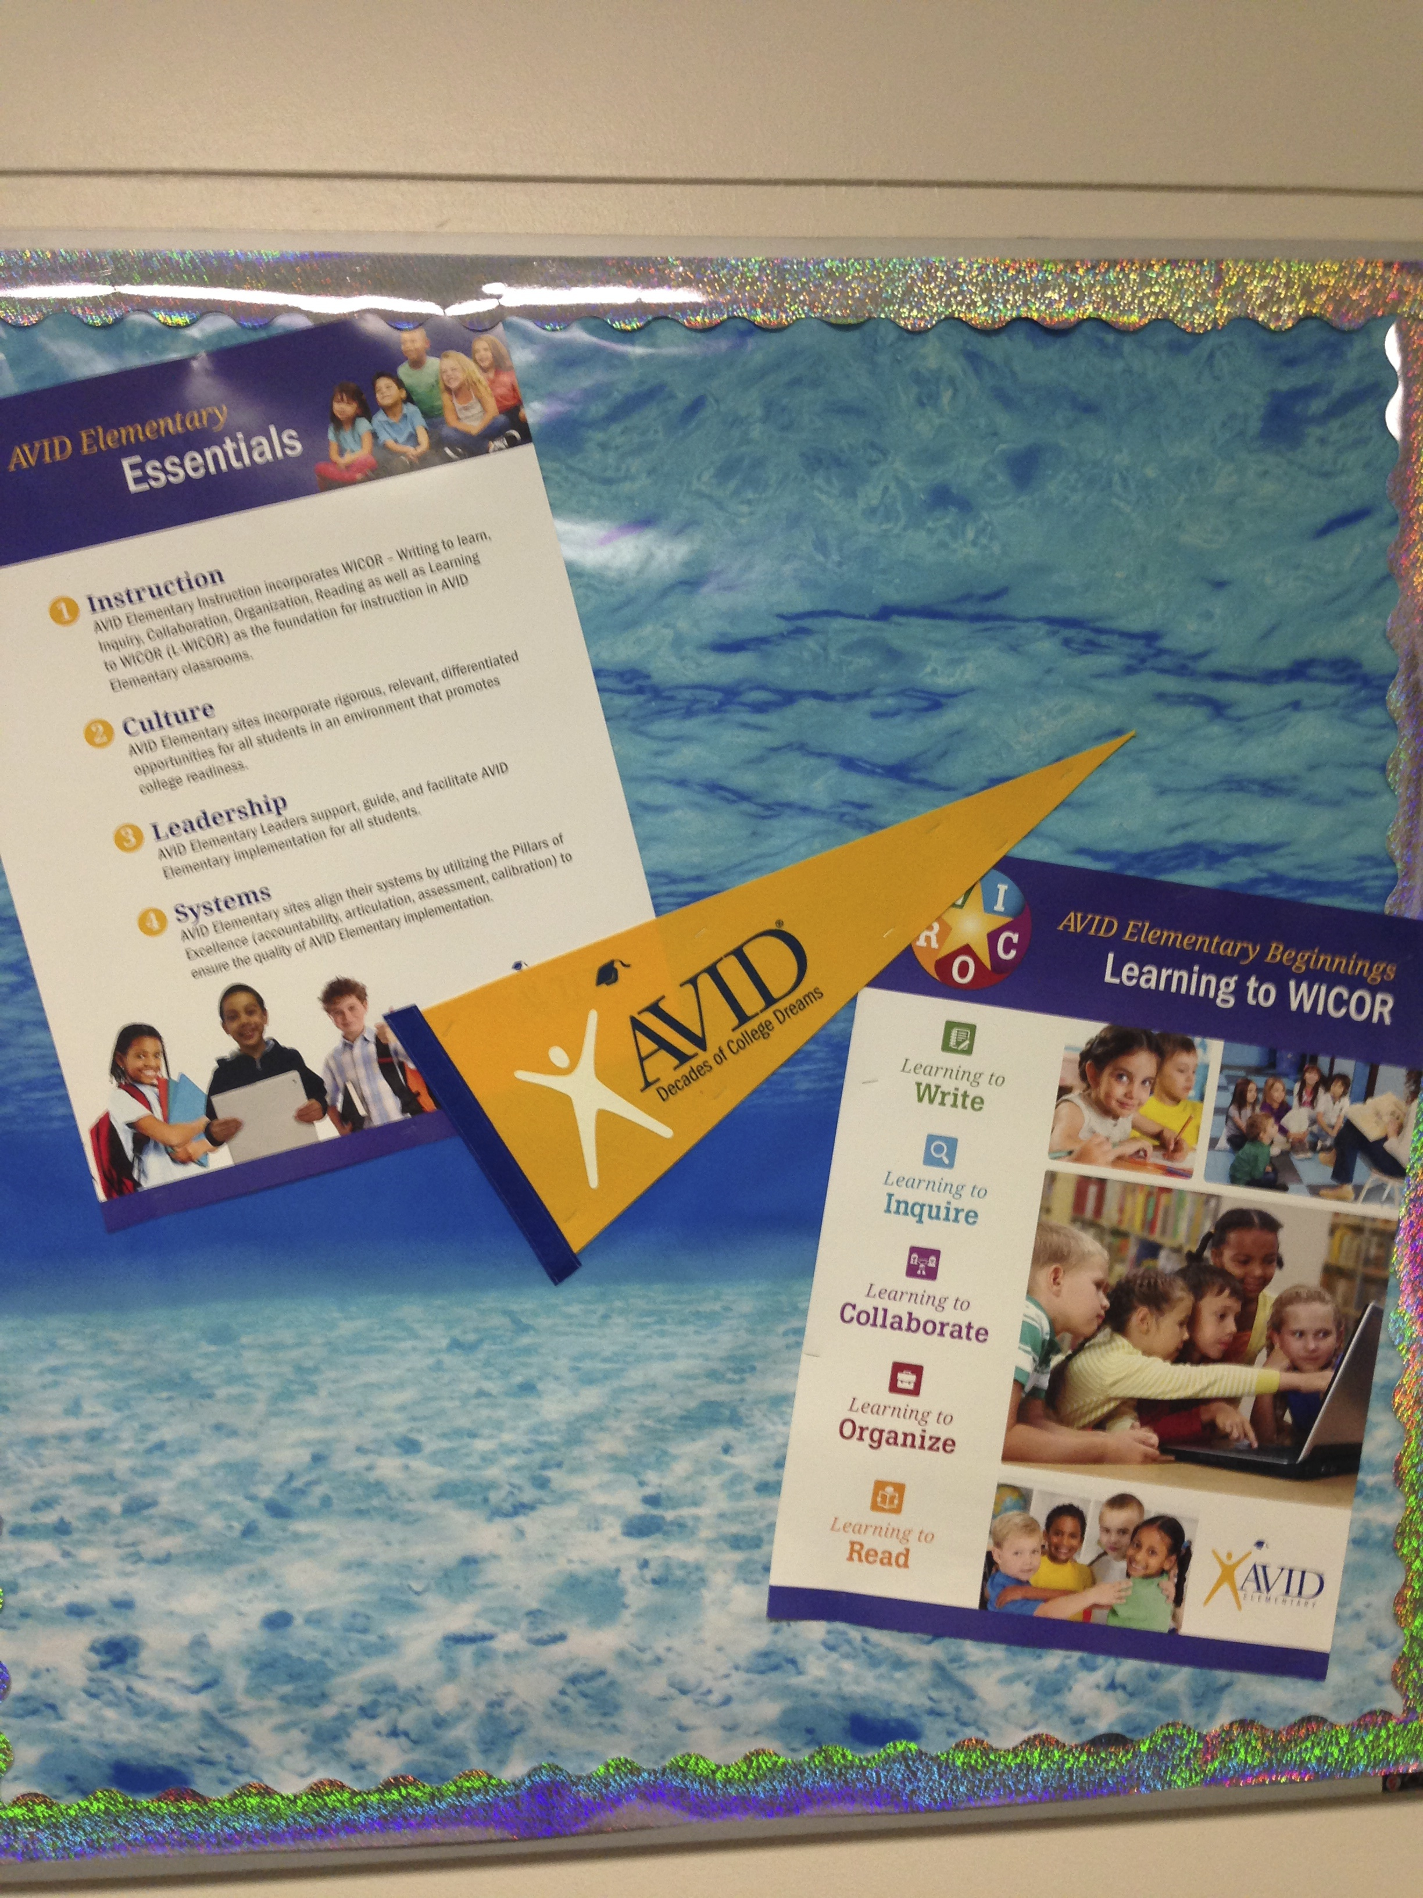
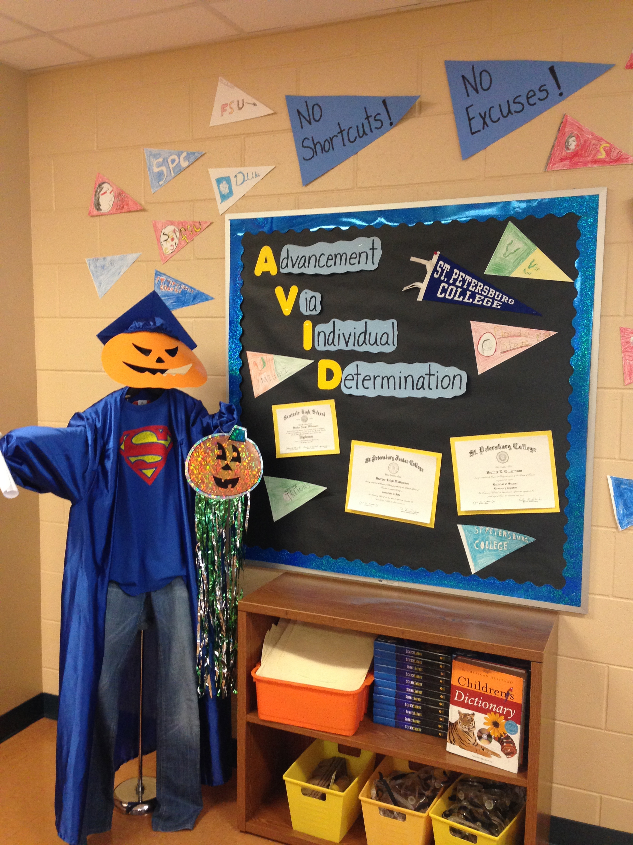
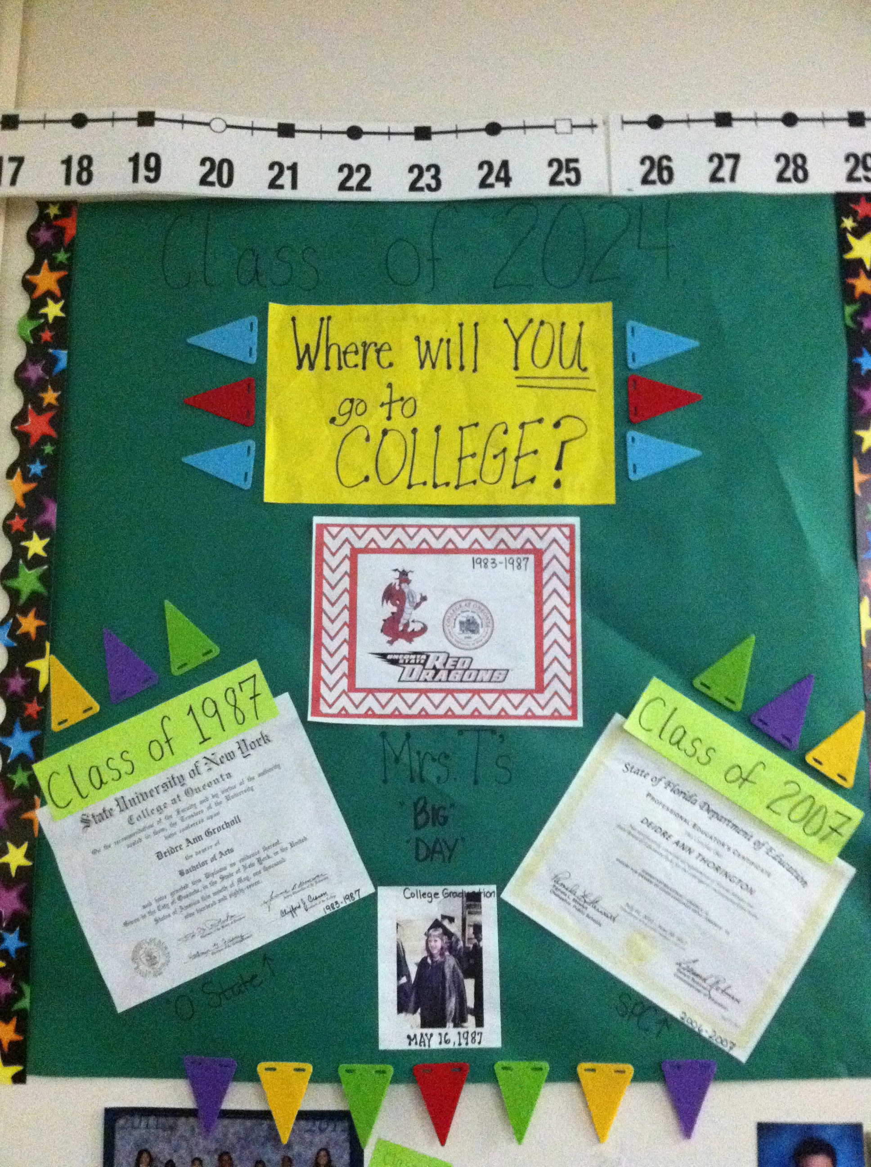
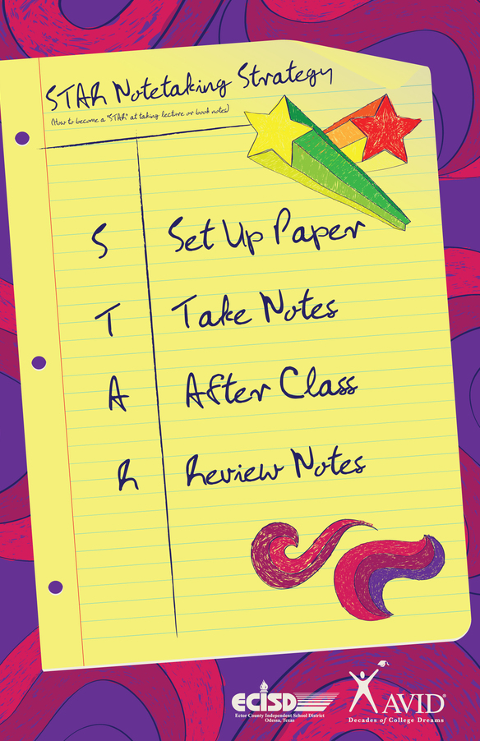
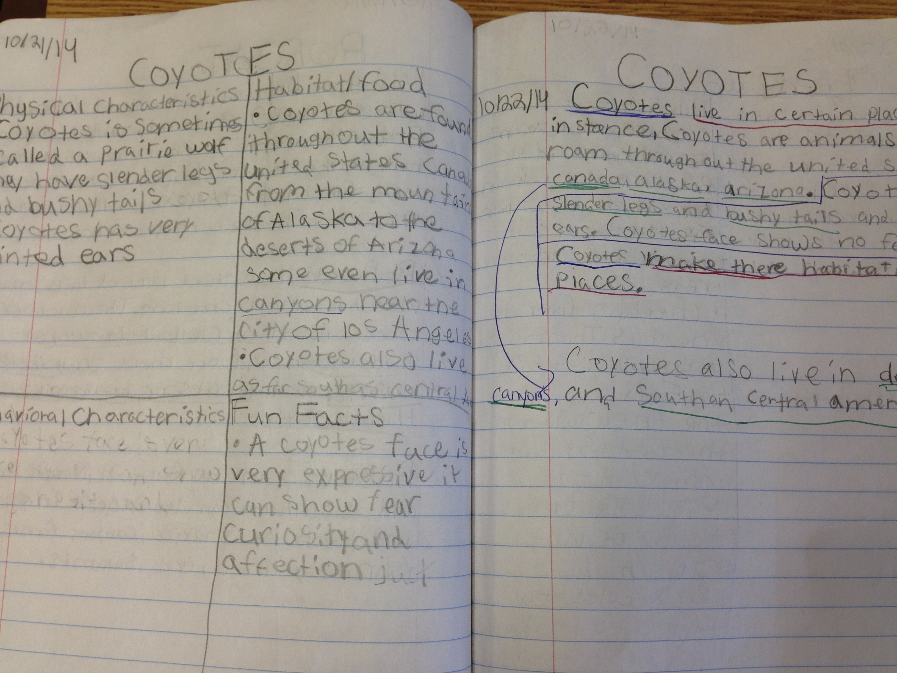
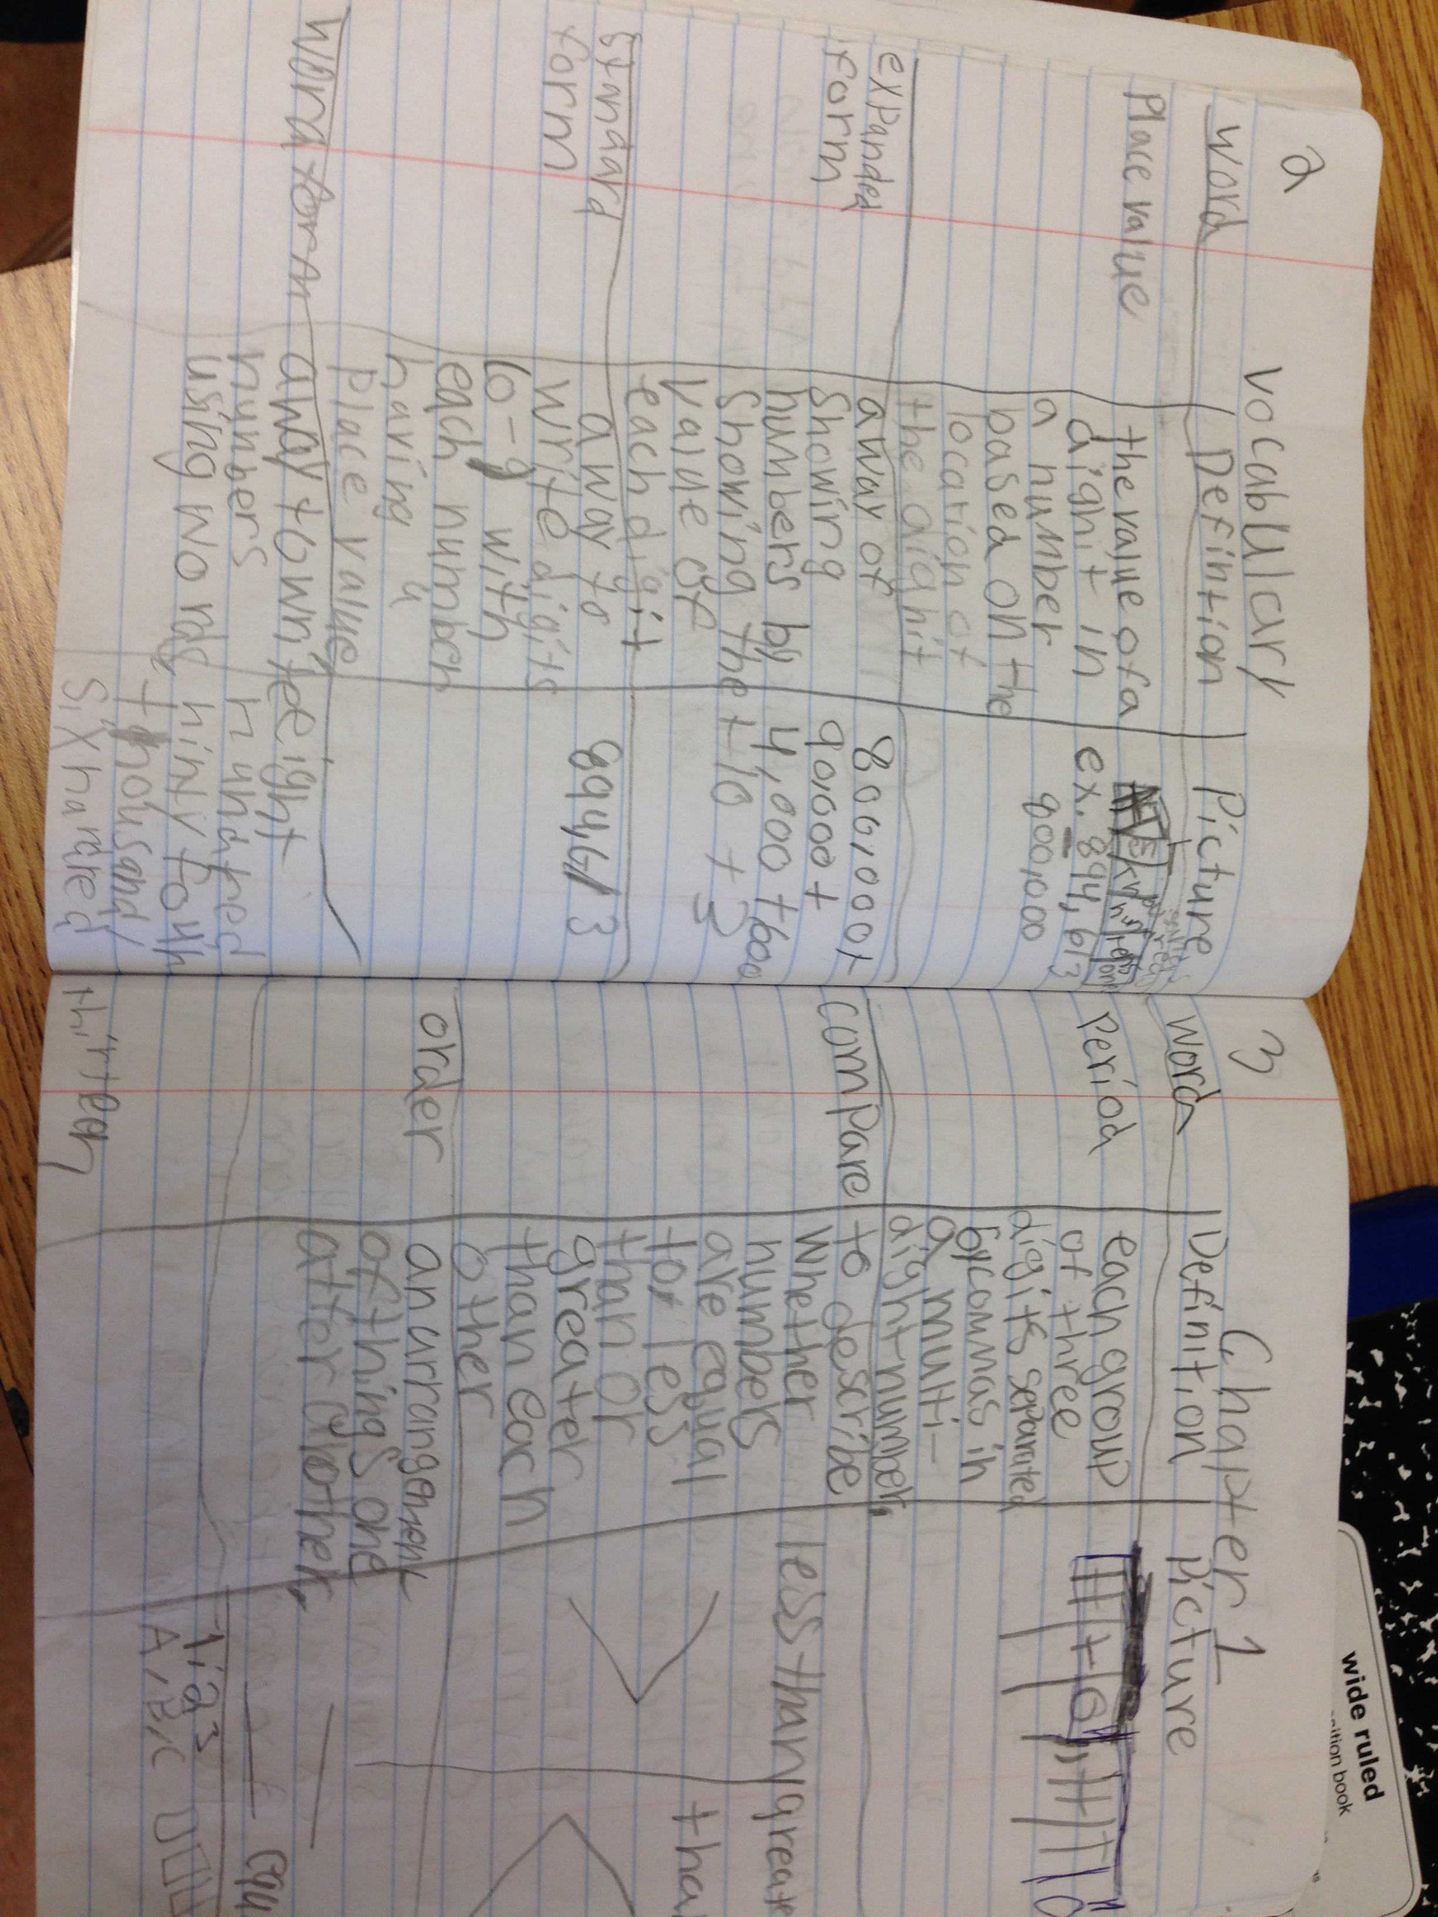
I have really enjoyed getting into the schools, seeing the kids, and working with the teachers and leadership teams! We have amazing things happening in Pinellas County. During the next two busy months I will be available for Data Chats, Site Plans, and Coaching Sessions. The Coaching Sessions have been going really well, and I can’t wait to hear how the lessons went. If you have questions about what the coaching model looks like let me know!

Highlights

Here are a few of the highlights that I have seen around the schools!
Complete college going culture from Pre –K through 5th Grade at Sandy Lane! From College Binders to College Claps these kids believe that they are going to college!
Amazing One-Pagers at Pinellas Central! The students are owning and showing their thinking with well thought out One-Pagers.
Organization galore at New Heights! With amazing notes, planners, and a color-coded system the students know exactly where everything is.
Look for the pictures throughout the newsletter.
This is the student data collected by the teacher.
11/21/14
Use the CSS document to determine where you think your school will be in the spring.

Pinellas AVID-E
  - District Director Kerrale Prince * princeke@pcsb.org * 588-6438 * cell – 455-2944

Site Visits

Save the Date!
Your DMT will be able to pull this information quickly.
11/21/14
On Site Visit

ISS Data

Student Data

Site Data
November/December 2014

Complete the ISS Data and upload into MyAVID (see data email)

Complete the School Data and upload into MyAVID (see data email)

Re-vist Site Priorities and Grade Level Priorities: Where have you made gains, and where do you have areas to grow as a school in your implementation?

Site Team Meetings

What is your AVID Strategy for instruction this month?

Ideas: Note Taking, One-Pagers, Collaborative Structures, or Reading Strategies?

Plan an AVID Family Night!

Ideas are in the Administration and Foundations Book. Combine these with a PTA night!!

What is your college going culture focus this month?

Ideas: College Binders, Middle School or High School presenters (work with your feeder programs AVID class), Dreams and Goals posters, Staff College Posters

Site Priorities November/ December
Set-up Notes – Name, Date, Title, Format
Take Notes – Write facts and details, Use abbreviations, Use drawings and color, Skip lines for organization and corrections
Add to Notes – Make clarifications, Work with Study Buddy or Round Robin, Highlight, Add visuals
Review Notes – Reflection summaries, Study sessions, Ask questions

Why STAR Note-Taking? STAR allows students to not only create the notes, but then to use them. The AR portion of the STAR Strategy is when students are able to move information from their short-term memory to their long-term memory. This develops life-long study habits to move our students forward in their thinking.

STAR Note-Taking Strategy
The Why and What!
Note-taking is a vital skill that our students need to be able to accomplish during their academic career. This is also a skill that integrates into every content area. The note-taking used in the AVID Elementary classroom is two-column and three-column formats that are the beginning steps to Cornell Notes. Cornell Notes is the system of note-taking that is used in all Pinellas County secondary schools. The better the note-taking skills are the more a student will understand, be able to retain information, and reach success!
Process Over Format!
In AVID we realize that the process is more important than the format. The format we teach is adaptable as needed. With two-column notes the main ideas are on the left side and the details and evidence are on the right side. With three-column notes the first two columns are the same. The third column can represent a visual, question, or example problem. The three-column format is a great way to differentiate for our ELL and ESE students. All notes should include reflective summaries at the end that show the students thinking and learning.

Curriculum Focus: AVID Note-Taking

One-on-One Coaching with a teacher, grade-level team, or administrative team
The focus will be on data chats, increasing evidence of AVID, and building culture. This is ongoing and as needed. I’m here to help!

Site Team Meeting Coaching: If you would like me to attend the site team meetings to be a part of the collaborative process please let me know.

AVID Overview:
Offered throughout the year as needed. Target Audience – The entire instructional staff of an AVID school that has not had the opportunity to attend AVID Summer Institute. Duration: 2 Hours
Content: What is AVID, why AVID, and how to implement with ease? We will discuss how using AVID methodologies matches the Marzano Evaluation, the Pinellas County Content, and the Florida State Standards expectations.

These trainings can be during the day, or after school. The idea is to have these trainings work similar to a lesson study. Target Audience: Grade level teams and coaches if available Duration: 2 – 3 hours with a survey follow-up.

I completed the WICOR training with a few schools using the ELA Modules for 4th and 5th during ½ day PLC’s and that seemed to work really well.

Increasing Rigor through WICOR
Lesson study focused on effective lesson planning that is student centered. We will incorporate WICOR into the current content modules in order to increase rigor, student achievement, and teacher effectiveness.
The grade level will choose the content area module they would like to work with.

AVID Elementary Weekly
How to integrate AVID Elementary Weekly into the literacy block? The lessons created by AVID Weekly are researched based and aligned to the Florida State Standards.
The lesson study focus will be ELA based.

Using Student Success Skills to Increase Student Achievement
Giving students ownership of their learning through incorporating collaborative structures, and learning styles into our lessons. What makes a successful student?
The grade level will choose the content area module they would like to work with.

Inquiry Defined! Using inquiry to allow students to show their thinking
Focusing on effective questioning we will plan specific strategies to increase the level of questioning used by students in a lesson.
The grade level will choose either a math or science module they would like to work with..

Creating a College Going Culture
We will work on how to create a college going culture in a classroom and school through visuals, lessons, and a common language.

Professional Development/ Coaching Opportunities
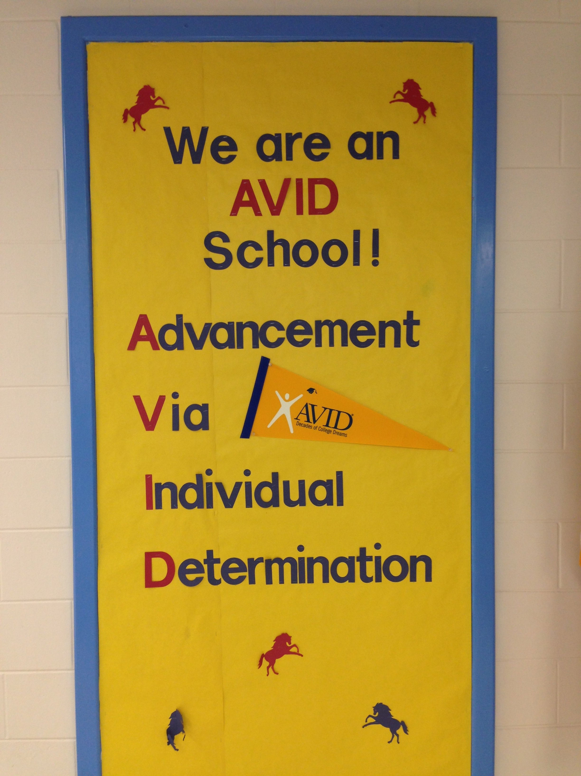
Next Steps:

Schedule any of the following with me for the next two months.
I look forward to supporting you and moving AVID forward
at your schools.
- School Visit and Walkthrough
- Coaching Visit either Team Level or Individual
- Professional Development for the Whole Staff
- Family Nights
- Data Chats
- Site Team Meetings

Upload ISS and School Data to avid.org within MyAVID

Collect Evidence for the CSS Document – Student Samples, Pictures, Walkthrough Forms, Site Team Meeting Minutes
AVID Showcase at Three Points Elementary: November 11 http://www.avid.org/contact-us--eastern.ashx#Showcase

AVID National Conference: December 11 – 13 in Orlando http://www.avid.org/2014-avid-national-conference-.ashx

AVID Foundations PATH Training: January 12 – 13 in Orlando
http://www.avid.org/dl/events/path_20150112.pdf

Upcoming Events
Winter 2016

