



Seminole Elementary Times

Upcoming Events DECEMBER
1st
- PTA General Meeting 5:15pm
- SEM Showcase Night 5:30-7:30pm
5th
- Culver’s Spirit Night 3-8pm
6th
- Winter Concert K-6pm, 1st 6:30, Chorus 7pm @ Seminole High
9th
- Last day for Shoe Drive
11th
- Seminole Lights Parade 6:15pm

14th
- Character Kids Assembly 8:35am PE Court
16th
- Last Day to Order EPIC Cards
- Grading Period Ends

19th - 30th
- Winter Break No School

JANUARY
3rd
- Students Return

WEEKLY EVENTS
Extended Learning Program
Monday & Wednesdays 2:40-3:40pm

STEM Club
Tuesdays 2:40-4:00pm

SEM Enrichment Clusters
Fridays 8:45-9:45am

Good News Club
Thursdays 2:40- 4:00pm

Mad Science
Thursdays 2:40

A Note from Your Principal Mrs. Grasso
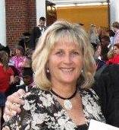
News from the Principal:
Dear Seminole Elementary families,

I hope you had a wonderful Thanksgiving week and are now anxiously anticipating the upcoming winter holidays. It is hard to believe that 2017 will be here by the end of the month!

What a joy it has been watching the students grow, learn and mature! As I reviewed each report card I am pleased to say that Seminole Elementary has a large population of smart and capable students! Your interest in education and encouragement is very important regarding your child’s attitude towards school; the more interested and enthused you are in what they are learning the more eager your child will be to study, read and do their best!

I have one reminder regarding safety and that is “drop offs” in the morning. There should not be students on campus before 8:05 unless they are enrolled in the R’Club program. We have seen a steady increase of students in front of the Centennial Building as well as those dropped off in the car circle before 8:00. This is not safe; we do not have personnel available for supervision at this time. Students have been playing tag games and getting hurt; please help your child with arrival times –coming in between 8:05-8:15; this gives plenty of time for eating breakfast and morning prep in the classroom. Thank you for your support. One other reminder is in regards to student cell phones, they must be turned off and put away during the school day. No texting or picture taking is permitted. Thank you for understanding and your support with that also.

Please take time this season to rest and enjoy family moments and friendships. Peace, love and Happy New Year to all!

Mrs. Grasso

Kiwanis Donates to Seminole ES
Members of Kiwanis presents check to Principal Grasso for student and classroom needs.
Congratulations to Mrs. Carlson
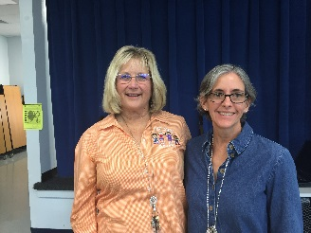
Mrs. Carlson is Seminole Elementary’s
2016-17 Teacher of the Year.

Shoe Donations

Now – December 9th

Donate your gently worn or new shoes. Bins are available in the office and by the cafeteria sidewalk.
Our school will receive $.25 per pound. More information coming.

Principal List Bowlers

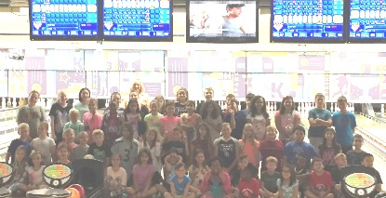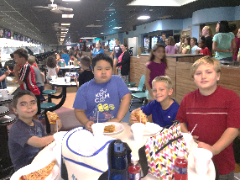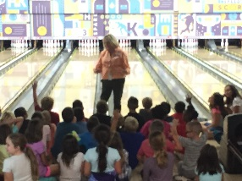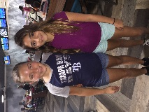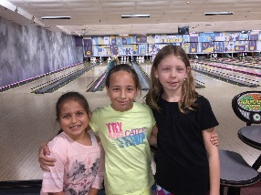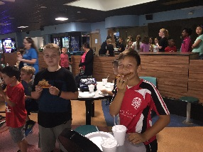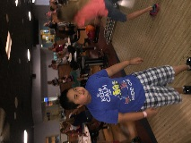

Culver’s Spirit Night

Join us Monday December 5, 2016
From 3pm – 8pm

Culvers
10425 Park Blvd
Come have dinner while spending time with our school family & having fun.

Part of proceeds will go to our school

Page 1 December 2016 ● Issue 4 ● Seminole Elementary Times ● (727)547-7668

Character Kids – November

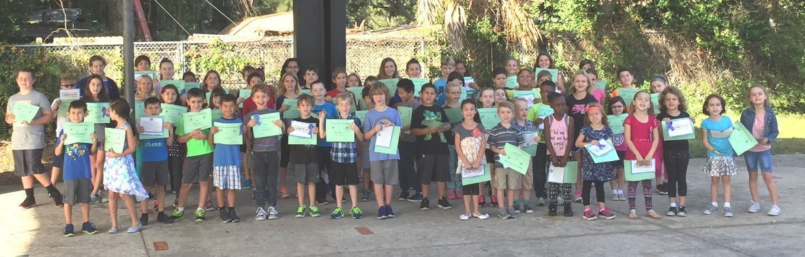

Family Fitness News You Can Use
From the Seminole Elementary PE Department

How Can Families be Healthier?

Involving the whole family is the best way to promote better eating habits and healthy activities for your kids.
A whole-family appraoch simply means that everyone – parents and kids alike – work together as a team to achieve good health and well being. As with any team, there’s a leader or coach – and that’s you!

Lead by example. Adult family members are important role models for healthy eating and exercise. Talk about why you eat fruit as a snack, take an exercise class, or go for walks.

Start ‘em young. Don’t wait until your child is at an unhealthy weight to institute good eating and activity habits. It’s much easier to maintain a healthier weith than to lose pounds later.

Be active together. Make it usual for the family to be active, not sedentary. Being active as a family allows kids to expend energy in a positive way, and adults get the healthy benefits too.

Cook together.It may not be possible to do everyday, but invite kids into the process of preparing food. Little kids can learn math skills by measuring and they’ll begin to understand the chemistry of cooking. They’ll also gain an understanding of healthy ingredients.
Older kids will enjoy having the authority to choose and prepare foods they like and will be more likely yo eat what they’ve made. It might inspitre them to make healthy choices on their own.

Eating together. Eating a meal as a family sends the right message about nutrition. Kids will see their parents eating healthy food and may want to try new foods. They’ll alson see mealtime as a time for socializing and sharing. Parents get a chance to offer nutritious food, note their kids likes and dislikes, and talk about daily triumphs and troubles.
Dinner Dilemmas
Decembers Word of the Month is Kindness. Kindness is being nice and considerate to others
Purpose: To create family discussions that promotes Character Education in Pinellas County.
Dinner Dilemmas are designed to go home once a month with the students. Schools that send home a weekly newsletter could print one dilemma each week in its publication. During the week families are asked to discuss the dilemma. It is hoped that families will talk about the dilemma and decide how the character quality of the month relates to the situation presented. It is further hoped that families will discuss the dilemma of the week and decide how the character quality of the month applies to each family member.
Week 1
Situation: A new student from a foreign country has difficulty speaking and understanding English. Sue notices the girl sits by herself at lunch.
Dilemma: On one hand Sue knows a kind person would sit with the new student. On the other hand Sue wants to sit with her friends.
Discussion: What advice do you have for Sue?
Week 2
Situation: Sam is given a partner that is a slow runner for Field Day. Even through Sam is the fastest runner at his school his team did not win the race. Some classmates tease Sam because his team lost.
Dilemma: On one hand Sam could blame his teammate for the loss. On the other hand Sam could be kind and praise his teammate for trying his best.
Discussion: What should Sam say and do?
Week 3
Situation: A substitute teacher cannot find the spelling book for the spelling test. She is looking all over the room for the book.
Dilemma: On one hand Sue knows it would be kind to help the substitute find the book. On the other hand Sue knows it would be easier to just sit and talk with her friends.
Discussion: What advice do you have for Sue?
Week 4
Situation: Sam mother’s sends him to the grocery store. She told him to hurry. While in the checkout line Sam notices the man behind him had only one item—ice cream.
Dilemma: On one hand Sam knows his mother told him to hurry. On the other hand it would be kind of Sam to allow the man to go ahead of him.
Discussion: What advice do you have for Sam?
3rd
Barto | Carmella Adams | Madison Dunn
Carlson | Balazs Tar | Bryanna Badillo
Poolson | Brendon Gavigan | Tyger Landt
Rudolph | Ari Hovespian | Aryannna Badillo
Kopkau | Zachary Berry | Shannon Smith
Kappler | Mason Chiarini | Zackery Peacoe
Fugate | Isiah Thomas
4th
Taylor | Neveah Bates | Ian Hernandez
Swartz | Kersten Davis | McKenna Cote
Crose | Brandon Lucas | Leslie Finck
Arnold | Aiden Arcidiacono | Dallas Burke
Leonard | Lily Sills | Richard Rollins
5th
Henkel | Jamie Sisk | Kelvin Franklin
Grimm | Isabella Kuhn | Olivia Amerine
Lentz | Aidan Reagle | Angelena Markova
Sadock | Hailey Hession | Austin Martinez
Tripp | Kailee Vanover | Charles Worth

PreK
Green/Piper | Owen Stancill | Sophia Mlynarski
KG
Horton | Carson Blakey | Bella Rodriquez
Conde | Sophia Leili | Lailah Johnson
Schuler | Zachary Petrouchtchak | Alexis Fontaine
Davis | Addisyn Houck | Jaylynn Huntoon
Fellows | Honesty Edwards
1st
Flock | Kaydin Whitenton | Kymani McMurray
Dupre | Chelsey Keim | Eleazar Torres
Ellis | Neveah Middleton | Jaxsen Blair
Gamble | Benjamin Dyer | Collin Holton
Guglielmo | Skylar Eagle
2nd
Luczaj | Eli Spearl | Aiden Lopez
Gorman | Gabrielle Nemethy | Jaylen Tarrance
Patterson | Zachary Toth | Derek Soto
Mucerino | Jayden Roche | Emily Huntoon
Smith | Amanda Fuentes-Hernandez | Charlie Winnemore
Blanchet | Carl Loudermilk | Jackie Weng

Page 2 December 2016 ● Issue 4 ● Seminole Elementary Times ● (727)547-7668

VFW Memorial Salute

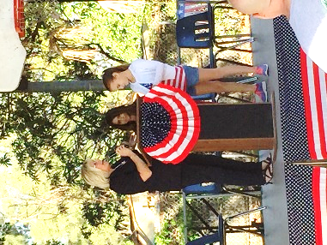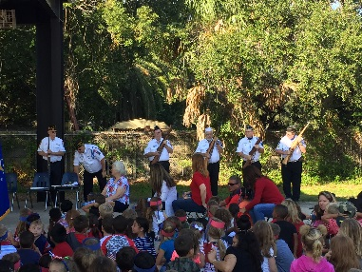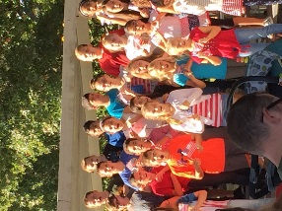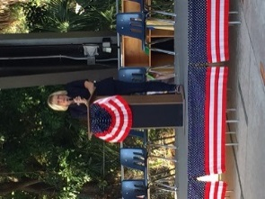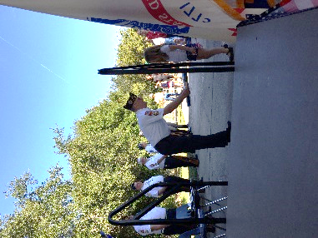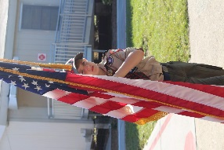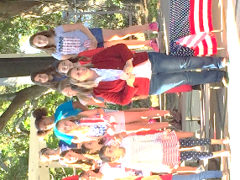
Great American Teach In
Thank you to our Great American Teach-In Speakers! Our students had such a great day!
Mr. Berry, Publix 1320, Mr. Vernon YATES, Ms. Tubbs, Donna C., Russell Douton, Melissa Mari, Lynne Wolf, Maura Scanlon, Mr. Widlansky, Mr. Stokes, Sarah Krieger, OHS Taekwondo, Authentic Martial Arts, Traditional Taekwondo, Bradley Patrick, Fire Station 29, Mr. Mancuso, Mr. Nguyen, Ms. Adams, Nina Sweet, Officer Festa, Michelle Carnahan, Clearwater Marine Aquarium, Mrs. C., Officer Sherri Evans, SPCA, Mr. Moriarty, SPC Nurses, Officer Dimundo, Seminole Starbucks, Seabird Sanctuary, Mr. Rollins, Mr. Corbin, Bark Life, Mr. Martin, Ms. Torres
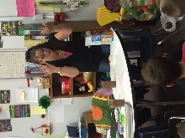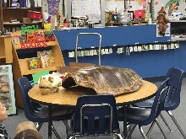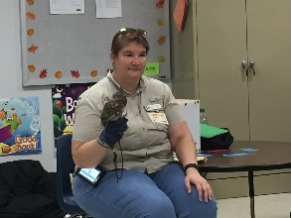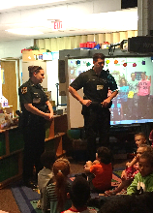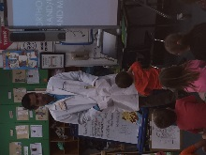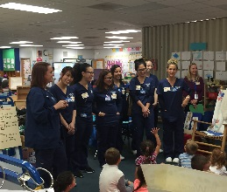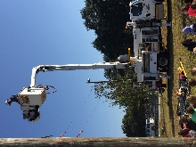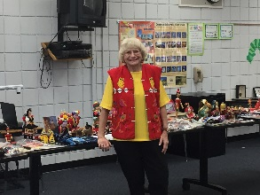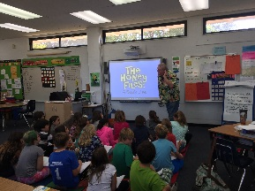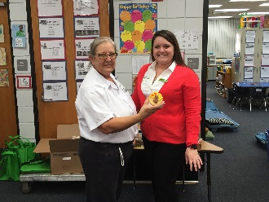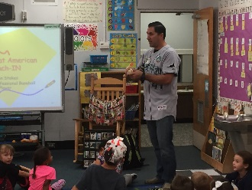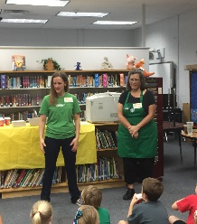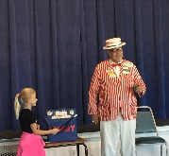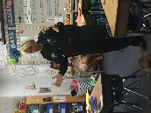
2016 Annual Holiday Lane Market Place FAMILY NIGHT

Location: Palm Way Campus, Building C 1614 Palm Way, Largo FL 33771
Open: Tuesday, December 13, 2016 6:00 – 7:30 PM

Holiday Lane Market Place will be available to all families in need, who are not already enrolled in a holiday giving program. Families do not have to be a PEMHS client to shop at the Market Place. New & gently used items will be available while supplies last.

•Visit with Santa and Mrs. Clause •Holiday Movies
•Enjoy Hot Chocolate & Cookies •Children’s activities
***Wrapping Paper, tape, and gift tags will be available to wrap & personalize your gifts whilesupplies last.
Agency Questions call PEMHS FSI System Navigation at (727) 362- 4289
Or email ccovington@pemhs.org


4th Grade St. Augustine Field Trip
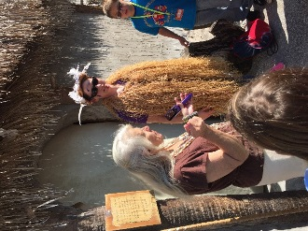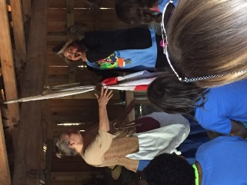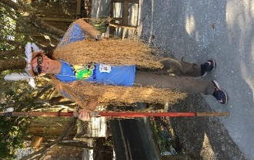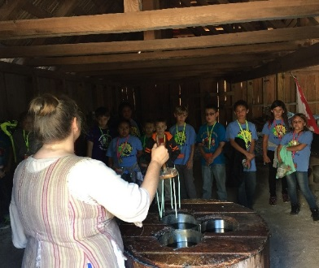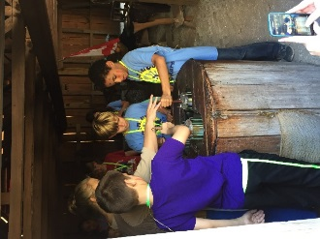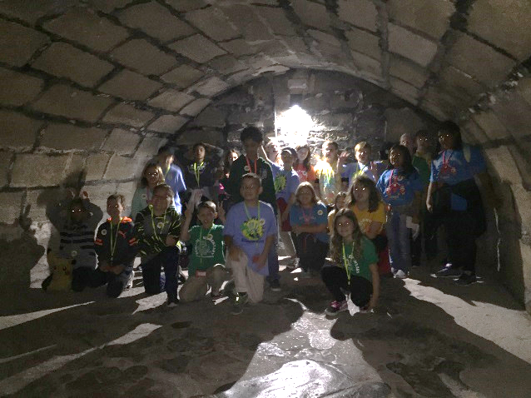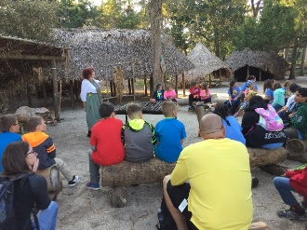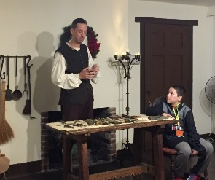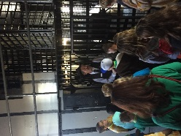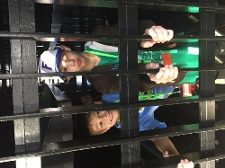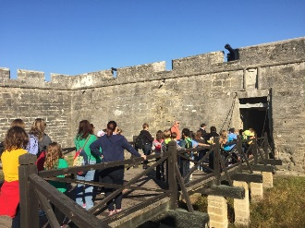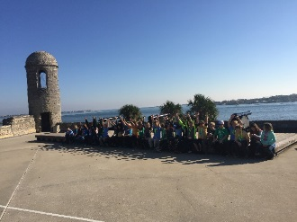
More Info

Page 3 December 2016 ● Issue 4 ● Seminole Elementary Times ● (727)547-7668

DECEMBER PINELLAS COUNTY SCHOOLS - MENU
Monday | Tuesday | Wednesday | Thursday | Friday
 |  |  | 1 Apple Cinnamon Texas Toast  Choose One:  Chicken & Dutch Waffle Grilled Cheese Chicken Cobb Salad Chicken Caesar Wrap Choose:  Tomato Soup Mixed or Tossed Side Salad  Choose:  Broccoli, Veggie Dippers | 2 Pancake Pup  Choose One:  Pizza  Potato Crusted Fish Sticks & Corn Muffin Loaf  Chicken Popper Salad  Italian Sub  Choose: Green Beans  Veggie Dippers
5 Sausage Gravy Bagel  Choose One:  Max Stix  Mandarin Orange Chicken Bowl w/Roll  Chef Salad  Turkey & Cheese Hoagie  Choose: Marinara Cup  Stir Fry Vegetables  Veggie Dippers | 6 Maple Pancake Minis  School Favorite Day  Choose One:  Hot Dog on Bun  Bean Burrito  Jamwich Kit, Chef Salad  Choose: Curly Fries, Romaine Salad | 7 Chicken Biscuit  Choose One:  Chicken Drumstick w/Hush Puppy  Macaroni & Cheese  Yogurt Parfait  Ham & Cheese Croissant  Choose:  Sweet Potato Waffle Fries  Sliced Cucumbers | 8 Apple Bosco Stick  Choose One:  Beef or Pork Tacos  Mini Calzones  Farmer’s Salad  Chicken Caesar Wrap  Choose: Marinara Cup  Refried Fiesta Beans  Mixed or Tossed Side Salad | 9 Egg & Cheese Croissant  Choose One:  Pizza  Fish Cake w/Cheese Sandwich  Chicken Caesar Salad  Italian Sub  Choose:  Spinach or Collard Greens  Veggie Dippers
12 Banana Pancakes Minis  Choose One:  Hamburger or Cheeseburger on a Bun  Turkey Pot Roast & Noodles w/ Roll  Veggie Double Dipper Salad  Turkey & Cheese Hoagie  Choose:  Corn  Veggie Dippers | 13 Sausage Biscuit  Choose One:  ►Holiday Meal ◄  ♦ Herb Roasted Chicken w/Roll ♦ ♦ Bell Cookie ♦  Pepperoni Stromboli  Farmer’s Salad •  Jamwich Kit  Choose :  Mashed Potato w/Gravy Green Beans • Marinara Cup Romaine Side Salad | 14 Glazed WG Dunker  Choose One:  Chicken Nuggets  Spaghetti & Meatballs  Hummus Salad Plate  Ham & Cheese Croissant  Choose:  Broccoli  Sliced Cucumbers | 15 Bacon, Egg & Cheese Pizza  Choose One:  Breakfast for Lunch  Giorgio Cheesy Bread  Chef Salad  Chicken Caesar Wrap Choose:  Marinara Cup Deli Roasted Potatoes  Mixed or Tossed Side Salad | 16 Apple Cinnamon Sausage Stick  Choose One:  Pizza  Ocean Treasure Fish Nuggets  Chicken Caesar Salad  Italian Sub  Choose:  Oven Baked Beans  Veggie Dippers

December 2016 ● Issue 4 ● Seminole Elementary Times ● (727)547-7668

Page 4

A special message from our family

THANK YOU BUSINESS PARTNERS FOR
OUR REPORT CARD INCENTIVES


Smugglers Cove Astro Skate


McDonalds Buffalo Wild Wings


Chick-Fil-A Splash Harbour


Culver’s Authentic Matial Arts


Texas Roadhouse Treasure Island Fun Center

Thank You for Supporting Our School:
We would like to thank:
Authentic Martial Arts
Seminole Chamber of Commerce,
Seminole VFW post 9272,
Barnhorn Financial,
Bay Pines Dunkin Donuts,
The Courtney Apartments Staff,
Scott Strohbhar,
St. Anne’s Episcopal Church,
First Baptist Church of Indian Rocks
Entemann’s Bakery
For all of your generous donations of school supplies!

Thank you for an awesome Spirit Night!
Thank you to our business partners for your hospitality and to our family and friends that came out to support our school!

McDonald’s

Dairy Queen
Astro Skate

Treasure Island Fun Center

Thank you for Adopting
Our Classes
Dogfish Tackle Co,
Juan LI,
Michael and Sarah Fisher
Servi-Stat LLC
Bayou Family Dental Inc.
Will and Bonnie Lloyd,


Largo Target,
Priority Welding,
The Belcaster Family
Eagle Crest Reality Inc.
Grade Power Learning

Seminole Elementary
10950 74th Ave N
Seminole, FL 33772
Phone: (727)547-7668
Fax: (727)547-7668
Web Site:
www.pcsb.org/seminole-es

Nanette Grasso Principal
Reva Faust Assistant Principal

Robert Poth Area III Superintendent, (727)588-5020

