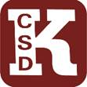
Secondary Assessment Calendar 2025-2026
Kingston High School
Date | Assessment | Grade
Ongoing | Locally Developed Common Assessments | 9-12
March 9-June 5 | New York State Alternative Assessment | 9-12
Fall SAT 10/9/25  Spring 3/2026 | SAT Fall (Seniors only)  SAT Spring (Juniors and Seniors) | 11-12
10/16/25 | PSAT Fall Only | 10-11
January 20-23 | January Regents | 9-12
TBD | ASVAB | 10-12
April 6 – May 22 | NYSESLAT Speaking (ENL students only) | 9-12
May 4 - 22 | NYSESLAT Reading/Writing/Listening (ENL students only) | 9-12
May 4—May 15,  May 19 (pm) May 20 (pm) | AP Exams | 11-12
June 9, 10, June 17-25 | June Regents | 8-12
June 16 AM | Spanish Checkpoint A | 8-9
June 22 AM | Spanish Checkpoint B | 10-12
August 18-19 | August Regents | 9-12
7/2025
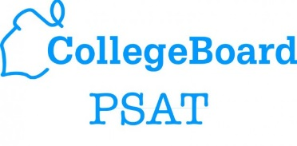
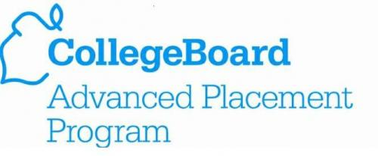
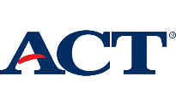
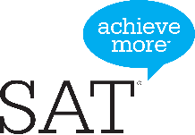
Select the images below for more information:

