

265 Peninsula Blvd, Hempstead, New York 11550

Parent Handbook
2025-2026

Keesha Keller, Principal
Jaelle Mann-Tineo, Assistant Principal

Prospect is an IB World School for the International Baccalaureate (IB) Primary Years Program. IB World Schools share a common philosophy—a commitment to improve the teaching and learning of a diverse and inclusive community of students by delivering challenging, high-quality programs of international education that share a powerful vision.



Dear Parent(s) and/or Guardian(s),
We want to welcome you and your child to Prospect Elementary School. We look forward to an exciting year of new experiences and lots of fun! It is during the first years of life that children form attitudes about themselves, others, and the environment. These attitudes last a lifetime, so we work very hard to find ways to help children develop positive attitudes. Educating a child is most successful when families and schools work together in the best interests of the child.
At Prospect School we house Prekindergarten and Kindergarten students. The goal of our program is to meet your child's needs not only intellectually, but also physically, socially, and emotionally. Going to school is one of the most important experiences in a child’s life. School can be an exciting place where children meet new and different people and participate in many new and different experiences. We promise to work diligently to provide the children with wonderful experiences that help them feel good about themselves and their school.
Best wishes for a productive and enriching school year.

Educationally Yours,
Keesha Keller, Principal
Jaelle Mann-Tineo, Assistant Principal

Welcome to Prospect Elementary School
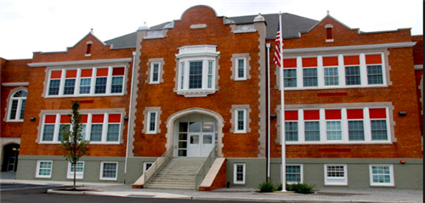

265 Peninsula Blvd
Hempstead, New York 11550
(516) 434-4700

Our Mission
Prospect School inspires students to become lifelong inquirers who are globally minded. We create experiences that empower students to express their unique voices, develop a sense of community, and appreciate diverse cultures.

Our Vision
Prospect School aims to provide developmentally appropriate learning experiences by making learning interactive, exploratory, and fun. We will integrate differentiated approaches to teaching and learning using multi-dimensional resources. Prospect School will maintain a home school connection to recognize and celebrate the uniqueness of every child. We will promote social awareness and global citizenship.

What is the Mission of IB?
The International Baccalaureate Primary Years Program aims to develop inquiring, knowledgeable and caring young people who help to create a better and more peaceful world through intercultural understanding and respect. To this end, the organization works with schools, governments, and international organizations to develop challenging programs of international education and rigorous assessment. These programs encourage students across the world to become active, compassionate, and lifelong learners who understand that other people, with their differences, can also be right.

Prospect School
Student Pledge

P - We are Principled
R - We are Reflective
O - We are Open-minded
S - We are Smart
P - We are Partners
E - We are Enthusiastic Learners
C - We are Caring
T - We are Thinkers who are Globally Minded


WE ARE PROSPECT SCHOOL!

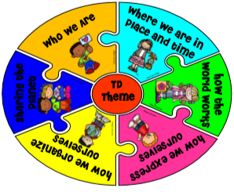

As of May 26, 2021, Prospect School is proud to be an authorized International Baccalaureate (IB) World School for Primary Years Program (PYP). We are the first authorized PYP school in Nassau County and are part of a larger network of over 1,700 PYP schools in 109 countries.

What Does IB PYP Look Like at Prospect School?

In the classroom/school:
- Essential agreements and a sense of community
- Students engaged in inquiry based learning and hands-on activities
- Teachers collaborating and sharing best practices
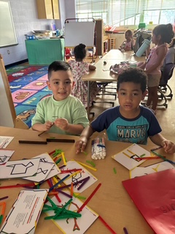
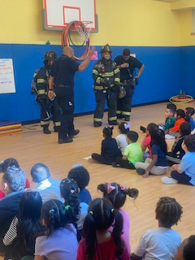
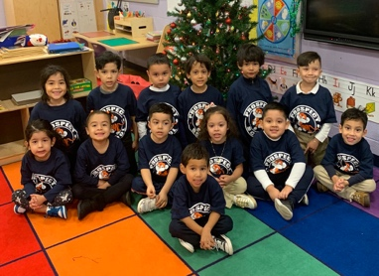

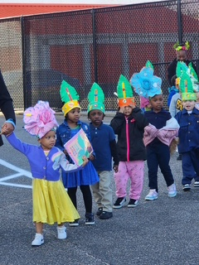
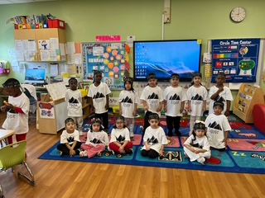
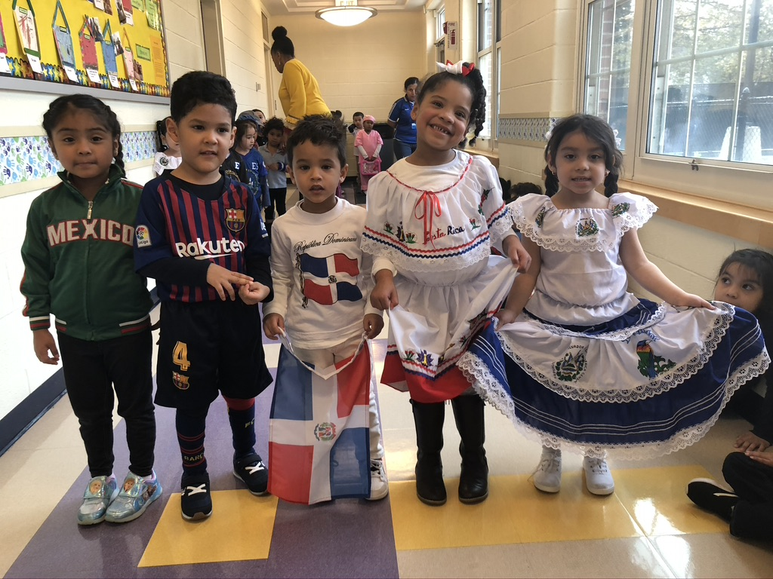

In the community:
- Active, compassionate, life-long learners who understand that other people, with their differences, can also be right
- Members taking action to make their communities a better place to live for all

Contact Ms. Rhonda Chung, IB Coach for more information - rchung@hempsteadschools.org

How will students learn?
Students engage in IB transdisciplinary themes each year for several weeks at a time (please refer to our school’s Program of Inquiry on our website). Early learners engage in units of inquiry driven by a central idea. Throughout each unit, students are guided to inquire and explore the central idea through key concepts, approaches to learning skills and the learner profile attributes.
Themes:
Who we are: Inquiry into the nature of the self; beliefs and values; personal, physical, mental, social, and spiritual health; human relationships including families, friends, communities, and cultures; rights and responsibilities; what it means to be human
How we express ourselves: Inquiry into the ways in which we discover and express ideas, feelings, nature, culture, beliefs, and values; the ways in which we reflect on, extend, and enjoy our creativity; our appreciation of the aesthetic
How the world works: Inquiry into the natural world and its laws; the interaction between the natural world (physical and biological) and human societies; how humans use their understanding of scientific principles; the impact of scientific and technological advances on society and on the environment
How we organize ourselves: Inquiry into the interconnectedness of human-made systems and communities; the structure and function of organizations; societal decision-making; economic activities and their impact on humankind and the environment
Sharing the Planet: Inquiry into rights and responsibilities in the struggle to share finite resources with other people and other living things; communities and the relationship within and between them; access to equal opportunities; peace and conflict resolution
Where We are in Place and Time: Inquiry into orientation in place and time; personal histories; home and journeys; the discoveries, explorations, and migrations of humankind; the relationship between and the interconnectedness of individuals and civilizations, from local and global perspectives

IB learners strive to be globally minded through the learner's profile attributes.

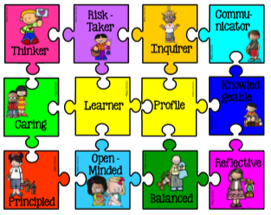
Inquirers Open-Minded
Knowledgeable Caring
Thinkers Risk-taker
Communicator Balanced
Principled Reflective

IB learners use Key Concepts to engage in higher order thinking and apply their understanding of what they learn across the curriculum and culture.

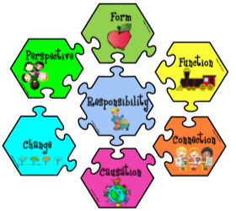
Form – What is it like?
Function – How does it work?
Causation – Why is it like this?
Change – How is it changing?
Responsibility – What is our responsibility?
Connection – How is it connected to other things?
Perspective – What are the points of view?

IB learners us Approaches to Learning Skills to learn independently and with others.
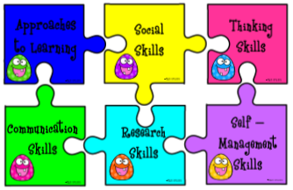
Social Skills – I care. I can take turns.
Self-Management Skills – I finish my work on time.
Thinking Skills – I think about my learning.
Communication Skills – I share my ideas.
Research Skills – I ask questions.

Prospect School Telephone Directory:

Main Office: 516-434-4702
Assistant Principal: 516-434-4703
Nurse’s Office: 516-434-4705
Attendance Office: 516-434-4706
School Social Worker: 516-434-4707
Psychologist: 516-434-4713

Stay in Touch through our School Website:

From the Hempstead Public School Website
www.hempsteadschools.org
Click on Schools (a drop-down menu will appear)
Select Prospect School
You can access:
Parent Announcements
IB PYP
Learning Resources
School Calendar / Monthly Highlights
Academic Links


Instructional Teams
Pre-Kindergarten – Ms. Gedeon, Ms. Frank, Ms. Hodish, Mrs. Hoppe, Mrs. Lentini, Mrs. Lewis-Mency, Mrs. Gioia, Mrs. Krug, Mrs. Levy, Ms. Norris
Kindergarten – Mrs. Lanzer, Ms. Pugliese, Ms. Timmerman, Mrs. Whitfield, Mrs. Valentine, Ms. Cullum, Ms. Hauser, Mrs. Walker
ENL- Mrs. Bayat, Mrs. Horowitz, Mrs. Escobar, Ms. Qazi Speech - Ms. Nuesi and Ms. Browne
AIS (PreK) - Mrs. Wilson-McNeal and Mrs. Ronan AIS (K) – Mrs. Maldonaldo
Art - Ms. Geyer Music - Ms. Livingston Physical Education - Mrs. Sicurella
IB Inquiry (Media) - Ms. Tortora IB Instructional Coach – Ms. Chung

Support Staff
Social Worker - Mrs. Wilkins-Walker Resource Room - Mrs. Truncale

Building Security
Building security is extremely important at Prospect School. Many precautions are taken to make our schools as safe as possible. We are a locked campus. All doors are locked after school begins. All visitors must present valid identification upon arrival. Students will only be dismissed to an authorized ADULT who possesses valid identification and is listed on the dismissal form. Any meetings with staff members must have an appointment. To make an appointment, please call the main office.
Birthday Party Protocol Classroom parties
Birthday celebrations do not need to have food as a focus, just fun! Ideas for food-free birthday celebrations for the birthday child:
❖ Parents can send in stickers, birthday pencils ❖ The birthday boy or girl can be the teacher’s “assistant” for the day, have a celebration dance, extra recess time, or have students create arts and crafts projects to bring home to their families, (birthday banner or birthday cards) ❖ Select a book to donate to the library ❖ Choose the game classmates play at recess ❖ Wear a special button for the day ❖ Invite a special visitor to the class to read a story to classmates ❖ Eat lunch with a friend and a teacher in the cafeteria ❖ Place the child’s name and picture in the front of the book donated by the birthday child ❖ Announce the birthday child’s name over the school PA system during morning announcements ❖ Announce the birthday child’s name in the classroom during lunch and everyone sings “Happy Birthday To You” ❖ Have classmates design and decorate a birthday crown to be worn by the birthday child ❖ Have classmates prepare a page about the birthday child; teacher compiles pages and then reads “book” to the class.

Cellphone Policy
Policy 5695: Students and Personal Electronic Devices
In alignment with new guidance from Governor Kathy Hochul and New York State’s commitment to creating distraction-free learning environments, Hempstead Public Schools is proud to announce the adoption of Policy 5695-STUDENTS AND PERSONAL ELECTRONIC DEVICES. This policy will go into effect starting with the 2025-2026 school year across all Hempstead school buildings.
Policy 5695 reflects the district’s continued dedication to fostering academic excellence, promoting digital responsibility, and ensuring the safety and well-being of all scholars during the instructional day. The policy outlines clear expectations for personal electronic devices, including restrictions during classroom instruction, lunch, and transition periods unless otherwise authorized for educational purposes.
Please refrain from sending any devices or cellphones to school with your children. Any cellphone confiscated will be locked in a cellphone safe and returned at the end of the day.
Communication
At Prospect School, we communicate using ClassDojo. Please make sure you are signed up with the classroom teacher. The teacher and school will post all information on that platform. If you have any questions or concerns, you can communicate with ClassDojo.

Attendance Procedures
Students are expected to attend school every day. If your child is absent from school, you must call the attendance office at 516-434-4706 and send a note with your child upon return to school. If your child is absent from school due to an illness, a doctor's note must be provided. If a note is not provided, your child's absence will be recorded as an unexcused absence. Your child's attendance in school is very important to his or her success. If a pattern of absences occurs, an investigation will take place by the attendance teacher.

School Nurses
Our school Nurses is Ms. Alpern 516-434-4705.
Health Concerns: Please communicate in writing any medical condition or health concerns your child has to the School Nurse.
Food Concerns: Please communicate in writing any food restrictions or allergies your child has to the School Nurse.
Communicable Illness: If your child is sick or has a temperature, do not send your child to school. Please report any communicable illness your child has to the School Nurse as soon as possible. This includes, but is not limited to: Covid-19, chicken pox, scarlet fever, Fifth’s disease, ringworm, pink eye, and lice. Please review with your child the importance of good hand washing practices.


Student Arrival and Dismissal Procedures
Arrival:
Students should not arrive at the school campus before 8:00 a.m.
Students who are walkers must be escorted to the rear entrance. If your child takes the bus from your home school, please do not arrive at your home school before 8:15 a.m. Every student receives a color-coded bus tag, which corresponds to the home school. Please ensure that your son/daughter has this color-coded tag adhered to the book bag every day.

Dismissal:
Buses will arrive at home at school bus stops at about 2:45 - 3:00 pm. Please arrive 5 minutes prior to arrival time.
Walkers:
Student dismissal for walkers begins at 3:05 p.m. Parents, guardians, and daycare providers will enter the rear of the building to sign-out the students in their assigned room in the lower wing. Please note that proper identification is required to sign out a student at Prospect School. Each parent is required to complete a student dismissal form, which indicates the adults who may legally sign out a student. If you need to add a person to your dismissal form, you use the following methods: class dojo, in-person or email.
Bus Students:
Student dismissal for bus students begins at 2:30 p.m. Students will arrive to the home school about 2:45 - 3:00 p.m. Your punctuality is expected, however should you have an emergency or will be tardy in picking up your child please inform the home school as soon as possible. Students who are not picked up at the bus stop on time, will return to Prospect School.
Below are the numbers to the main office at the six elementary schools.
Barack Obama- 516-434-4402
David Paterson- 516-434-4452
Joseph A. McNeil - 516-434-4502
Jackson Main- 516-434-4652
Rhodes Academy – 516-434-4801






Specials:
Kindergarten students participate in Art, Music, IB Inquiry (Media) and Physical Education classes. The classroom teacher will inform you of the class schedule. Please remember to have your child wear athletic clothing and sneakers on days that they have physical education.
Report Cards/ Marking Periods:
Please note that there are four marking periods. Parent Teacher conferences are held three times per year; however, you may schedule an appointment to meet with your child’s teacher at any time. Please reach out to the teacher via class dojo.

Report Card Distribution | Dates | Method of Distribution
First Marking Period | November 13, 2025 | Parent Teacher Conference
Second Marking Period | February 4, 2026 | Parent Teacher Conference
Third Marking Period | May 4, 2026 | Parent Teacher Conference Elementary/Bilingual/ENL Teachers
Fourth Marking Period | June 26, 2026 | Sent home with students



Four ways parents can prepare their child for Prekindergarten

Read
Read to your child every day. Read favorite books so often that you and your child have them memorized.

Talk
Developing your child’s oral language skills is a crucial part of preparing her for preschool. Engage your child in a discussion about the world around her. Ask questions. Talk about nature, colors, letters, and feelings. Put down your phone and listen when your child talks to you. Encourage your child to make eye contact and greet others with a “Hello” and a “Goodbye.”

Play
Spend time every day on the floor playing with your children. Encourage pretend play and role playing. Get messy! Laugh and have fun together. Offer your child time to play by him or herself, giving him/her the opportunity to decide what to do.

Encourage Independence
Children who can take care of some of their personal needs do better at the beginning of preschool than children who rely on adults for everything. Make sure your child has shoes that she can put on herself. Allow extra time before you leave the house each day so that your child can put on her own shoes. Support your child in taking care of her own bathroom needs. Teach your child to wash their hands and flush the toilet to support self-help.



Skills Children Should Bring to Kindergarten
• Say first and last name
• Recognize his/her name in print
• Say birthday and age
• Recognize some letters and numbers (0-10) • Recognize and name some colors
• Count to 10
• Count five objects
• Recite the alphabet
•Communicate needs in a simple sentence
• Able to wait his/her turn and shares
• Follow two-step instructions
• Listen to others
• Attend to a story being read aloud
• Snap, zip and button jacket (and other clothing items)
• Care for toilet needs independently
• Experience drawing with crayons and pencils • Experience using scissors
• Experience playing with clay or play dough
• Bounce and catch a large ball
Helping Your Child Succeed in School
Your child is more likely to succeed in school when you . . .
Encourage reading at home by....
- Reading to your child and encouraging him/her to share books
- Asking questions about stories you have read
- Answering your child’s questions about reading and stories
- Taking your child to the public library where she/he can choose books
- Keeping books, magazines, and newspapers around the home and reading in your child’s presence
- Having a variety of children’s books in an area where your child can go and spend time with them.
- Choosing some repetitive, rhythmic books. Children enjoy them.
Guide your child in the development of socials skills by ...
- Talking about feelings such as anger and how to deal with them
- Supervising and playing games with him/her so that they have experiences dealing with rules and cooperative play
- Teaching respect for rights and property of others
- Encouraging him/her to share his/her toys or games with others


The Hempstead School District Mission – Children First
The mission of the Hempstead Union Free School District (HUFSD)
A suburban-urban culturally diverse public school system is to ensure that students achieve personal growth, academic success enabling them to compete and perform in a technological global society. Students, staff, family and community will be engaged in a comprehensive, challenging curriculum and effective instructional programs that respond to each student's needs and aspirations in a safe and nurturing environment.

