
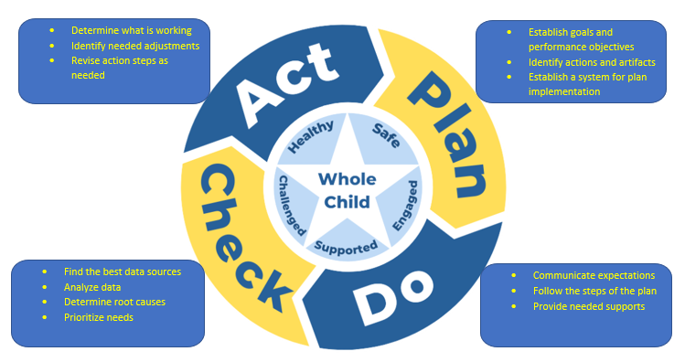

Review the current School Improvement Plan. List the main initiatives that the school is working on.
Initiatives:
- ______________________________________________________________________________
- ______________________________________________________________________________
- ______________________________________________________________________________
Review the data.
School’s current CCRPI Score __________ Last year’s CCRPI Score ________
Did CCRPI increase or decrease? Why? _____________________________________________________
_____________________________________________________________________________________
What does the school’s test scores look like? Is there any trend? Any one area of weakness that stands out? What is the school strong in? Why? __________________________________________________
_________________________________________________________________________________________________________________________________________________________________________________________________________________________________________________________________________________________________________________________________________________________________________________________________________________________________________
Do the initiatives meet the needs indicated by the data? Why or why not? ________________________
__________________________________________________________________________________________________________________________________________________________________________

