
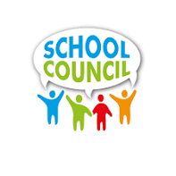
Your School’s Name
Address
City, State Zip

What do you think about our school’s homework policy? Would you like to provide? Do you have good ideas on how to get parents involved? If you are interested in making a difference in your child’s education, please sign up for our school council election.

WE NEED YOU TO SERVE ON OUR SCHOOL COUNCIL


WHAT DOES A SCHOOL COUNCIL DO?
YOUR SCHOOL COUNCIL IS A LINK TO THE COMMUNITY AND SHOULD PROVIDE RECOMMENDATIONS ON THE FOLLOWING:
- School improvementplans
- Curriculum and assessments
- Development of the school’s profile
- School budget priorities
- SCHOOL-Communication strategies
- Methods of involving parents AND COMMUNITY
- Extracurricular activities
- Any other appropriate topic involving student achievement AND SCHOOL IMPROVEMENT

____ I wish to serve as a School Council Member.

Name: _____________________________________________
Employed by: _____________________________________
Phone number: ___________________________________
Email: ______________________________________________

Your signature: ___________________________________

Please return this form to your child’s school.

School Councils help to improve student achievement

