
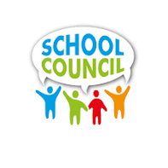

SCHOOL COUNCIL PLANNER
Richmond County School System School Council webpage:

http://www.rcboe.org/Page/8577

First Semester:
- Determine your School Council members. Remember, you must have at least 7 members – a majority of members must be parents. Required members are the Principal, 4 parents (2 of whom must be businesspersons), and 2 certified teachers.
- Make sure that all new members go through School Council training.
- Parent Flyer that you can personalize for your school.
- Set your meeting dates (the Council must meet at least 2 times per year).
- Attend any System‐wide School Council meetings that are scheduled.
- Submit your School Council Members by September 16th
- Set your agenda for the first meeting – take minutes and upload artifacts in the Canvas Course
- Upload your School Council By‐Laws to the Accountability Office by September 30th
- Set your agenda for the second meeting (timeline optional, may take place second semester) – take minutes and upload artifacts in the Canvas Course
Second Semester:

- Set your agenda for your third meeting (optional) – take minutes and upload artifacts in the Canvas Course
- Attend any System‐wide School Council meetings that are scheduled Set your agenda for your fourth meeting (optional)– take minutes and upload artifacts in the Canvas Course

