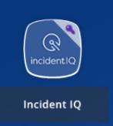
Creating Tech Support Tickets in Incident IQ
Anyone can submit a ticket

Step 1: Log In
In Classlink, find the Incident IQ Icon in your Tools folder
Select the icon. Incident IQ will log you in using your credentials.

Step 2:
Search for the student's name using the “Magnifying glass.”
Type in the student's name.

Select the student's name, verify that the correct school is associated

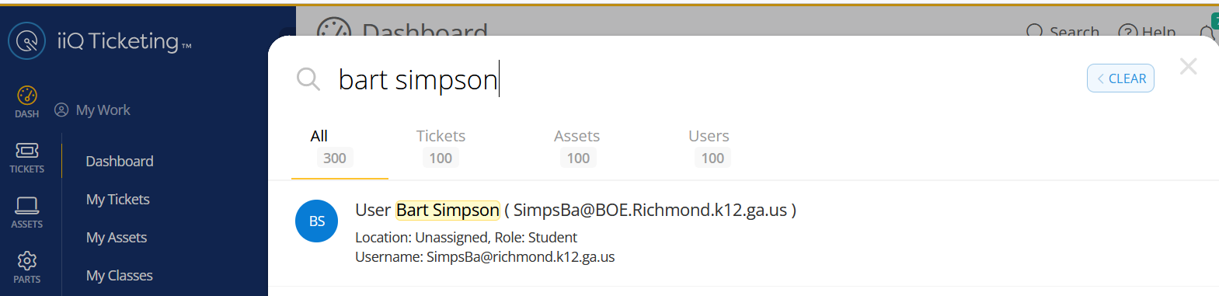
Select the student's device

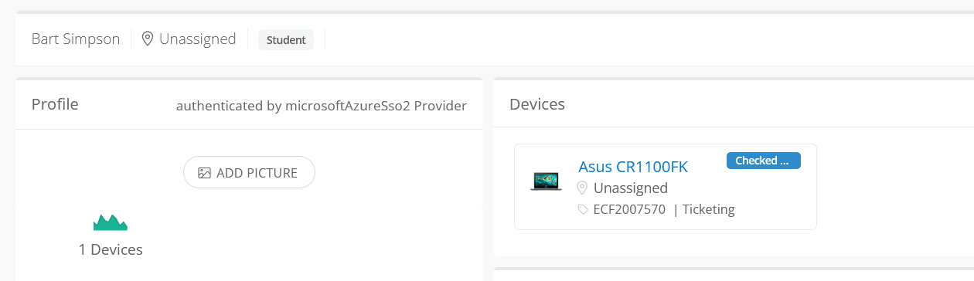
Select Submit Ticket

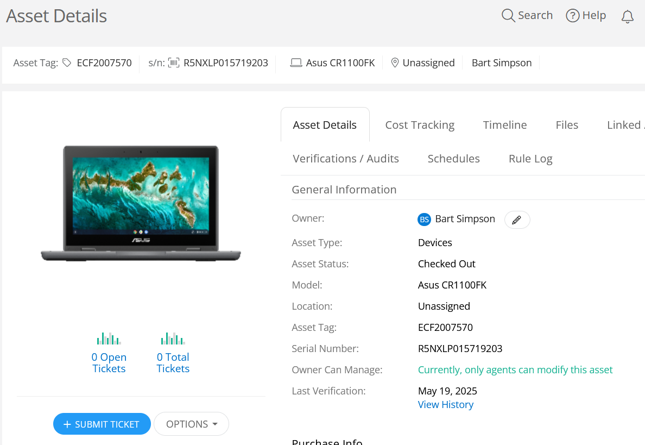
Select the Device Issue
Select the Specific Issue

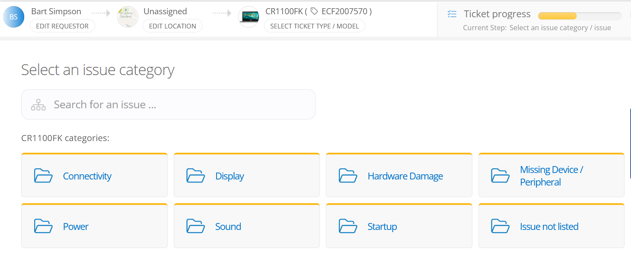

Describe the issue in more detail Ex: how the damage occurred.
Please do not include any Personal Identifying Information (PII) such as Social Security Number or GTID numbers.

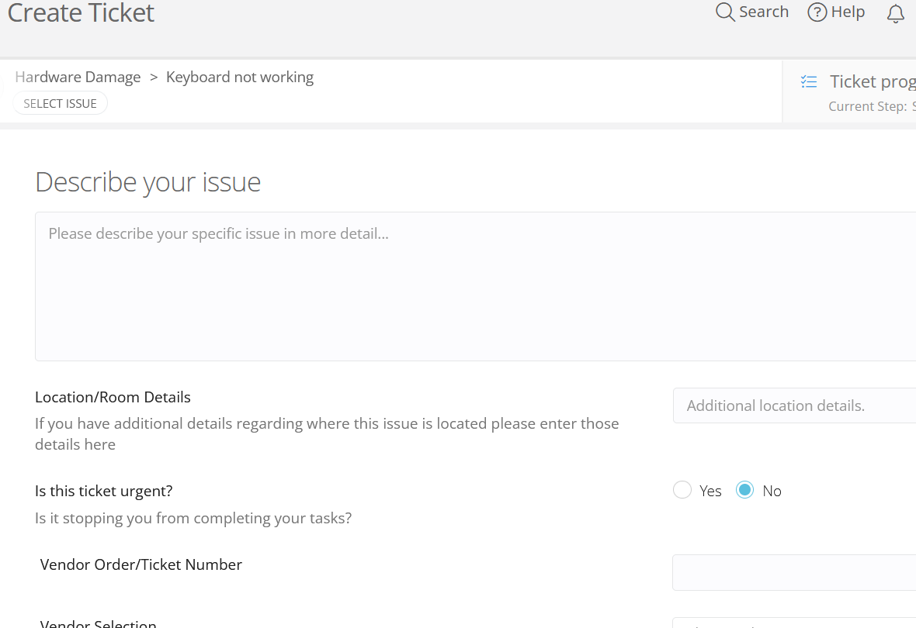

Submit Ticket

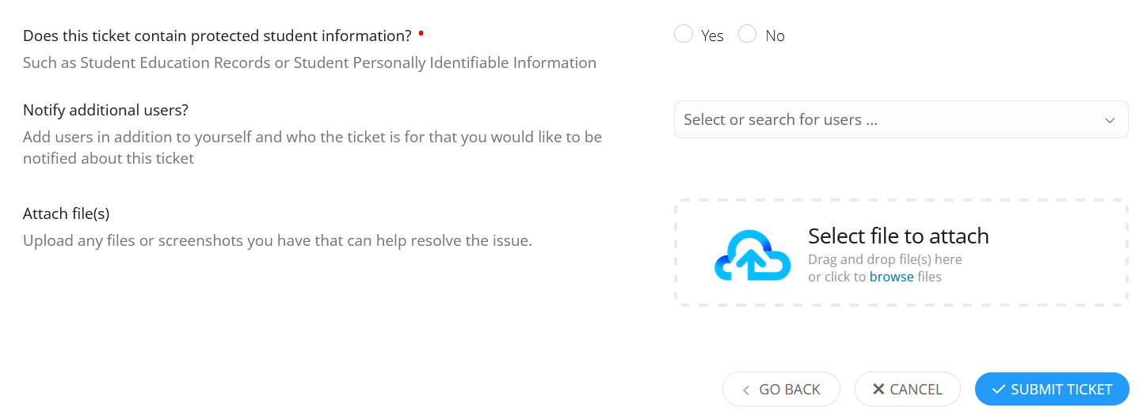
Digital Steps: Please watch the recap of the steps to Submit an Incident IQ Ticket

Thank You!
We appreciate your support in using Incident IQ to submit your tech support requests. Utilizing a ticketing system allows your technical support staff to stay on top of your requests, track trends, and provide the very best level of support for your staff and students.

Media Specialists (Rapid Search)
Handheld Scanner Required

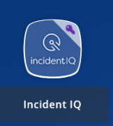
This process is set up to allow a seamless and rapid ticket submission for the Media Center environment and requires a handheld scanner:

Step 1: Log In
Scan the device barcode
Device Information will show: Student name, location, status, etc.
Select the Device Issue
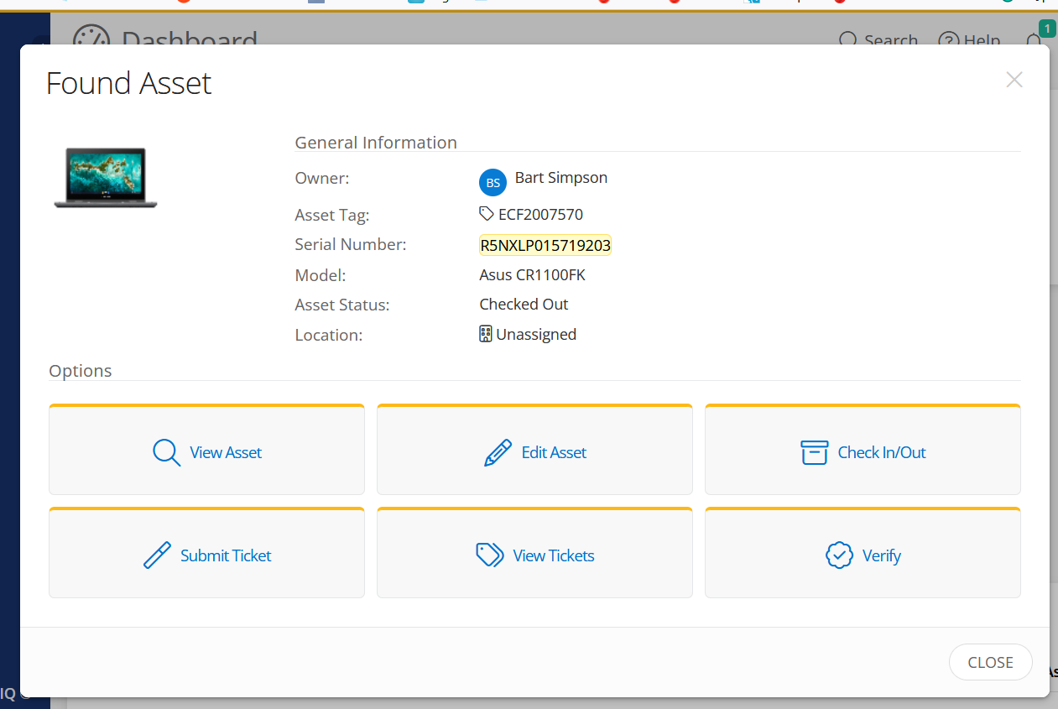
Step 2:
Select the Specific Issue

Describe the issue in more detail (Example: how did the damage occur)?
Please do not include any Personal Identifying Information (PII) such as Social Security or GTID numbers.
Scroll down

Submit Ticket
Thank You!
We appreciate your support in using Incident IQ to submit your tech support requests. Utilizing a ticketing system allows your technical support staff to stay on top of your requests, track trends, and provide the very best level of support for your staff and students.

School-Based Technology Specialists (SBTS)
Incident IQ Ticket Assignment Validation

Step 1: Validate IIQ Ticket Assignment
SBTS receives and verifies that the IIQ ticket contains the correct Location, Student Name, device “Serial Number”, and description details of the incident.

Incident IQ ticket information is critical to device inventory, repair status, SBTAS SLA’s, and district report readiness.

Step 2:
Verify that the issue type is correct. Example: (Cracked Screen, Missing Keys, No Power)
Select More to update the issue

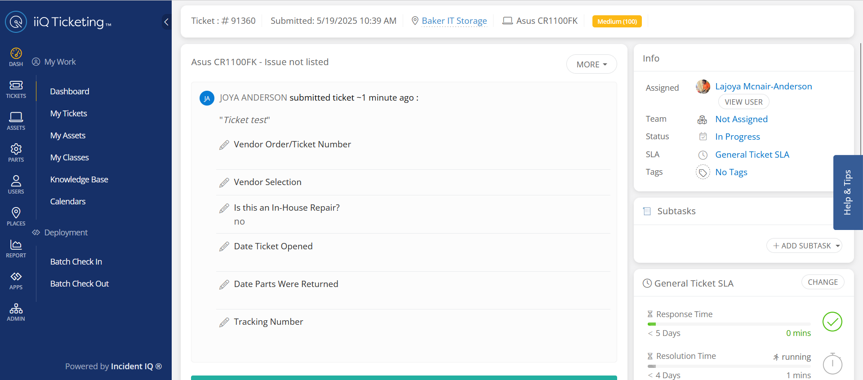

Scroll Down

Submitted By
The ticket must reflect the student's name under Submitted By: on behalf of
Select Change to update

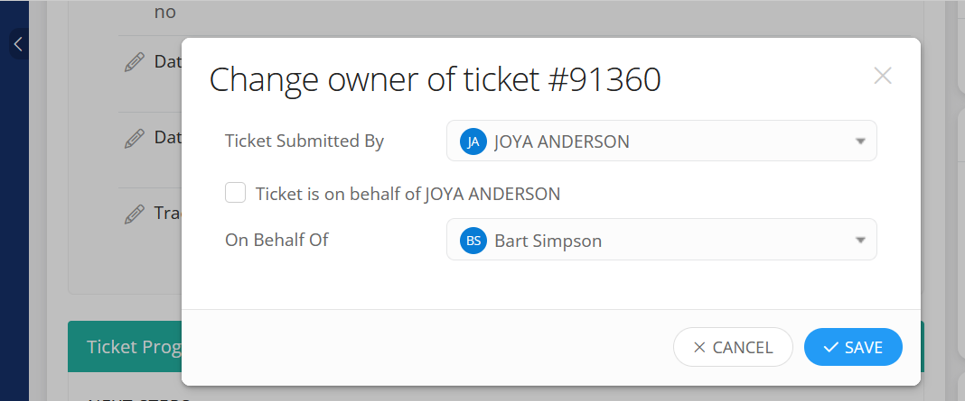

Confirm the issue
Add actions and or Verify Asset

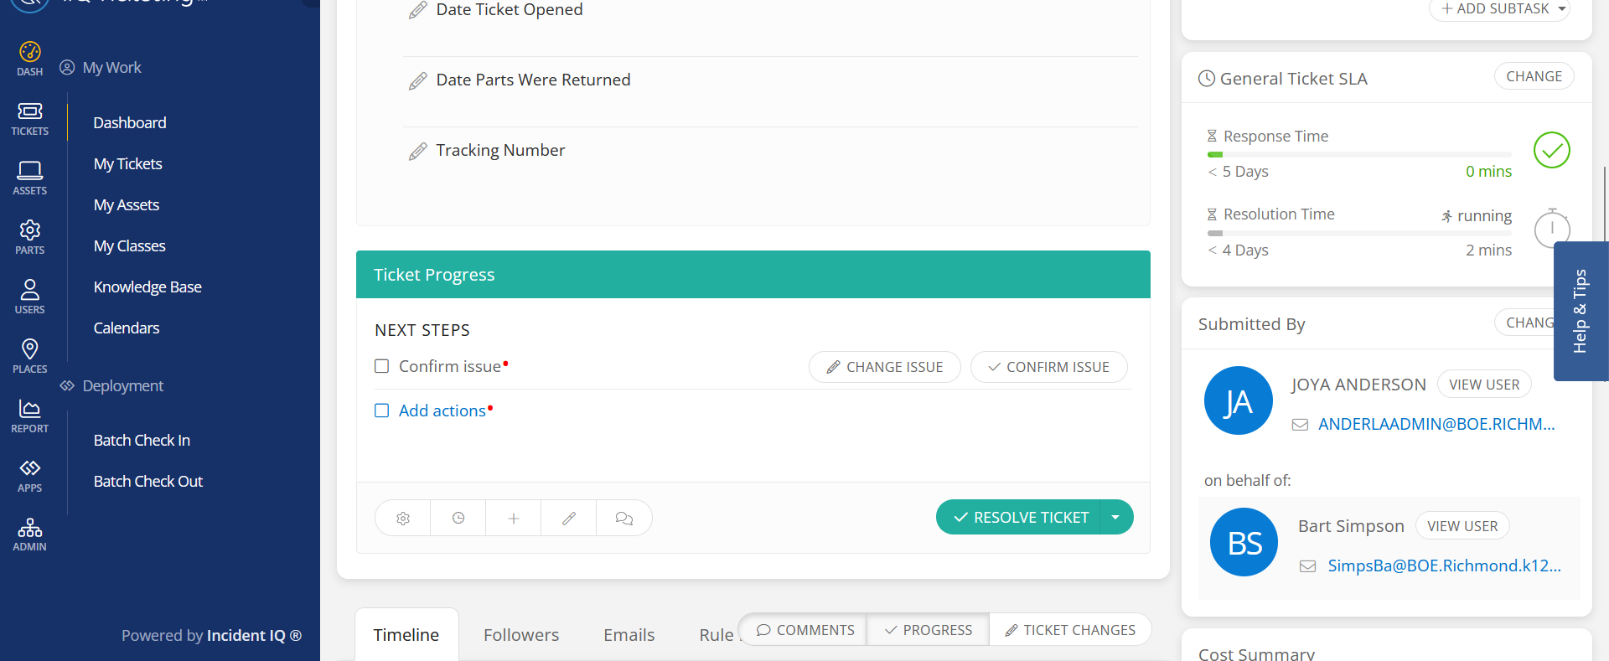

Scroll Down

Asset
Verify that the user, serial number, and asset are correct.
If not, change the information to reflect the corrections.
This section reflects the 1:1 report support ticket

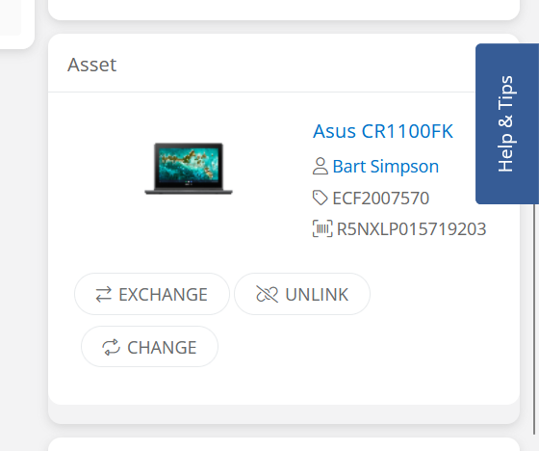

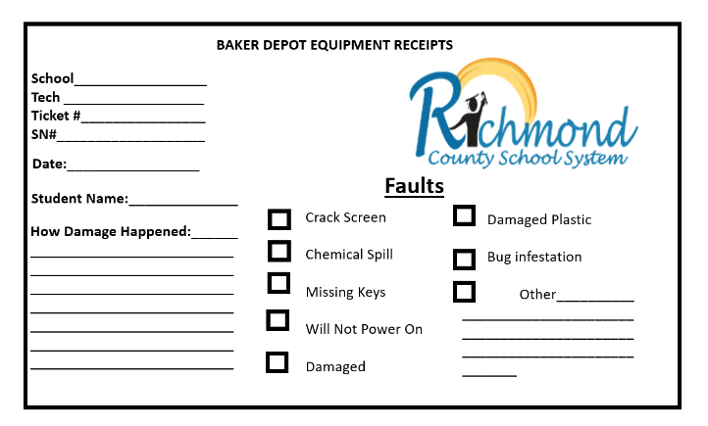
Please make sure the ticket information is reflected on the Baker Receipt if the device is escalated to repair outside of the school.

Appendix:
Select the category that best fits the problem you are experiencing at this time.
• Devices/Hardware: Used when something is physically wrong with a piece of technology (i.e., broken screen, cracked case, missing key, not working correctly, etc.)
• Software/Online Systems: Used when a problem arises with an application (i.e., Google, LaunchPad, i-Ready, Infinite Campus, etc.)
• Network/Wi-Fi: Used when a network issue occurs (i.e., a computer will not connect to the network/internet, etc.)
• User Accounts: Used to request an account login, password reset or change in Permissions.
• Other Requests: Used for any requests that do not fit into any of the above categories. (Please first check the above categories before using this option.)

