1st Grade Class Schedule
All Subjects
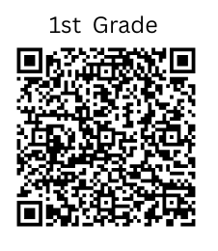
TIME | SUBJECT
7:30 am – 7:40 am (10 mins.) | - Homeroom/Community
7:40 am – 10:00 am (100 mins.) | ELA Block/ Reading/Language Arts/Writing/Social Studies  • Fundations  • MyView  • Science/S.S. Integration
9:00 am – 9:30 am (30 mins.) | Reading Intervention
9:30 am – 10:00 am (30 mins.) | Writing
10:00 am – 10:20 am (20 mins.) | Recess
10:25 am - 10:55 am (30 mins.) | Lunch
11:00 am – 11:15 am (15 mins.) | Independent Reading
11:15 am - 12:00 pm (45 mins.) | Specials
12:00 pm - 1:30 pm (125 mins.) | Math/Science  - Number Sense/Number Talks  - Whole Group (ReadyMath; GaDoe)  - Small Groups/Stations
1:30 pm – 2:00 pm (30 mins.) | Math Intervention
2:00 pm - 2:15 pm | Prepare for Dismissal
Specials Schedule
STEM | MUSIC | HEALTH | P.E.
11:15 am - 12:00 pm | 11:15 am -12:00 pm | 11:15 am - 12:00 pm | 11:15 am - 12:00 pm

