


Science Fair Information

Dear parents/guardians,
All Richmond County third-fifth graders are required to submit a Science Fair Project. McBean’s Science Fair will be held on December 5, 2025. All projects are due December 3, 2025 Projects will not be accepted for judging after the morning of December 4, 2025 .
Your child will need a composition journal to be used as a log book, a 3-prong folder or clear folder for the typed formal report, and finally a backboard for display of their project. Students may also present their projects using Powerpoint or Google slides. The following packet of information attached to this letter is provided to assist you in helping your child with their Science Fair project. Inside you will find information on selecting a topic, research questions, how to do research, forming hypotheses, and directions on testing those hypotheses. You will see information on how to collect data and the proper way to set up a display board. I have also included a page with websites of science project ideas that I hope is helpful in getting you started. Please be sure that your project is an experiment and not a model (no volcanoes, etc) and there should be no photos showing any body part including hands on your display board. Take pictures of the actual experiment only. Per Richmond County, please do not do any experiments on vertebrate animals or humans (this includes taste tests) or anything having to do with growing mold.
All information gathered should be written in their composition journal (log book). That is where I will look for all assignments from the checkpoints listed on the back of this letter. This packet and/or any of the sheets inside do not need to be returned to me; it was created to help guide you in the right direction. Be sure to hold onto this packet and keep in a safe place, as no replacement packets will be given out due to the budget (copies, paper…). If lost, feel free to use the Internet as another resource or guide, as well.
I have also attached list of due dates. On those dates I will check your child’s work on only the assignments listed for that particular date. Each due date will count as a grade, and then will be averaged to count as a quiz grade. The final completed project will count as two test grades in Science, so be sure all the needed components are there. Please make sure that your little scientist is turning in their information by the required due dates listed below! Please allow your child to assume as much responsibility as possible for the project. They will need your assistance, but I do not want you to do it for them. For example, when your child writes the report to accompany the project, you should proofread the written report, make suggestions, and offer assistance in typing the report.

If you have any questions, do not hesitate to call.
Mrs. Mullins
706-592-3723 mullike@boe.richmond.k12.ga.us
Science Fair Coordinator
Science Fair Due Date Checklist

Scientist’s Name_____________________Class___________Proj. #_______
Title of Project____________________________________________
Due Date | Assignment | Correct | Needs Improvement | Areas in need of improvement
Science fair timeline and packet will be posted to the McBean website.
August | Title and Purpose
August | Research and Bibliography
September | Hypothesis, Variables, Materials, Procedure  Experoment
October | Data, Analysis, Conclusion, Extension Statement
November | Abstract and Formal Reports
November | Display Boards
December | Any revisions
Total Score (average of all due dates): __________
100 - Turned in on time
80 - Not turned in by due date, but is in composition journal for the next due date
75 - Turned in, but is very late
0 - Never Completed

Projects due December 3. Judging is December 5, 2025

Per Richmond County, please do not do any experiments on vertebrate animals or humans (this includes taste tests) or anything having to do with growing mold.

How to create a science fair project:
https://www.youtube.com/watch?v=xcsIbotRdc4
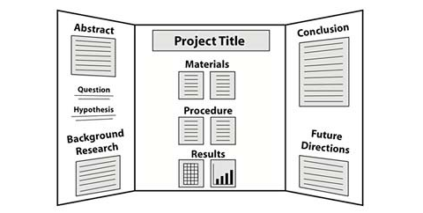
Science Project Ideas

The following websites are extremely helpful in finding Science Fair project ideas.
http://scienceprojects.com
http://rosearts.org/naples/ideas.htm
http://tetrimore.com
http://www.all-science-fair-projects.com
http://www.factmonster.com

https://www.sefmd.org/Resources/200%20Science%20Fair%20Project%20Ideas.pdf

This is the best site to use:
http://www.sciencebuddies.org

Teacher Checklist for Science Fair Entry

Teachers,
Please use this checklist for each project you plan to enter in the school Science Fair. This will save us a ton of time when we are setting up the projects. Please turn these sheets in to me when you bring the projects that morning. This way I way will not have to chase down student names, etc. Projects that do not have all the necessary parts by the morning of December 5, 2025, will not be accepted.

Student Name ________________________ Class___________ Proj. #_____
Title of Project _________________________________________________
Please make sure project has the following:
No name on any part of project _______
Project number (example: Mayson1) written on left flap of board ______
Complete Log Book ________
Complete Formal Report _________
Abstract (Keep separate from Formal Report) ________
Science Buddies Proposal Form _______
Display Board (regular size tri-fold board only) _______
Pictures on display board DO NOT show any body parts including hands ______
Display Board does not contain staples or tape _______
Display Board is neat, pleasing to the eye, and well put together _______
Project is an experiment and NOT a model (example: volcano, solar system) ______

*The only four things that will be brought to the Fair are the Log Book, Formal Report, Abstract, and Display Board. Nothing else may be displayed.

1. Purpose – Ask a Testable Question

A Testable Question has 2 Part:
Part 1: The part that is being tested. It is called the independent variable. This is the manipulated variable or the one that changes.
Part 2: The part that is being observed or measured. It is the dependent variable, or the responding (measured) variable.

The question describes the relationship between the two parts:
How does the (independent variable) affect the (dependent variable)?
Example: How does the temperature affect the rate of seed germination?

What is the effect of the independent variable on the dependent variable?
Example: What is the effect of temperature on the rate of seed germination?

You MUST be able to measure your dependent variable.

2. Conduct Your Research and Create a Bibliography
*This information DOES NOT go on your display board.
Once you have chosen your topic, it is important to research the written materials on your subject. By finding out as much information about the subject, you will gain a better understanding of your problem. *Follow these guidelines for conducting your research.
1. Read books and articles on your subject. Make sure this information is up to date (not older than 5 – 10 years).
2. You must use at least 3 resources. Cite your work above your notes.
3. In your log book, you will include only your notes from your sources. Use will use these notes to write the research paper in your formal report after you complete the entire experiment.

Bibliography
Make a list of all the books, magazines, internet articles, interviews, or other sources that were used. *Write your bibliography using the following format:
Books:
Author’s last name, first name. Book title. City of publication: Publishing Company, publication date.
Example:
Allen, Thomas B. Vanishing Wildlife of North America. Washington, D.C.: National
Geographic Society, 1974.

Internet:

Author’s last name, first name (if available). “Title of work within a project or database.” Title of site, project, or database. Editor (if available). Electronic publication information (Date of publication or of the latest update and name of any sponsoring institution or organization).
Date of access and <full URL>.

Note: If you can’t find some of this information, cite what you can.

Example:
Devitt, Terry. “Lightning injures four at music festival.” The Why? Files. 2 Aug. 2001. 23 Jan. 2002.
<http://whyfiles.org/137/lightning/index.html>

Encyclopedia and Dictionary

Author’s last name, first name. “Title of Article.” Title of Encyclopedia. Date.

Examples:
Pettingill, Olin Sewall, Jr. “Falcon and Falconry.” World Book Encyclopedia. 1980.
“Azimuthal Equidistant Projection.” Merriam-Webster’s Collegiate Dictionary. 10th ed. 1993.

*See me for help if you use any other type of source.

3. Construct a Hypothesis

A Hypothesis includes a prediction about you believe, based on your research, will happen when your investigation is completed.
Follow these steps to complete a hypothesis:
- List observations or gained research knowledge you have about the variables.
- Write an if…..then statement describing what the effect of changing one variable on another variable. (This is a cause/effect relationship).
Example:
If (what will be changed with the independent variable), then (what will happen because of the change – dependent variable) because (use your observations or gained research knowledge to explain your belief).
If seeds are exposed to freezing temperatures for a short period of time, then the germination rate will increase because research indicates that certain seeds will germinate more quickly if they are put in a freezer before planting.

Identify the Variables

Create a list of each type of variable. Remember, the independent variable is the one that changes. The dependent variable is the response you are looking to get. The control variable is the one that remains the same.
Example:
Control Variable: number of beans per bag, time stored, amount of water and sunlight while germinating
Independent Variable: temperature of storage
Dependent Variable: number of seeds germinating

Materials

Make a list of all materials that you use.
Example:
16.7cm x 15.1cm Zip-Loc bags
60 uncooked butterbeans
(3) 27.9cm x 26.4cm paper towels
Permanent Marker
De-chlorinated tap water
Approximately 70 degrees Fahrenheit room
Approximately 38 degrees Fahrenheit refrigerator
Approximately 0 degrees Fahrenheit
Procedure
Write a set of directions for completing your experiment. Remember to write complete sentences and use punctuation.
Example:
1. Label the plastic bags as follows: Room temperature (control) bean, 50 degree F. (refrigerator) bean, 30 degree F. (freezer) bean.
2. Fold paper towels to fit in bags. Place in bags.
3. Place 20 beans in each bag.
4. Put each bag in proper place as said on bag label.
5. Leave undisturbed for 5 days.
6. After the 5 days remove the bags. Wet the paper towel with 15mL of dechlorinated tap water but leave the towel and seeds in bag. Towel should be moist but not soaking.
7. Place bags in warm, sunny spot.
8. Check every day for 10 days for germination. Keep towels moist.
9. Record your findings. Repeat as necessary.
4. Collect Data

You will need to construct a table to collect your data. A table contains rows and columns.
- Give your data table a title. The title should contain your independent variable (the one that changes) and the dependent variable (the responding) and be at the top of your table. For example: Germination Rate of Butterbean Seeds vs. Temperature
- Make a row for each independent variable you are testing.
- Make a column for each dependent variable you are measuring.
- Include unit names for each measurement.
- Add an “Average” column or a “Total” column if applicable.
Example:
Germination Rate of Butterbean Seeds vs. Temperature

Days | Control – Room Temperature | Freezer | Refrigerator
1 | 0 | 0 | 0
2 | 2 | 0 | 1
3 | 6 | 2 | 4
4
5
6
7
8
9
10
*Keep recording daily for ten days.

Analysis

Create a graph of your recorded information. You may use a bar graph or a line graph. If you are showing information that happens over a period of time, a line graph is preferred.
Example:

You would need to conduct at least three trials. If after the three trials, you have the same results, then you can draw a conclusion.

Conclusion

A Scientific Conclusion has these parts in order:
- State the prediction.
- Include evidence from your data collection. Do not include all your data. Include a high and low, if possible – include averages, or appropriate central measures.
- Include a statement that analyzes the data.
- Include a statement that tells if the prediction was correct or incorrect. Use the sentence starter: Therefore my prediction was….(correct or incorrect).
Example:
The results of my experiment show that my hypothesis was incorrect. The seeds in the freezer germinated the fewest, while the ones at room temperature germinated the largest amount of seeds.

Extension Statement

In this section, you will tell what you would do differently next time to see if you get the same results.
Example:
I believe that further testing needs to be done to see which temperature induces the highest germination rate. If I was to perform this experiment again, I would use a different type of bean to see if my results would be the same.

Abstract

The Abstract is a summary of the entire project. It should be typed in three paragraphs using the same font and type size as your Formal Report. Do not punch holes in the Abstract. It is sheet that you will turn in separately from the Formal Report. You do not have to write the Abstract in your notebook. It should be no more than 250 words. Please make sure to do a word count to make sure that you do not go over this number.

Paragraph #1: Purpose of the experiment and the Hypothesis
Paragraph #2: Procedure written in paragraph form
Paragraph #3: Results and Conclusion

Example:
The purpose of this project is to determine if temperature will affect the germination rate of butterbean seeds. It is hypothesized that freezing the seeds for a period of time will cause them to produce more seeds at a quicker rate.
A set number of butterbean seeds were placed in plastic bags marked “room temperature”, “freezer”, and “refrigerator”. The bags were placed in the respective areas and left undisturbed for five days. They were all then moistened and placed in a warm, sunny area where they were observed for ten days.
The results showed that the coldest temperature actually harmed the germination rate of the seeds; therefore, my hypothesis was incorrect. To improve this study, I would try different types of seeds to see if my results could be confirmed.

Formal report template:

https://www.rcboe.org/cms/lib/GA01903614/Centricity//Domain/46/Science%20Fair%20Research%20Report%20TEMPLATE.pdf

Log book set up:
https://www.youtube.com/watch?v=0VRr8Mwr47Q

Display Board

Do and Don’ts:
- Do use computer generated graphs and charts.
- Do make display colorful, but limit the number of colors you use.
- Type information for the board.
- Do use headers in the correct order.
- Do use rubber cement to make sure that everything is securely attached to the board. Elmer’s Glue causes everything to wrinkle.
- Do space out everything evenly.
- Do use photographs of the procedure, but make sure that no body parts including hands are shown.
- Do use a catchy title. It should NOT be the question that is your purpose statement.
- Don’t leave large empty spaces on the board.
- Don’t use tape or staples on the board.
- Don’t handwrite information on the board, including headers.
- Don’t make spelling errors.
- Don’t print in color except for headers if you wish. Colored type makes the information very difficult to read.

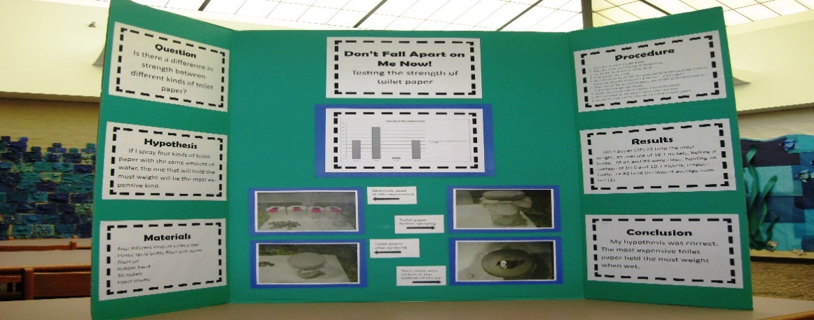
You should have the following on your board only: Title, Purpose (this is your question), Hypothesis, Materials, Procedure, Results, Conclusion, and any photographs, charts, and graphs.

