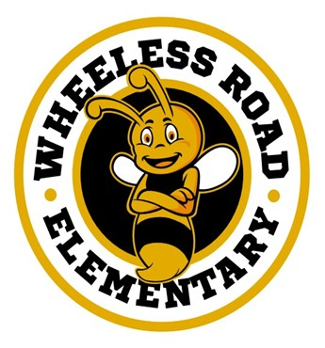
Bumblebee News

__________________________________________________________________________________________________________________________________________________________________________________________
Wheeless Road Elementary School Title 1 2530 Wheeless Rd., Augusta, GA
706) 796-4985 September 13, 2023 2nd Edition
________________________________________________________________________________________________________________________________________________________________________________________________________________________________
Principal’s Corner
Hello Bumble Bees,
We made it to our first progress report! Ask your teacher questions or concerns before the next grading period. A Progress Report monitors a student's academic and behavioral learning. The goal is for each student to master content on their grade level or above grade level. Wheeless Road Elementary School provides each student with intervention time to focus on areas needing improvement. Upcoming tutoring services will be provided during school and after school. If you have questions, contact Ms. Shackelford or Ms. Beeks at Wheeless Road Elementary School at (706) 796-4985.

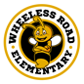
Sincerely,
Carl Robinson III, Ed.S.
Principal
Wheeless Road Elementary School
(706) 796-4985 Work
"Buzzing to Excellence."

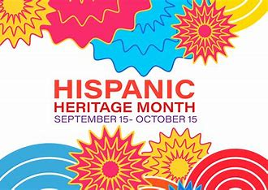

Hispanic Heritage Month is an annual celebration of the history and culture of the U.S. Latino and Hispanic communities. The event commemorates how those
communities have influenced and contributed to American society at large.

Infinite Campus & Volunteer Training
(Tuesday, September 19 – 8:00 a.m.)

Being involved in your child's academic life opens communication between you, your child and the school. Using the Portal to review your child’s assignments, attendance and academic progress aids in your student being more active and aware of their success.
Volunteer Training is made available to individuals interested in volunteering in Richmond County schools. Volunteers may help with classroom activities, computer labs, field trips, mentoring, office duties, storytelling and tutoring, just to name a few. If you have any questions, please contact Mr. Willis (Parent Facilitator) at (706) 796-4985 ext. 6219.

Upcoming Events
- Fall Semester Progress Report #1
Friday, September 15
- Volunteer Training
Tuesday, September 19 (8:00 a.m.)
- Kona Ice is coming! (See back for more info)
Friday, September 22
- National Family Day
Tuesday, September 26
- Student Holiday/Professional Learning Day
Thursday, October 5
- Power Up Asynchronous Learning Day
Friday, October 6
- Student/Teacher Fall Break
Monday, October 9 – Tuesday, October 10
- Fire Prevention Week
Sunday, October 8 – Saturday, October 14

Kona Ice is Coming!
Friday, September 22
(10:00 a.m.)

STEP 1: Choose Your Size:

STEP 2: Choose Your Flavor: Tiger's Blood, Blue Raspberry, Groovy Grape, Cotton Candy, Monster Mango, Lucky Lime, Watermelon Wave, Strawberry Treasure, Ninja Cherry, Piña Colada

Fire Prevention Week (October 8 - 14)

“Cooking safety starts with YOU! Pay attention to fire prevention”” is the theme for Fire Prevention Week, this year. This year’s focus on cooking safety works to educate the public about simple but important steps they can take to help reduce the risk of fire when cooking at home, keeping themselves and those around them safe.
Following are cooking safety messages that support this year’s theme, “Cooking safety starts with YOU! Pay attention to fire prevention”:
- Always keep a close eye on what you’re cooking. For foods with longer cooking times, such as those that are simmering or baking, set a timer to help monitor them carefully.
- Clear the cooking area of combustible items and keep anything that can burn, such as dish towels, oven mitts, food packaging, and paper towels.
- Turn pot handles toward the back of the stove. Keep a lid nearby when cooking. If a small grease fire starts, slide the lid over the pan and turn off the burner.
- Create a “kid and pet free zone” of at least three feet (one meter) around the cooking area and anywhere else hot food or drink is prepared or carried.

RCSS Student Technology Agreement

Everyone is encouraged to read and sign the RCSS Student Technology Loan Agreement that was sent to you via your child. The Richmond County School System’s vision is to provide an equitable education for all students to prepare them for life beyond the classroom. We are loaning out laptops/tablets for students to use in the classroom and if possible, at home as well. After reading the terms and agreement, all students and parents/guardians need to fill out the form, sign it, and bring it back to their teacher.

Homework Quick Tips
- Make sure your child has a quiet, well-lit place to do homework.

- Make sure the materials your child needs, such as, paper, pencils, and a dictionary, etc. are available.
- When your child asks for help, provide guidance, not answers.
- Be positive about homework. Tell your child how important school is. The attitude you express about homework will be the attitude your child acquires.
- Help your child with home management. Establish a set time each day for doing homework. Don’t let your child leave homework until just before bedtime.


Attendance Matters: "Every Student Every Day". We want to see each student each day.

