Parents’ Guide to Student Success in Mathematics

Fifth Grade

Why Are Academic Standards Important?
Academic standards are important because they help ensure that all students, no matter where they live, are prepared for success in college and the workforce. Standards provide an important first step — a clear roadmap for learning for teachers, parents, and students. Having clearly defined goals helps families and teachers work together to ensure that students succeed. They also will help your child develop critical thinking skills that will prepare him or her for college and career.

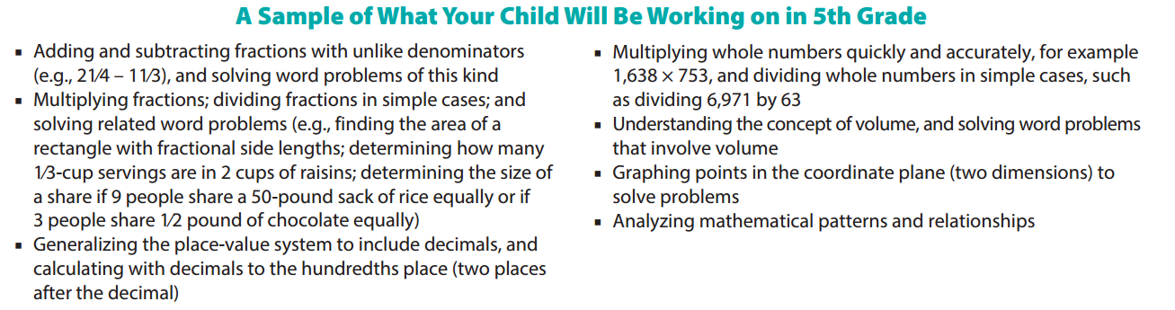

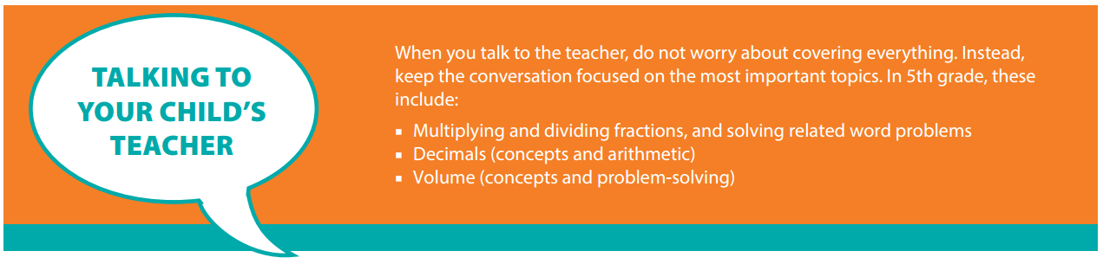

Help Your Child Learn at Home
Try to create a quiet place for your child to study, and carve out time every day when your child can concentrate. You should also try to sit down with your child at least once a week for 15 to 30 minutes while he or she works on homework. This will keep you informed about what your child is working on, and it will help you be the first to know if your child needs help with specific topics. Additionally, here are some activities you can do with your child to support learning at home:
Look for “word problems” in real life. Some 5th grade examples might include:
- Doing arithmetic with decimals, for example when balancing a checkbook.
- Multiplying with fractions — for example, if you used about 2⁄3 of a 3⁄4-cup measure of vegetable stock, then how much stock did you use? About how much is left?
- Using the length, width, and depth of a garden plot to determine how many bags of garden soil to buy.

Resource: http://www.pta.org/parents/

Fifth Grade
Nine Week Checkpoints for Parents and Students

First Nine Weeks | Second Nine Weeks
Helpful websites to help students master the first and second nine week concepts:
https://www.khanacademy.org/commoncore/grade-5-OA
https://www.khanacademy.org/commoncore/grade-5-NBT
https://www.khanacademy.org/commoncore/grade-5-NF
Students should know and be able to:  - Explain the relationship between digits in different decimal places  - Multiply and divide with powers of ten  - Fluently multiply 3-digit by 2-digit whole numbers using the standard algorithm¹  - Fluently divide 4-digit numbers by 2-digit numbers  - Read write and compare decimals to the thousandths place  - Round decimals to a given place  - Add and subtract decimals | Students should know and be able to:  - Multiply and divide decimals  - Solve word problems involving addition and subtraction of fractions with unlike denominators  - Multiply a whole number or fraction by a fraction  - Solve word problems involving multiplication by fractions
Third Nine Weeks | Fourth Nine Weeks
Helpful websites to help students master the third and fourth nine week concepts:
https://www.khanacademy.org/commoncore/grade-5-G
https://www.khanacademy.org/commoncore/grade-5-MD
Students should know and be able to:  - Classify shapes based on properties  - Multiply whole numbers by fractions  - Multiply mixed numbers within word problems  - Divide a whole number by a unit fraction  - Measure volume of objects  - Solve real word problems involving volume | Students should know and be able to:  - Graph points on a coordinate plane  - Locate points in a geometric figure  - Follow a distance and path from one point to another  - Represent the context of a problem using a coordinate plane
¹ After students have a conceptual understanding of multiplying multi-digit numbers.

