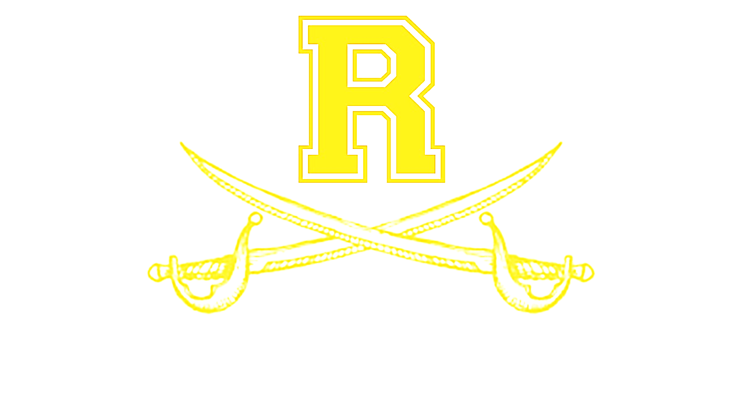

Richmond Varsity Academy Basketball
Date | Day | Time | Opponent | Boys/Girls | Location
Nov. 8 | Fri. | 6, 7:30pm | Josey | Boys/Girls | Richmond
Nov. 12 | Tue. | 6, 7:30pm | Laney | Boys/Girls | Richmond
Nov. 15 | Fri. | 4:30/7:30pm | Rickey Moore Classic  Girls vs Aug. Christian @ 4:30  Boys vs Aug. Christian @ 7:30 | Boys/Girls | Curtis Baptist
Nov. 16 | Sat. | 4:30/9:00 | Rickey Moore Classic  Girls vs 1st Baptist @ 4:30  Boys vs Midland Stem @ 9:00 | Boys/Girls | Westside (2nd Gym)
Nov. 19 | Tue | 6, 7:30pm | Laney | Boys/Girls | Laney
Nov. 29 | Sat. | TBA | 100 Blk. Men Thanksgiving Classic (TBA) | Boys | TBA
Dec. 3 | Tue. | 6, 7:30pm | Harlem* | Boys/Girls | Richmond
Dec. 6 | Fri. | 6, 7:30pm | Thomson | Boys/Girls | Thomson
Dec. 10 | Tue. | 6, 7:30pm | Cross Creek* | Boys/Girls | Richmond
Dec. 13 | Fri. | 6, 7:30pm | Hephzibah* | Boys/Girls | Hephzibah
Dec.17 | Tue. | 6, 7:30pm | Baldwin* | Boys/Girls | Baldwin
Dec. 20 | Fri. | 6, 7:30pm | Westside* | Boys/Girls | Westside
Dec. 26 | Thur. | TBA | Girls: North Augusta  Boys: Washington Co. | Boys/Girls | Laney
Dec. 27 | Fri. | TBA | Girls: South Aiken  Boys: Josey | Boys/Girls | Laney
Dec. 28 | Sat. | TBA | Girls: TBA  Boys: Glenn Hills | Boys/Girls | Laney
Jan. 3 | Fri. | 6, 7:30pm | Howard* | Boys/Girls | Richmond
Jan. 4 | Sat. | 6, 7:30pm | Aquinas* | Boys/Girls | Aquinas
Jan.7 | Tue. | 6, 7:30pm | West Laurens* | Boys/Girls | Richmond
Jan. 10 | Fri. | 4, 5:30, 7,  8:30pm | Harlem* | Boys/Girls JV&V | Harlem
Jan. 17 | Fri. | 6, 7:30pm | Cross Creek* | Boys/Girls | Cross Creek
Jan. 21 | Tue. | 6, 7:30pm | Hephzibah* | Boys/Girls | Richmond
Jan.24 | Fri. | 6, 7:30pm | Baldwin* | Boys/Girls | Richmond
Jan. 28 | Tue. | 6, 7:30pm | Westside* | Boys/Girls | Richmond
Jan. 31 | Fri. | 6, 7:30pm | Howard* | Boys/Girls | Howard
Feb. 4 | Tue. | 6, 7:30pm | Aquinas* | Boys/Girls | Richmond
Feb. 7 | Fri. | 6, 7:30pm | West Laurens* | Boy/Girls | West Laurens
Boys Coaching Staff Girls Coaching Staff
Steve Nobles – Head Coach Warren Washington- Head Varsity Coach
Shaun Bradley – Assistant Coach Jamia Bradley- Assistant Coach
Chris Jones – Assistant Coach Adam Mullis- Head JV/Assistant Coach
Jerry Arnett – Assistant Coach

