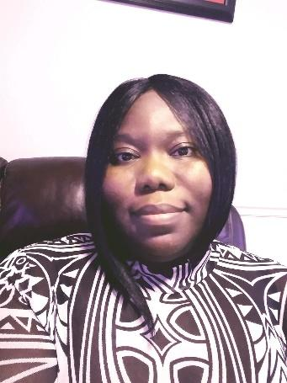
Welcome to Second Grade
My name is Ms. Huggins and I am so EXCITED to be your teacher this year! We are going to do so many fun things together as we learn all about reading, writing, math, science, and MORE! With everything going on right now, I hope you have had a WONDERFUL summer. I can’t wait to hear ALL about it.

A little about me...
I am a second-year teacher and I am very happy that I get to work with you, as we navigate through second grade together. I worked in mental health for over ten years and have a Master’s in Social Work from the University of Georgia, GO DAWGS!!! My family is originally from Estill, South Carolina, but I grew up between Estill and Louisville, Georgia. I come from a long line of teachers, so I guess you can say that I was destined to become a teacher.

My favorites...
Color: Blue
Food: Seafood
Season: Fall
Hobby: Anything that allows me to be creative and video games

In our class...
YOU are cared about, I value your ideas, thoughts, and actions. You have unique talents and strengths that we will unlock together. You will bring so much to OUR class and I can’t wait to learn more about you!

Contact me...
I would love to have conversations with parents throughout the year to ensure the success of OUR second graders. Please feel free to contact me with any questions or concerns. I can be reached via email at Huggita@boe.richmond.k12.ga.us or call the school at 706-737-7228.

I can’t WAIT to meet you!!!

Ms. Huggins

