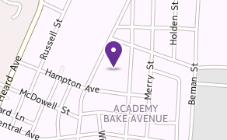
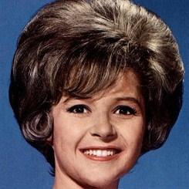

The Community

Lamar-Milledge Elementary School is very fortunate to h a v e o n g o i n g a n d dedicated support from a n u m b e r o f c o m m u n i t y partners. Wesley United Methodist Church, Bethel AME Church, Antioch Baptist Church, Baptists M i n i s t e r s ’ C o n f e r e n c e Georgia Regents School of Dentistry, and the Links, Inc., These partners are a c t i v e l y i n v o l v e d i n tutoring, mentoring and providing services that b e n e f i t n o t o n l y t h e students, but aide the parents and faculty as well.
Former World Famous
Students

Brenda Lee

Singer/Recording Artist

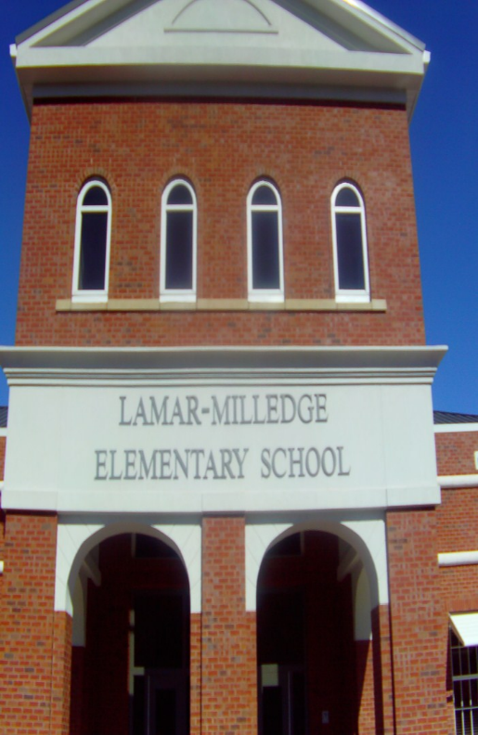
Lamar-Milledge Elementary School

Vernon Forest
Former WBC Welterweight Champion

Mr. Eric Lewis, Ed.S.


Surrounding landmarks include Bethel CME Methodist Church, Crawford Ave. Baptist Church, & the KROC Center.
Projects
Robotics
STEM Team
LME Roar Broadcast
Hydroponics Garden
Vegetable Garden
510 Eve Street
Augusta, Georgia 30904

Telephone: 706-737-7262 Fax: 706-737-7261

www.rcboe.org/lamar

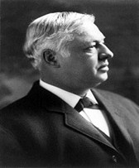
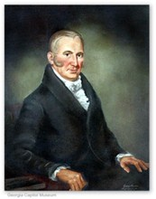

Historical Information

Lamar-Milledge Quick Facts
College & Career ReadinessPerformance Index (CCRPI)

Joseph R. Lamar
1857-1916
Justice Lamar lived in Augusta for a number of years as a boy. He served on the U.S. Supreme court from 1911-1916. His final rest-
ing place is in Summerville Cemetery, Augusta, GA.

John Milledge
1757-1818
Governor Milledge served as Governor of Georgia from 1802-1806. He was instrumental in establishing the University of Geor-gia. In 1818, he died
at his plantation home in Augusta, GA. and was buried in the Summerville
Cemetery.

The two schools named
for these distinguished gentlemen were merged in August of 2009.
The new school building located on the site of the old John Milledge Elementary
STUDENT DEMOGRAPHICS

Total Enrollment–480

Grade Range: PK, KK, 01, 02, 03, 04, 05 African American…….87.0% Hispanic…………………1.0% White……………….……..10.0% Multiracial……….……..…1.0%

STUDENT ENROLLMENT IN SPECIAL PROGRAMS

EIP (Early Intervention Program)…………26.4% Students with Disabilities…………..8.0% Eligible for Free/Reduced Meals…97.0%

CERTIFIED PERSONNEL DATA
Education/Certification Level of
Professional Staff

4 Yr. Bachelor’s……………….34.4% 5 Yr. Master’s… ……………….44.8% 6 Yr. Specialist’s………………20.6%

CERTIFIED PERSONNEL CATEGORIES
Administrators………………….2.9% Support Personnel………… ..8.6%
Teachers………………………….88.5%

CCRPI is a comprehensive school improvement, accountability, and
communication platform for educational stakeholders in Georgia. It is a 100 point scale that promotes college and career readiness for public school students.
2018
CCRPI SCORE: 57.5
ACCREDITATION INFORMATION
Southern Association of Colleges & Schools

Highlights
• Visited by authors Kandyce Mack, Cathy Fishman, and Tacardra Rountree; Dr. Jeanne Sinkford, national and international renowned dental educator & 1st female dean of Dental School, Howard University College of Dentistry, 1975-1991
- Made contributions to American Kidney Fund, United Way, & Golden Harvest Food Bank
- Teams: Robotics, Girls Who Code, Hydroponics, LMES Braodcast, Technology, STEM Track & More.

Mottos

“Where lions learn and lead”
“Imagine what you can do today” “Imagine who you’ll be tomorrow”

