Assessment Policy

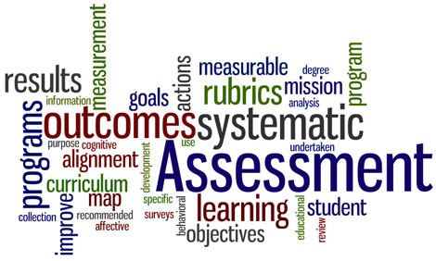

Hephzibah High School
IB MYP
Assessment Policy
Purpose for assessment
The purpose for assessment at Hephzibah High School (HHS) is to inform and support effective teaching and learning. HHS believes that assessment is a critical component of teaching and learning. To this end, students, teachers, and administrators work collaboratively to monitor student growth through a variety of assessment tools. Throughout the learning cycle, teachers and administrators collect data through a balance of formative and summative assessments to reflect, monitor, and evaluate current knowledge and experiences. All assessments are aligned with state and IB standards and assessments. Teachers continually provide timely and corrective feedback in order to guide and encourage their future learning. The data gleaned from assessments are also used to develop strategies that maximize student growth, teacher effectiveness as well as programme improvement.

Principles of Assessment
- Assessment informs, supports, and encourages effective teaching and learning.
- Assessment allows students the chance to exhibit and transfer skills across disciplines.
- Assessment reflects international-mindedness of the programme by providing assessments that are set in various cultural and linguistic contexts.
- Assessment is used to determine a student's level of understanding
using both formative and summative assessment.
- Assessments are designed to meet the needs of students at their particular stage of development.
- Assessment practices and reports are articulated and clearly communicated with all stakeholders.
- Assessments provide opportunities for peer and self-assessment.
- Assessment allows students to reflect on their own learning.

Assessment Practices
- Teacher will use a variety of assessment strategies to provide feedback on the learning process.
- Student performance on assessments will be reported with report cards, parent-teacher-student conferences.
- HHS follows all district and state rules regarding assessments. Throughout the school year, the school administers state and district assessments. Student achievement and growth scores are reported are distributed to administration, teachers, students and parents.

In the MYP
- School-based summative assessments are aligned to subject group objectives.
- In each subject, teachers will organize and create relevant assessment and reporting procedures according to the objectives of the programme.
- Teachers will use a variety of assessment that adapted to the learning objectives for each subject.
- Rubrics, exemplars, anecdotal records, checklist, and portfolios will be used to record students’ responses and performance on authentic assessments.
- Assessments will be monitored.
- A progress report with student achievement levels on MYP criteria will be reported periodically and at the end of the school year.

