Volume 3, Issue 1
September 2022

Copeland Elementary School
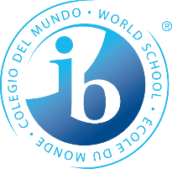

Wildcat PYP Newsletter

Upcoming Events
September – Celebrating Hispanic Heritage Month
Sept 5 – Labor Day Holiday-No School
Sept 6 – Learn from Home Day
Sept 22 – Student of the Month Breakfast 8-9am
Sept 30 – Grits w/Grandparents 8-9am.
Sept 30 – Literacy Make-N-Take PreK-1st Grade 8:30-9:30am

Copeland is an Authorized IB School

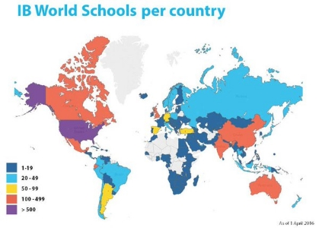
We have received our letter of authorization from the International Baccalaureate Program and are an official IB World School.

The process involves a meeting between the IB and all school stakeholders including parents, district members, administration, teachers and students.

The IB sent a team of visitors to conduct a virtual visit of Copeland. The process took between two days this past April. The visiting team interviewed all stakeholders, reviewed our units of inquiry, observed our instructional time and took a virtual tour of the facility. The visiting team compiled all of the artifacts and the observations and determined Copeland meets all of the criteria to be an official IB World School.

Our authorization visit took place this past May. We received our official Letter of Authorization in the middle of June. The IB has accredited us to offer the Primary Years Programme.

If you would like more information on what it means to be an IB World School, please visit Copeland’s website or one of the following links included below.

Thank you for your support!

https://www.ibo.org/become-an-ib-school/

https://www.ibo.org/programmes/primary-years-programme/become-a-pyp-school/

International School of Boston (2016) IB Network IB Schools Per Country https://www.isbos.org

We’re on the Web!
https://www.rcboe.org/copeland

Celebrating


In general, authorized means to be sanctioned, recognized, certified, and accredited. Public schools are accredited by their state. So, what is different about the IB?
The IB is a GLOBAL leader in education whose mission is to develop inquiring, knowledgeable, and caring young people who help to create a better and more peaceful world through education that builds intercultural understanding and respect. ~International Baccalaureate IBO.org~
This means our school, teachers, and staff are globally accredited and provide a nationally and internationally competitive education.
In addition, our students are globally recognized as student citizens and student ambassadors. They learn the attributes and skills necessary to succeed in a culturally diverse society through a nationally and internationally accredited education.

Did you know!?
iReady Reading & Math utilizes personalized instruction that students can practice at home by logging into their iReady account.

What does it mean to be Authorized by the IB?

Wildcat PYP Newsletter

IB Learner Profile of the Month:

We show sensitivity to ourselves and others. We take care of our community and Earth.

Using Key Concepts – Inquiry Everywhere!

As a parent, guardian or family member, you have a critical role in extending the learning process outside of school. Learning takes many different formats from formal learning to unplanned learning through playing and experiences. Connecting to the IB Key Concepts will help you develop questions that deepen your student’s learning.
Form: What is it like?
Function: How does it work?
Connection: How is it connected to other things?
Change: How does it change?
Causation: Why is it like this?
Perspective: What are the different points of view?
Reflection: What is your responsibility?
These questions and other similar will help deepen your student’s learning in a variety of settings.
~International Baccalaureate
Ibo.org~
~5 Ways to Support Your Child as a PYP Parent
Taryn Bond Clegg – Making~
Ask your students open ended questions like the ones above to help them develop critical thinking and problem-solving skills.

From Principles Into Practice - ibo.org - PYP Resources
Knowledgeworks.org

The 411
Did you know that Copeland has several policies that will help parents and stakeholders better understand the IB Program at Copeland?
Admissions Policy – Grading Philosophy and Process
Inclusion Policy – Special Education
Language Policy – Development of Language
Technology Policy – Roll of technology
Child Protection Policy – Ensuring the safety of our students
Admissions Policy – Enrollment requirements
Academic Honesty Policy – Safe and fair use
Policies are located on the website under the Parent tab – IB Candidate School – IB Policies

Students who provide help to others in need, including their families, local and global communities, the environment, and his or herself. They show empathy, compassion, and respect towards others and themselves. Students who are caring make a positive difference in the lives of others as well as their own lives. You can help your child become more caring at home. Try these tips!
- Be a role model by displaying caring behavior.
- Ask your child questions that relate to your community and the environment.
  - Ex: There are many stray cats and dogs around the neighborhood. How can we find them a home?
  - Ex: Our friend needs help around the house…how can we help them?”
- Ask your child questions about others.
  - Ex: How can you help your friend with his project/problem?
  - What other ways can we help?
  - Where are some areas around town that need help?
  - How did you help them?
Encourage questions related to their thought process. Help strengthen their caring skills by allowing your child to help you solve age-appropriate challenges.

The Learner Profile, Caring

