Setting up Mobile app Option for
Multi-Factor Authentication

The easiest verification method to use is the Microsoft Authenticator mobile app. Instead of typing in a 6-digit code, It's just one click. Roaming fees are not incurred when using the mobile app.
- Download and install Microsoft Authenticator app on your mobile device

Install the latest version of the Microsoft Authenticator app, based on your operating system:
- Google Android. On your Android device, go to Google Play to download and install the Microsoft Authenticator app.
- Apple iOS. On your Apple iOS device, go to the App Store to download and install the Microsoft Authenticator app.

- Using your computer, set up the Microsoft Authenticator app
Step 1:
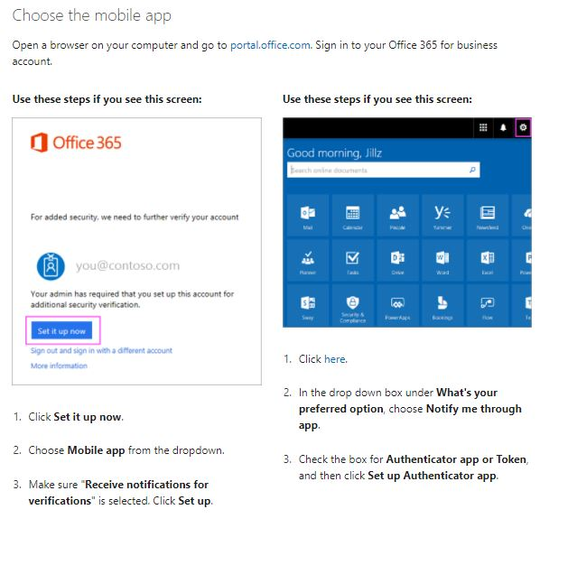

Step 2:
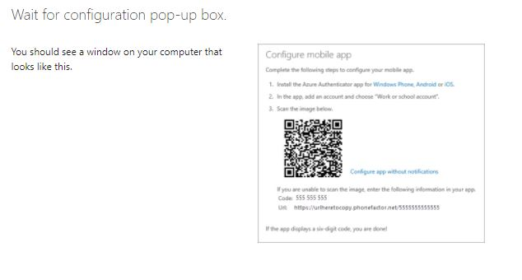
Step 3:
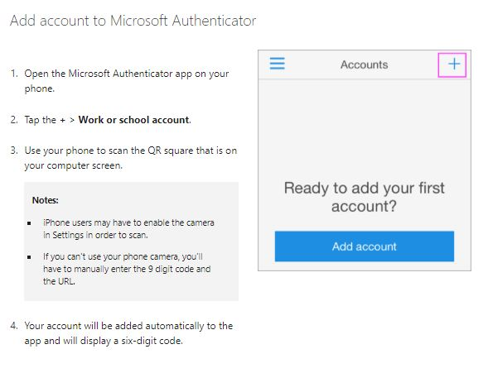

Step 4:
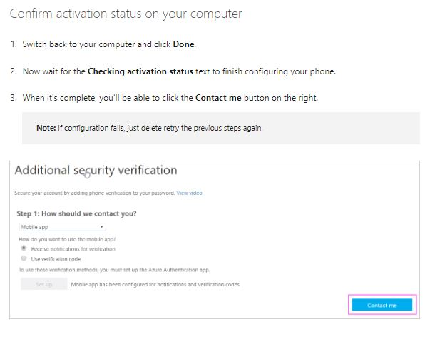
Step 5:
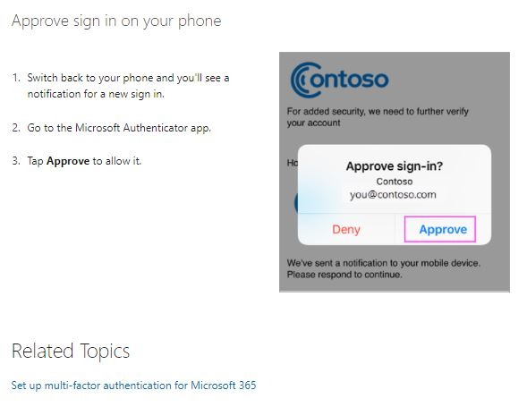
Step 6:
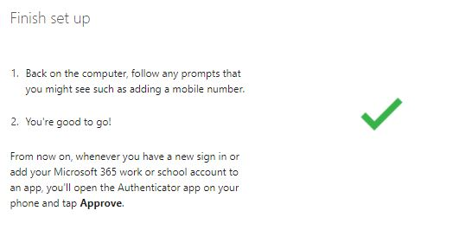
Step 7. The End

