Setting up the Text Option for
Multi-Factor Authentication

The first two (2) images are the normal login screens when logging into the Office 365 web portal.
- Using your computer, type or copy and paste the link into a browser: http://portal.office.com

Enter your login address in the field next to the red arrow and click <Next>.

Note: login address format is smithee@richmond.k12.ga.us

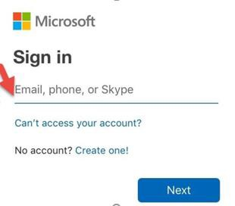

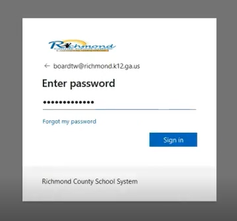
3. Enter the password used to log into your workstation and click <Sign In>.

4. The below screen “More information required” window will appear. Click <Next>.
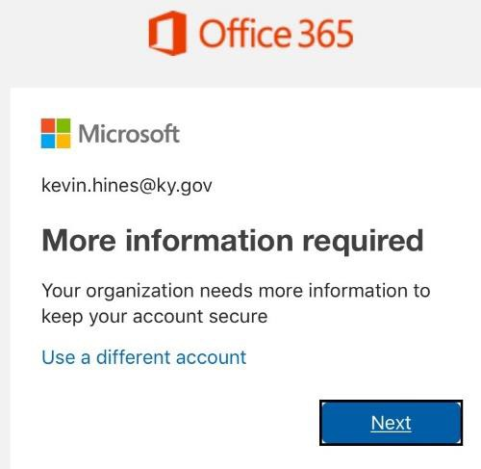

5. Select the authentication method

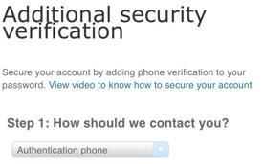

Do the following to setup the text message option for your mobile device as your verification method:
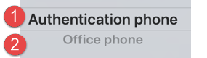
- Select Authentication Phone
- Enter your contact telephone number including area code. Note: you can change the mobile number by backspacing over the telephone number and typing in a new telephone number.
- Click on the radio button to select text message Methods:
Method: Send a code by text message – by clicking on the radio button, this option allows the user to receive a 6- digit code via SMS (mobile phone) to be keyed into a verification screen.
(Note: data rates will apply.)

6. After setting up the method, the image below is displayed to save a password to be used for additional

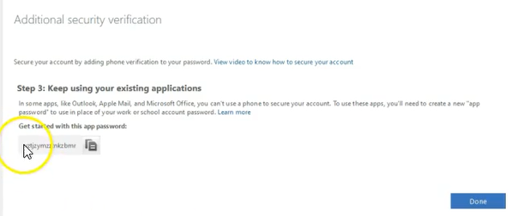
security. Save this password and then click <Done>.

7. You have completed setting up MFA. The image below is displayed “Stay signed in”. if select <Yes>.

MFA allows you to be logged in 30 days.

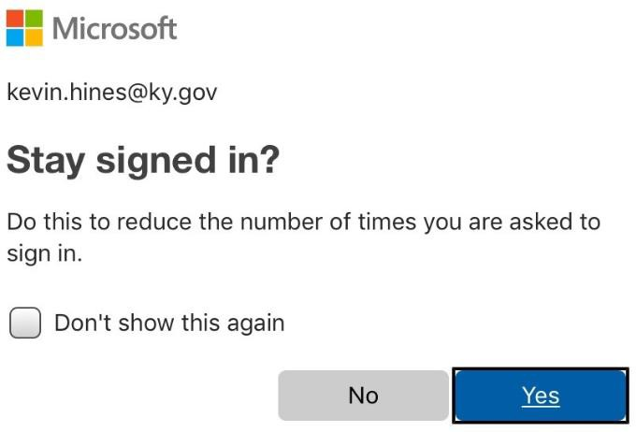

8. The End.

