How to get to your class session:

- Go to https://www.rcboe.org/

- Click on the Student’s tab 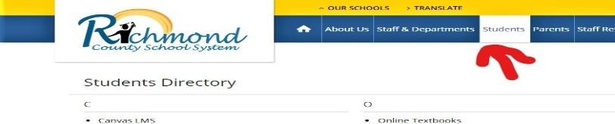

- Click on Launchpad
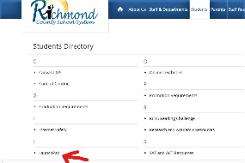
- Enter student’s user name and password
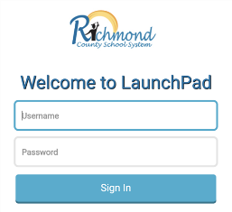
- Click on the Canvas App

- Click on Ms. Bussey’s Homeroom icon, (HR)

