Richmond Hill Middle School
Parental Involvement Policy and Plan for Shared Student Success
2025-2026
School Plan for Shared Student Achievement

What is it?
This plan describes how Richmond Hill Middle School will provide opportunities to improve parent engagement and support student learning. Richmond Hill Middle School believes that parent involvement means the participation of parents in regular two-way and meaningful communication about student academic learning and other school activities. We value the contributions and involvement of parents in establishing an equal partnership for the common goal of improving student achievement. This plan describes the different ways that Richmond Hill Middle School will support parent engagement and how parents can help plan and participate in activities and events to promote student learning at school and home.

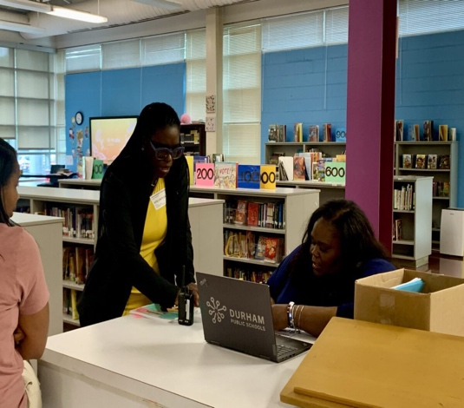
How is it created and how it is revised?


EOY Title, I meeting was held at Richmond Hill Middle virtually. Parents were invited to share their ideas and opinions in revising/creating a new school policy and compacts, that would serve as the foundation for parents.

Richmond Hill Middle School
Mrs. Kimberly Rouse, Principal 3420 Julia
Ave., Augusta GA 30906 706.796-4944
'Rouse(i.i@6oe.riclimona.fr12.ga.us

What is Title I?
Richmond Hill Middle School is identified as a Title l school as part of the Elementary and
Revisions will occur throughout the year. Parents will be invited to the Annual BOY and EOY Title I Meetings, as well as Input/Revision meetings. Input/Feedback are welcomed anytime. Feedback/Comments sheets will be in the Parent Resource Center.

Who is it for?
Secondary Education Act of 1965 (ESEAJ. Title I is designed to support State and local school reform efforts tied to challenging state academic standards to reinforce and enhance efforts to improve teaching and learning for students. Title I programs must be based on effective means of improving student achievement and include strategies to support parental involvement All Title I schools must jointly develop with parents a written parental involvement policy.
All students participating in the Title I, Part A Program, and their families, are encouraged and invited to fully participate in the opportunities described in this plan. Richmond Hill Middle will provide full opportunity for the participation of parents with limited English, parents with disabilities and parents of migratory children.

Where is it available?
The plan is available on the school website and in the office. Parents can also obtain a copy from the Parent Resource Center.
Revised May 23, 2025

 | 2025-2026 District Goals  Student Achievement  - During the 25-26 school year, we will increase student content mastery in tested subject areas on the Georgia Milestones by 6%.  - During the 25-26 school year, we will increase post-high school readiness by increasing our graduation rate by 2%. | 2025-26 School Goals | 2025-2026 Richmond Hill Middle Calendar  - Boo Bash at the Hill (October 29th)  - Turkey and Togetherness (November 20th)  - Books, Cocoa & Cheer (December 17th)  - Milestone Madness (February 11th)  **Please read all communications sent home for additional events.  We got that #SWAG  Richmond Hill Middle  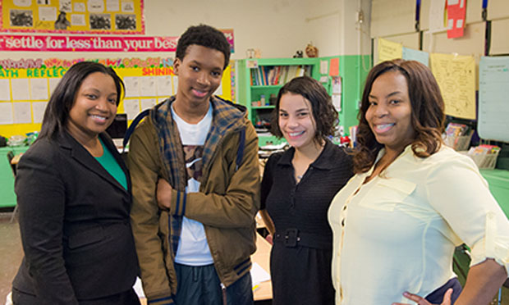
Initiative 1: By the end of the 2025-2026 school year, By the end of the 2025-2026 school year, Richmond Hill Middle School will increase by 10% in student proficiency on iReady Math Diagnostics.

Initiative 2: By the end of the 2025-2026 school year, By the end of the 2025-2026 school year, Richmond Hill Middle School will increase by 10% in student proficiency on iReady Reading Diagnostics.

Initiative 3: During the 2025-2026 school year, Richmond Hill Middle School will During the 2025-2026 school year, 100% of the teachers will participate in consistent collaborative planning.

Initiative 4: During the 2025-2026 school year, Richmond Hill Middle School will create a supportive and respectful learning environment to positively impact the school’s culture and climate.

 |  | 2




Parent Resource Center

Come visit the Parent Resource Center to check out books, study materials, and activities to use at home with your child.
Computers are available for parents to explore the Parent Portal and educational resources.
Monday-Friday (During School Hours)

Parental Involvement

Richmond Hill Middle believes that parental involvement means the participation of parents in regular two­ way and meaningful communication about student academic learning and other school activities, which ensure:

- Parents play an integral role in assisting their child's learning.
- Parents are encouraged to be actively involved in their child's education at school.
- Parents are active partners in their child's education and are included, as appropriate, in decision-making and on advisory committees to assist in the education of their child.
- The carrying out of other activities as described in this plan.
Richmond Hill Middle is Reaching Out to the Community!

Richmond Hill Middle will take the following measures to promote and support parents as an important foundation of the school in order to strengthen the school and reach our school goals. We will:
- Communicate with parents on a weekly basis and respond to parental concerns within 48 hours of contact.
- Keep parents informed about their child's academic progress and changes in behavior.
- Send home daily or weekly homework assignments.
- Develop reading and math goals based on student data and assist students in reaching them.
- Provide monthly trainings for staff during their planning periods on strategies to improve communication with parents and ideas to increase family engagement.
- Staff will also share best practices during regularly scheduled faculty meetings.
- Communicate with all families and the community on a regular basis regarding school­ wide events and activities, through phone messages, social media, and flyers.
- Work with our parents to develop relevant trainings and helpful presentations to educate our staff on the importance of parental involvement.
- Provide necessary materials and handouts for parents at conferences, meetings, and activities to help parents work with their child to improve their child's achievement.
- Use our Partners in Education and School-Community Team to improve awareness of the activities and events listed in the school parental involvement policy.
- Collect feedback from parents at all events, place input card around the building and post suggestion form on the school website in order to respond to parents' requests for additional support for parental involvement activities.
- Igniting Purpose

- Enriching Minds
- Developing Character
- Building Community

3



School Community Team
School Community Team
D Yes, I am interested and wish to join the School Council.
D Please contact me so I can learn more about the School Council.
D Please send me notifications about future meetings and updates.
Name:

Student's Name and Grade: ---------------- Address:
Phone Number:--------------------
Email address: --------------------

Richmond Hill Middle invites all parents to join the School Council to share ideas and ways to involve other parents and to build partnerships with the school, other families, and the community. The School Council will meet four times during the school year, but parents can also submit their ideas or suggestions at any school activity and/or meeting, as well as through our parent surveys located on our website. If you would like to learn more about the School Council, please contact the principal at 706.796.4944.

Share Your Thoughts
We want to hear from you. If you have any suggestions or if there is any part of this policy that you feel is not satisfactory with the students' and the school's goals for academic achievement, please provide us with your comments in the space provided and leave this form in the Main Office:
Name: (optional) Telephone Number: (optional) _ Comment:



4

