4-13. Write the equation represented in the equation mat below. (Html5)
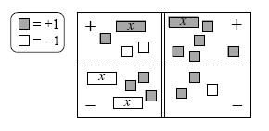
  - Simplify as much as possible and then solve for x.
  - Check your solution.
4-14. Simplify each of the following equations and solve for x. Show all work and check your solution
  - 7 − 3x = − x + 1
  - 2 3x = − (x + 6)

4-15. Leala can write a 500-word essay in an hour. If she writes an essay in 10 minutes, approximately how many words do you think the essay contains4-16. Copy and complete the table below
IN (x) | 2 | 10 | 6 | 7 | −3 |  | −10 | 1000 | x
OUT (y) | 9 | 25 | 17 |  |  | 15
  - Explain in words what is done to the input value (x) to produce the output value (y).
  - Write the rule you described in part (a) with algebraic symbols.

4-17. When Susan’s brother went to college, she and her two sisters evenly divided his belongings. Among his possessions were 3 posters, 216 books, and 24 CDs. How were these items divided? Tools

