4-2. For each tile pattern in problem 4-1, draw Figures 0, 4, and 5 on graph paper. If it helps, copy Figures 1, 2, and 3 onto your paper.
4-3. Make an x → y table for the rule y = x² − 2x.
  - Plot and connect the points on a complete graph.
  - Does your graph look like a full parabola? If not, add more points to your table and graph to complete the picture.
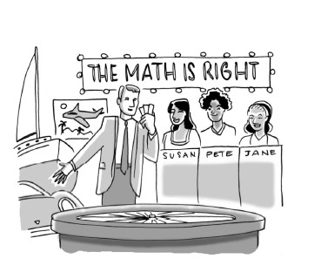
4-4. THE GAME SHOW
Susan had an incredible streak of good fortune as a guest on the exciting game show, “The Math Is Right.” She amassed winnings of $12,500, a sports car, two round-trip airline tickets, and five pieces of furniture.
In an amazing finish, Susan then landed on a “Double Your Prize” square and answered the corresponding math question correctly! She instantly became the show's biggest winner ever, earning twice the amounts of all her previous prizes.
A week later, $25,000, a sports car, four round-trip airline tickets, and five pieces of furniture arrived at her house. Susan felt cheated. What was wrong?
4-5. Write the equation represented by the diagram below.
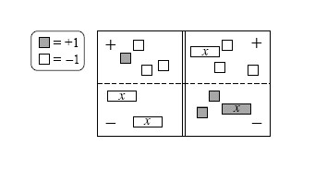
- Simplify as much as possible and then solve for x.
  - Check your solution.
4-6. Copy and simplify the following expressions by combining like terms.
  - y + 3x − 3 + 2x² + 8x − 5y
  - 2x + 4x² − 6x ² − 9 + 1 − x − 3x
  - 2y² + 30y − 3y² + 4y − 14 − y
  - −10 + 3xy − 3xy + y² + 10 − y²
4-7. Use your pattern-finding techniques to fill in the missing entries for the table below. Then find a rule for the pattern.
IN (x) | 4 | 8 | 3 | −2 | −6 | 0 | 5 | 7
OUT (y) | 17 | 65 | 10 | 5 |  | 1 | 26

