4-21. Two of the connections in your representations web are pattern → table and pattern → rule. Practice these connections as you answer the questions below.

  - On graph paper, draw Figure 0 and Figure 4 for the pattern at below.
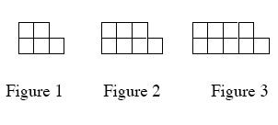
  - Represent the number of tiles in each figure with a table.
  - Represent the number of tiles in each figure with an algebraic rule.
4-22. For the rule y = x² − 4, calculate the y-values that complete the table below. Plot the points and connect them on a complete graph on graph paper. What does your graph look like?
IN (x) | −3 | −2 | −1 | 0 | 1 | 2 | 3
OUT (y)
4-23. For each of the equations below, solve for x. Show all work and check your solution.
  - −2 + 2x = −x + 2 + x
  - 2 − 3x = x + 2
4-24. The length of a rectangle is five centimeters more than twice its width. The perimeter is 100 centimeters. Use Guess and Check to find out how long and how wide the rectangle is.
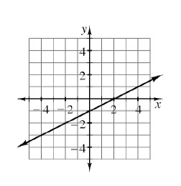
4-25. Another one of the connections in your representations web is graph → table. In Chapters 1 through 3, you developed tools to find a table from a graph. Consider this connection as you complete the table below based on the graph below right
IN (x) | −3 | −2 | −1 | 0 | 1 | 2 | 3
OUT (y)

