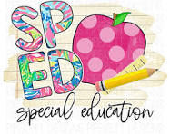
Villa SPED Activities for Book List

- Title: Wutaryoo
- All about me
- Animals
- SPED
- All About me Worksheet
- 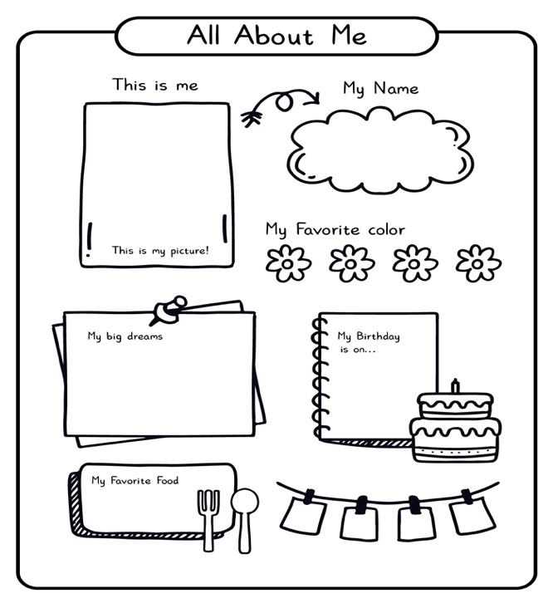
- Title: A Spoon full of Frogs
- Easy Origami
- Animals
- SPED
- Youtube
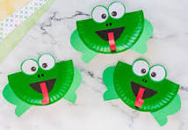

- Title: Song of Frutas
- Read Aloud
- Langues/Culture/food
- SPED
- Youtube

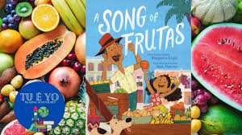

- Title: The Cool Bean
- Magic
- Dancing Beans
- Dance
- SPED
- Youtube
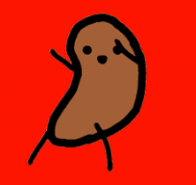

- Title: Gibberish
- Language
- Finger puppets
- SPED

