
Villa SPED Book List

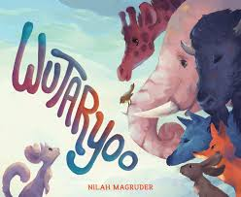

- Title: Wutaryoo
- Author / Illustrator: Nilah Magruder
- Publisher & Copyright Date: Versify (2022)
- Storytime Theme: Animals
- Ages/Grades: Intermediate SPED

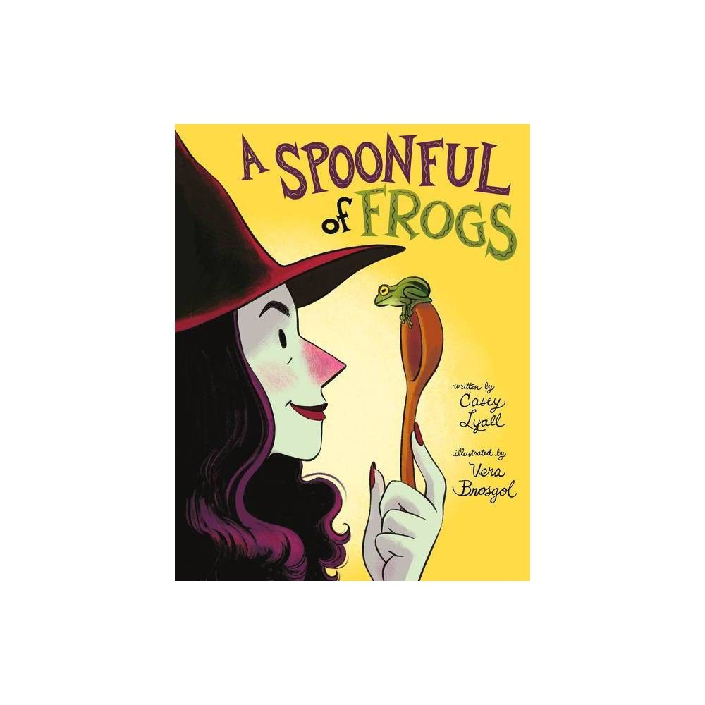
- Title: A Spoonful of Frogs
- Author / Illustrator: Casey Lyall
- Publisher & Copyright Date: Greenwillow Books (2022)
- Storytime Theme: Animals
- Ages/Grades: Intermediate SPED

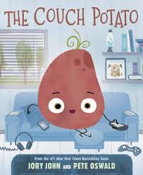

- Title: The Couch Potato
- Author / Illustrator: Jory Jhon/Pete Oswald
- Publisher & Copyright Date: Harper Collins (2020)
- Storytime Theme: Humor
- Ages/Grades: Intermediate SPED

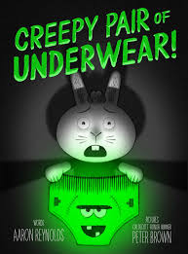

- Title: Creepy Pair of Underwear!
- Author / Illustrator: Aaron Reynolds/Peter Brown
- Publisher & Copyright Date: Simon & Schuster (2017)
- Storytime Theme: Humor
- Ages/Grades: Intermediate SPED

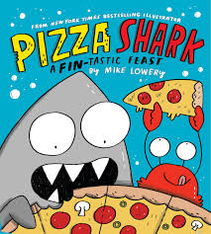

- Title: Creepy Pair of Underwear!
- Author / Illustrator: Aaron Reynolds/Peter Brown
- Publisher & Copyright Date: Simon & Schuster (2017)
- Storytime Theme: Humor
- Ages/Grades: Intermediate SPED

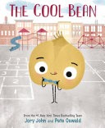

- Title: The Cool Bean
- Author / Illustrator: John Jory/Pete Oswald
- Publisher & Copyright Date: Green Willow Books (2019)
- Storytime Theme: Humor
- Ages/Grades: Intermediate SPED

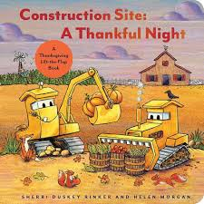

- Title: A Thankful Night
- Author / Illustrator: Sherri Rinker/Helen Morgan
- Publisher & Copyright Date: Chronicle books (2024)
- Storytime Theme: Holidays
- Ages/Grades: Intermediate SPED

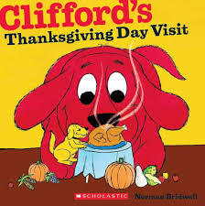

- Title: Clifford’s Thanksgiving Day Visit
- Author / Illustrator: Norman Bridwell
- Publisher & Copyright Date: Chronicle books (1993/2002)
- Storytime Theme: Holidays
- Ages/Grades: Intermediate SPED

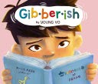

- Title: Gibberish
- Author / Illustrator: Young Vo
- Publisher & Copyright Date: Fourth Printing (2022)
- Storytime Theme: Language
- Ages/Grades: Intermediate SPED

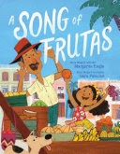

- Title: A Song of Frutas
- Author / Illustrator: Margarita Engle
- Publisher & Copyright Date: Atheneum (2021)
- Storytime Theme: Language & Culture
- Ages/Grades: Intermediate SPED

